Staff Selection Commission (SSC) conducts the SSC CGL Exam every year to select the staff in various reputed Government organizations.

Below I am providing you the process for SSC Combined Higher Secondary Level admit card Download:

1 Visit official web portal of SSC which looks like:

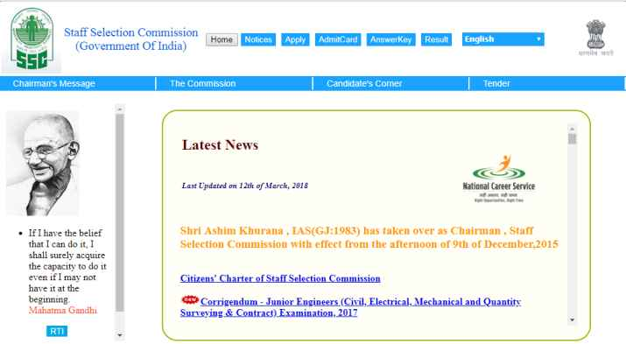
2 In the menu bar click on admit card link

3 Select the region for which you want admit card to be downloaded.

4 Enter your registration number/ roll number/ Name and DOB

5 Click on the submit button.

6 After that, your admit card will be displayed on the screen

7 Download it and take a print out of SSC CHSL Admit Card

Contact:

Staff Selection Commission
Block No-12, CGO Complex
Lodhi Road, New Delhi-110091

