Deccan Chronicle (DC) is an Indian English-language daily newspaper. It is published in Hyderabad, Telangana by Deccan Chronicle Holdings Limited.

The newspapers name derives from the originating place, the Deccan regions of India.

DC Epaper Download

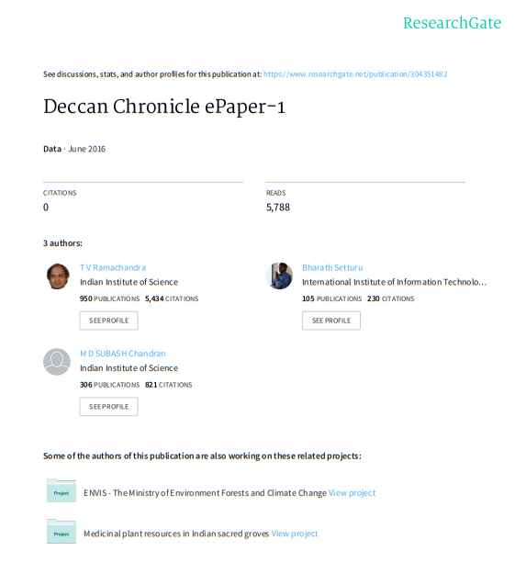
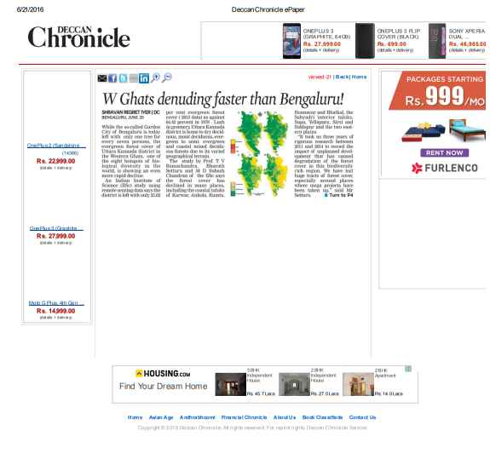
List of topics for which news displayed in DC:
Nation
World
South
Entertainment
Sports
Technology
Lifestyle
Videos
Gallery
Business
More
Opinion
Sunday Chronicle
Decaf
Discourse
360 Degree
Hyderabad Chronicle
Chennai Chronicle
Bengaluru Chronicle
Contact:
Deccan Chronicle
CORPORATE OFFICE
DECCAN CHRONICLE HOLDINGS LIMITED
36, Sarojini Devi Road,
Secunderabad - 500 003
Phone: (040) 27803930 (EPBX) (5 lines)
27805392, 27805393, 27805397 (Advt. Dept.)
Fax: (040) 27803870 (Advt.)
Grams: CHRONICLE & BHOOMI
Email: advt@deccanmail.com

