National Institute of Technology Raipur NIT Raipur (NITRR) Placement Report 2011

National Institute of Technology Raipur which is commonly called as NIT Raipur which is one among the Best Engineering Institute in India Which offers Various Undergraduate Programs and Postgraduate Programs. Students who are Targeting for AIEEE Entrance Exam Can check the Placements Statistics and Salary details National Institute of Technology Raipur.
Students can View the Salary Packages and their Ranges(Highest, Average, Median and Lowest) and also the Details of Companies that visited NIT Raipur for Placements Drive. students can also search the details of Company wise and Branch wise Placement details of NIT Raipur NITRR 2011.

NIT Raipur Placements 2011 Salary Ranges and Statistics :
Students can check the Branch wise Salary details offered by the Companies for the Students who studied in National Institute of Technology Raipur.
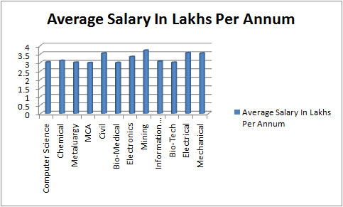

NIT Raipur Branch wise Placements Offered in 2010 & 2011 :

Branch Nane | Placements offered in 2010 | Placements offered in 2011
Bio Medical Engineering | 11 | 9
Bio Technology | 6 | 8
Civil Engineering | 32 | 39
Mining Engineering | 21 | 21
Metallurgical Engineering | 35 | 38
Mechanical Engineering | 42 | 47
Electrical Engineering | 45 | 50
Chemical Engineering | 22 | 30
Electronics & Telecom. Engineering | 33 | 44
Computer Science and Engineering | 38 | 52
Information Technology | 37 | 43
Total B.Tech Placements | 322 | 381
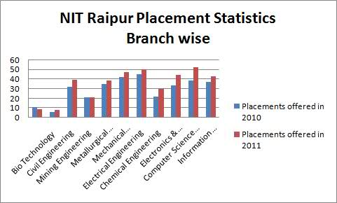

NIT Raipur Company wise Branch wise Placements Details 2011:

S. No. | Name of the Companies | Name of the Branch
S. No. | Name of the Companies | BT | BM | CE | Civil | CSE | EE | ET | IT | ME | MTE | MIE
1 | India Bulls Power ltd. |  |  |  | 3 |  | 2 |  |  | 1
2 | LG India
3 | MU-SIGMA |  |  |  |  | 4 | 1 |  | 2
4 | Tata Motors ltd. |  |  |  |  |  |  |  |  | 2
5 | Shapoorji Pallonji & Co. Ltd. |  |  |  | 6
6 | Arcelor Mittal |  |  |  |  |  |  |  |  | 3 | 1
7 | ABB |  |  |  |  |  | 2 |  |  | 1
8 | Godrej & Boyce |  |  |  |  |  |  | 2 |  | 7
9 | Tata Steel |  |  |  |  |  | 1 |  |  | 3 | 2
10 | Belzabar |  |  |  |  |  |  |  | 1
11 | NTPC |  |  |  |  |  | 2 |  |  | 2
12 | Hindustan Copper Limited |  |  |  |  |  | 3 |  |  | 2 |  | 5
13 | Reliance Power ltd. |  |  |  |  |  | 4 |  |  | 4
14 | Coal India Ltd. |  |  |  |  |  | 8 |  |  | 5 |  | 9
15 | Lnt ECC |  |  |  | 5
16 | Jindal steel plant ltd. |  |  |  |  |  |  |  |  |  | 7
17 | CTS | 6 | 3 |  |  | 21 | 3 | 5 | 12 |  | 2
18 | Shapoorji Pallonji INFRA |  |  |  |  |  | 2 |  |  |  |  | 1
19 | ISPAT |  |  | 1 |  |  | 1 | 4 |  | 2 | 4
20 | SAPIENT |  |  |  |  | 1
21 | Samsung Electronics ltd. |  |  |  |  | 6 |  |  | 4
22 | Punj Lloyd ltd. |  |  |  | 6 |  | 2
23 | Capgemini | 1 |  | 2 |  | 5 |  | 4 | 13 | 1 | 1
24 | Persistent |  |  |  |  | 7 |  | 3 | 1
25 | Essar Group |  |  | 3 | 3 |  | 3 |  |  | 1 | 8
26 | Accenture | 1 |  | 1 |  | 3 |  | 4 | 6 |  | 2 | 1
27 | Patni Computers |  | 1 |  |  | 2 |  | 1 | 2
28 | Hindustan Petroleum Co. Ltd. |  |  |  |  |  | 3 |  |  | 2
29 | Monnet Ispat ltd. |  |  |  |  |  |  |  |  | 1 | 4 | 1
30 | BASF India Limited |  |  | 3 |  |  | 1 |  |  | 1
31 | Adani Power ltd. |  |  |  | 1 |  | 1 | 2
32 | CCCL |  |  |  | 4
33 | ACC Cement ltd. |  |  | 3 |  |  | 2 |  |  | 1
34 | Ace Calderys |  |  | 2
35 | Lnt ECC
36 | HCL System |  | 5 |  |  | 3 |  | 8 | 2
37 | Tech Mahindra |  |  |  |  |  |  | 1
38 | Zauri Paradeep Phosphates ltd. |  |  | 1
39 | Bharti Infratel ltd. |  |  |  | 3 |  | 1
40 | Lanco Group |  |  |  | 2
41 | Lafarge India Pvt. ltd. |  |  | 1 |  |  |  |  |  | 3
42 | Tata Autocomp System Ltd. |  |  | 5 |  |  | 4 |  |  | 3
43 | JSW |  |  | 1 |  |  |  |  |  |  | 5
44 | TVS Motors |  |  |  |  |  |  |  |  |  | 1
45 | HZL |  |  |  |  |  |  |  |  |  |  | 4
46 | Rancore Technology ltd. |  |  |  |  |  |  | 7
47 | D. B. Power Limited |  |  |  | 3
48 | ONGC |  |  | 6 |  |  | 2 | 3 |  | 2
49 | Tech Endeavour Software
50 | OPM |  |  | 1 |  |  | 1
51 | Sunflag Iron & Steel Co. |  |  |  |  |  |  |  |  |  | 1
52 | NRDA |  |  |  | 3 |  | 1
Total |  | 8 | 9 | 30 | 39 | 52 | 50 | 44 | 43 | 47 | 38 | 21

