The CMJ University is a first private university established in Meghalaya situated on a 40-acre campus on a hillock in Jorabat on the Guwahati-Shillong Highway conducting variosu programs to students.

CMJ University Admission Form

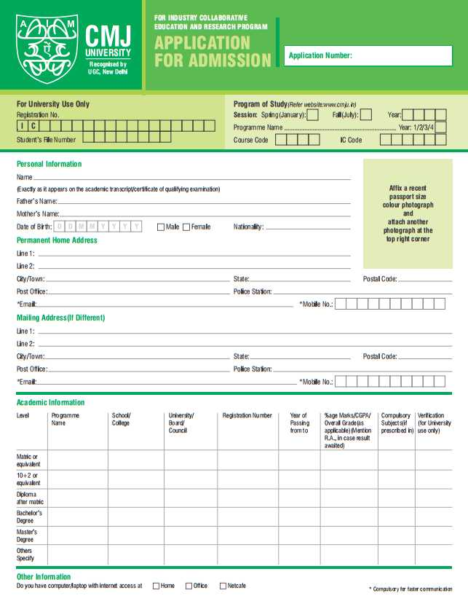

Faculties
FACULTY OF ARTS
FACULTY OF SCIENCE
FACULTY OF MANAGEMENT
FACULTY OF COMMERCE
FACULTY OF TECHNOLOGY
FACULTY OF DISTANCE EDUCATION
FACULTY OF FINE ARTS
FACULTY OF LAW
FACULTY OF NURSING

Various streams
RESEARCH PROGRAMMES
I.T. STREAM
MANAGEMENT STREAM
SCIENCE STREAM
FASHION STREAM
GEMOLOGY AND JEWELLERY STREAM
TRADITIONAL STREAM
PARAMEDICAL STREAM
MASS COMMUNICATION, MEDIA AND JOURNALISM
FIRE AND SAFETY MANAGEMENT COURSES
VOCATIONAL STREAM
ENGINEERING STREAM

Address:-
CMJ University
Modrina Mansion, Nongkynrih, Laitumkhrah, Shillong, Meghalaya 793003

Phone:-
0364 250 5028

