Buddy I would like to tell you that IIT JAM exam has been conducted already for that I will get the information so that you can have idea about it.

Here I’m telling you process to get the admit card

GO to the official site of IIT JAM which looks like this

IIT JAM

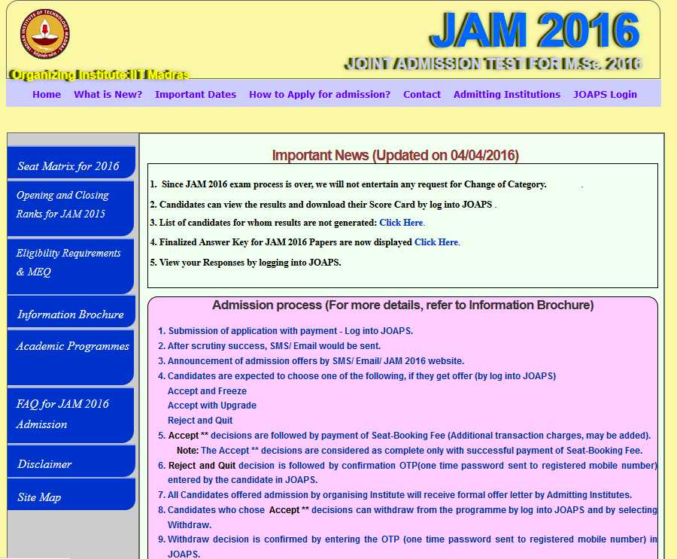

Site page will open at right hand side page
You can see section of login
Click on that section a new page will open which looks like this
There you can get the admit card easily

IIT JAM login

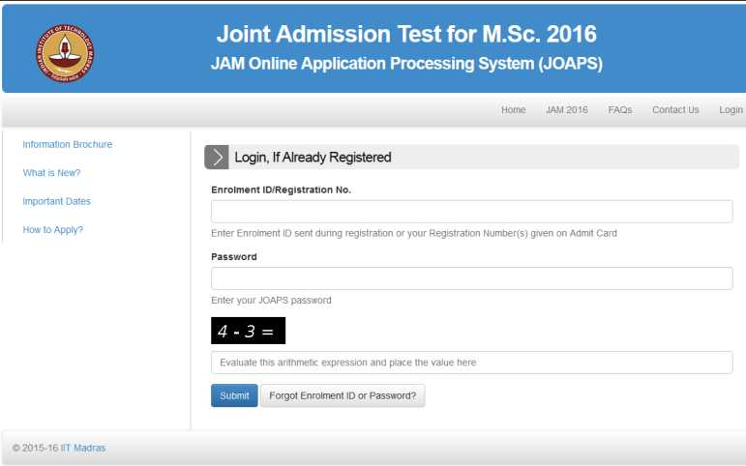

Here I’m telling you dates so that you can have idea about it
Commencement of ONLINE Registration and Application on JAM 2016 Website
September 02 2015 (Wednesday)

Last Date for generation of E-Challan
October 10 2015 (Saturday)

Last Date for payment in SBI branches using E-Challan
October 14 2015 (Wednesday)

Last Date for Registration on JOAPS
October 14 2015 (Wednesday)

Last Date for Online Application Submission and Uploading of Documents on the Website
October 14 2015 (Wednesday)

Last Date for Change of examination City/Town maybe permitted,if request with a valid reason for the same is received in the office of the Chairman, JAM 2016, IIT Madras along with a Demand Draft of Rs. 500/- drawn in favour of Chairman JAM-2016, IIT Madras
October 31 2015 (Saturday)

Download of Admit Card from JAM 2016 website
December 31 2015(Thursday)
till Examination Date

Date of JAM 2016 Examination
February 7 2016 (Sunday)

Announcement of the Results of JAM 2016
March 23 2016 (Wednesday)

Submission of Application Form for Admission on the JAM 2016 Website
April 15-27 2016

Last Date for receipt of request for change of category in proper format/rectification of defective documents at IIT Madras
May 10 2016 (Tuesday)

Declaration of First Admission List
June 03 2016 (Friday)

Declaration of Second Admission List
June 20 2016 (Monday)

Declaration of Third and Final Admission List and the Closure of Admissions through JAM 2016
July 4 2016 (Monday)

Address:-
JAM Offices
IISc Bangalore,Bengaluru-560012
IIT Bombay,Powai Mumbai-400076
IIT Delhi,Hauz Khas,New Delhi-110016
IIT Guwahati,Guwahati-781039
IIT Kanpur,Kanpur-208016
IIT Kharagpur,Kharagpur-721302
IIT Madras,Chennai-600036
IIT Roorkee,Roorke-247667

