Assam Public Service Commission (APSC) holds APSC written exam for recruiting different posts for Assam government at different examination centres .

Follow the steps mentioned below for the Admit Card.

Visit at official website of Assam Public Service Commission .

On top of the page there is Notices section click on it.

The page looks like the image given below

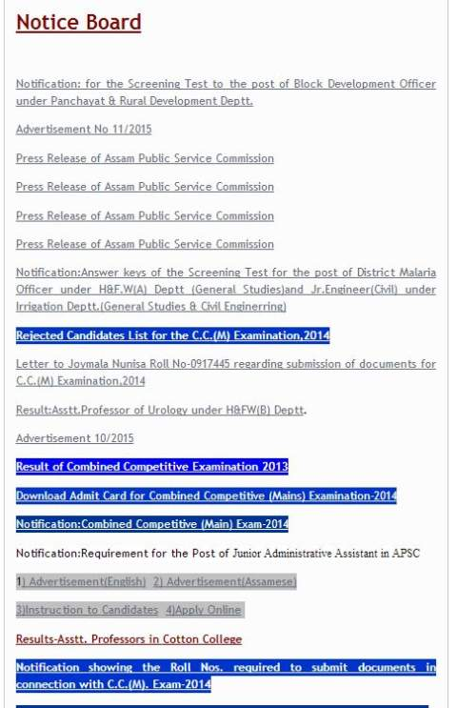

As on today 27-May-2015 Assam Public Service Commission written exam admit card is not available .
Keep visiting notices section for admit card .

Contact Details :
Assam Public Service Commission
Jawahar Nagar
Guwahati 781022
Tel: +91-361-2365426
Fax: +91-361-2368207

