The Uttar Pradesh Unaided Medical Colleges Welfare Association has organized the UPCMET examination for the candidates and this examination is completely known as Uttar Pradesh Combined Medical Entrance Test.

Below I am providing you the process to Download UPCMET Admit Card:

1 First of all, candidates have to visit on the official website of Uttar Pradesh Unaided Medical Colleges Welfare Association looks like:

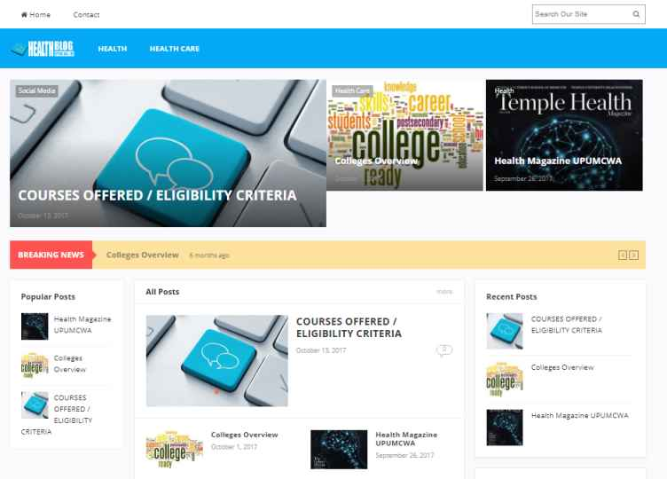

2 The UPCMET admit card link will be available for the candidates.

3 To download the admit card, candidates have to enter their application number and password.

4 The admit card of UPCMET will provide to the candidates in the PDF format.

5 Applicants are suggested to take the print out of admitting card after downloading for the future use.

Important dates:

Events Dates
UPCMET admit card available on 2nd week of April 2019
UPCMET examination held on 2nd week of May 2019

