Here I am providing the procedure to download the JCECE exam admit card conducted by Jharkhand Combined Entrance Competitive Examination Board
which you are looking for .

Applicants can download the JCECE Admit Card from the Jharkhand Combined Entrance Competitive Examination Board official website .

JCECE Admit Card will not be sent by post.

Applicants have to enter the registration number and password for downloading the hall ticket.

Admit Card constitutes name of candidate, roll number, SMQ, PH, photograph, date of birth, father's name, category, subject group with address of J.C.E.C.E. Examination centre allotted.

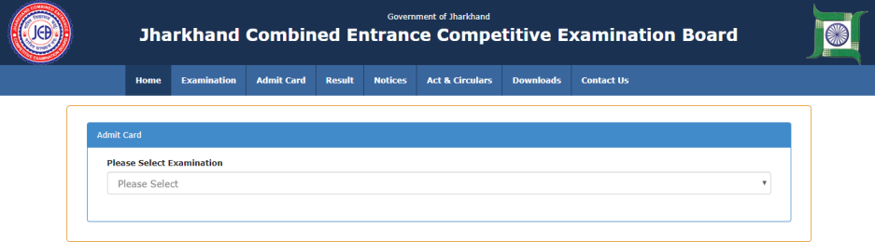

Applicants should not mutilate the admit card or change any entry made therein.

Contact Details:
Jharkhand Combined Entrance Competitive Examination Board
Science & Technology Campus, Sirkha Toli,
Namkum-Tupudana Road Namkum,
Ranchi [Jharkhand] – 834010
Phone : +91-651-2260114
Fax : +91-651-2260336

