State bank of India recruits talented candidates every year for the PO, Clerk posts, for that the SBI releases notifications. To pay the application charges aspirants may check that how to download SBI online challan slip

How to Download SBI Challan Form

Candidates who need to get the means to download the SBI challan form they should read the underneath specified strides:

Firstly hopefuls need to sign on the authority

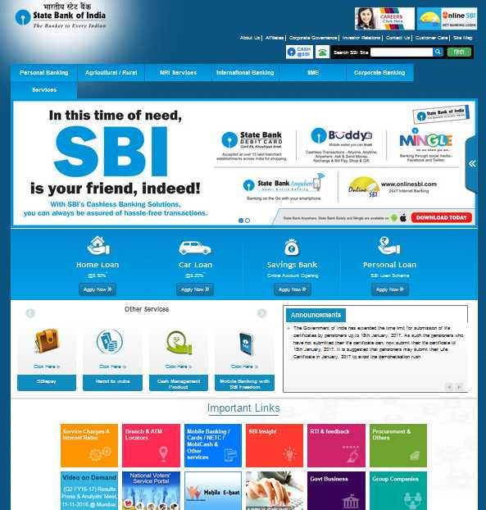

After that must go to the “Careers with Us” segment which is given on left hand area

They need to explore enlistment connect and requested apply on the web.

Candidates are asked for to see this connection and after they are divert to another page.

After that you need to enter the right asked subtle elements worried to instructive capability and some individual data.

Subsequent to filling the application shape appropriately need to go to submit catch and now they are asked for take printout of use.

Presently you will have challan form with filled application.

Lastly, you have installment with this challan form.

