SSC has released the Admit Card for SSC Stenographer Grade C & D Skill Test Exam.

Below I am providing you the process for SSC Stenographer Examination Call letter Download:

1 Visit the official website of SSC looks like:

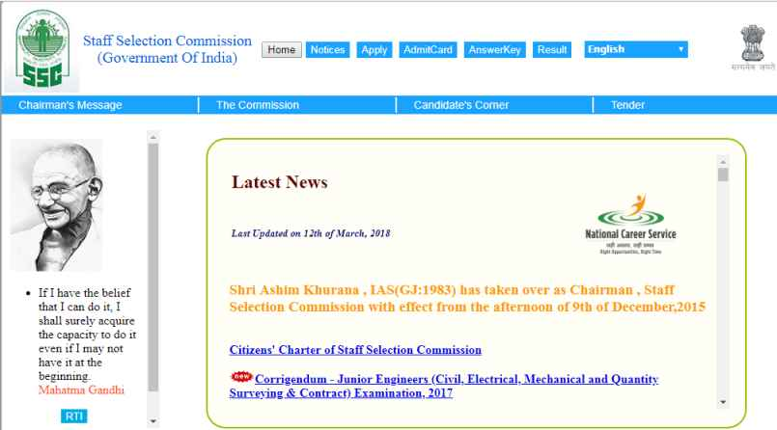

2 Click on the Call letter Tab

3 Check your Region and Click on the given link

4 Click on the call letter for SSC Steno Grade C & D Exam

5 Enter all the login credentials like Registration Number and Date of Birth

6 Click on Submit Button, and the call letter will be displayed on the screen.

7 Take out the hard copy of call letter SSC Stenographer

