Hello, here I am providing you the procedure of downloading the hall ticket of the AP EAMCET as under:

About the exam:
Engineering, Agriculture and Medical Common Entrance Test (EAMCET) is conducted by Jawaharlal Nehru Technological University Kakinada on behalf of APSCHE.

Procedure of downloading the hall ticket
Go to the official website of the AP EAMCET
Click on the admit card at the top of the home page
Here you will be on the new page

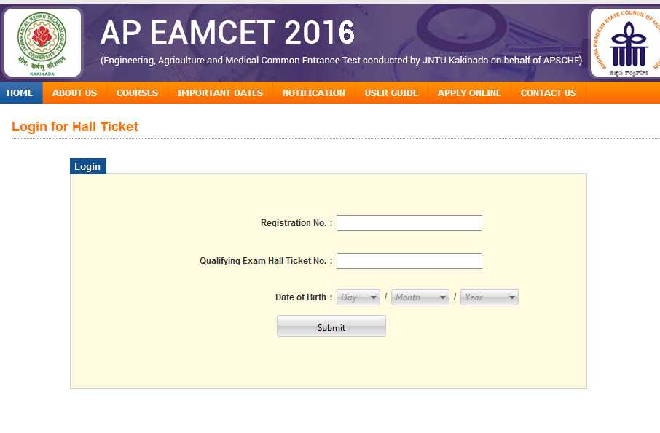

Here enter the details and login
Here you will get the admit card
Take the print of the admit card

Important dates:

Last date for Submission of Online Application with late fee of Rs. 500/-

02-04-2016

Last date for Submission of Online Application with late fee of Rs. 1,000/-

11-04-2016

Last date for Submission of Online Application with late fee of Rs. 5,000/-

19-04-2016

Downloading of Hall Tickets fr

21-04-2016

to

27-04-2016

Last date for Submission of Online Application with late fee of Rs 10,000/-

27-04-2016

Date of AP EAMCET Examination

29-04-2016

Time Of Examination

(a) Engineering (E)

10.00 A.M. to 1.00 P.M.

Time Of Examination

(b) Agriculture and Medical (AM)

2.30 P.M. to 5.30 P.M.

Declaration of Preliminary Key

01-05-2016

Last Date for receiving of objections on Preliminary Key

06-05-2016 (5.00 PM)

Declaration of Ranks (Marks)

16-05-2016

