The Bihar Combined Entrance Competitive Examination for admission in various professional courses in different Engineering colleges, Medical colleges, Agriculture colleges under the Govt.of Bihar is being conducted by Bihar Combined Entrance Cometitve Examination Board as constituded under the Bihar Combined Entrance Cometitve Examination Act, 1995.

Below I am providing you the process to download the DCECE Admit Card

1 Visit the official portal of DCECE looks like:

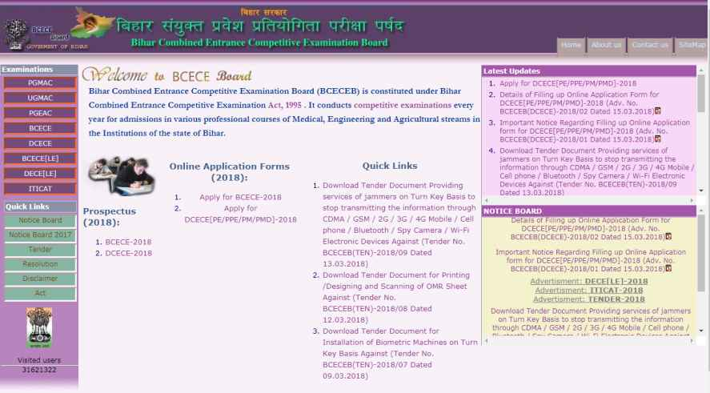
2 Find the link for DCECE Admit Card and click on it (when available)

3 Enter Full Name and Date of Birth OR Registration Number OR Form number

4 Click on Show my admit card.

5 The pdf version is generated. Save the admit card.

6 Connect a printer to your PC.

7 Insert plain white sheets in the printer.

8 Download the admit card and take three print outs.

9 Note the instructions mentioned on the admit card carefully.

