The Indo Tibetan Border Police has as of late declared a Recruitment warning of ITBP Constable Recruitment 2016 there are complete 496 Constables (Tradesman) empty posts in different stations. Presently they welcome to fill online application structure on its primary authority site

Insight About ITBP Constable(Tradesman) Recruitment 2016

Number of post: 496 posts

Name of Organization :- Indo Tibetan Border Police ( ITBPF)

Official site â€“

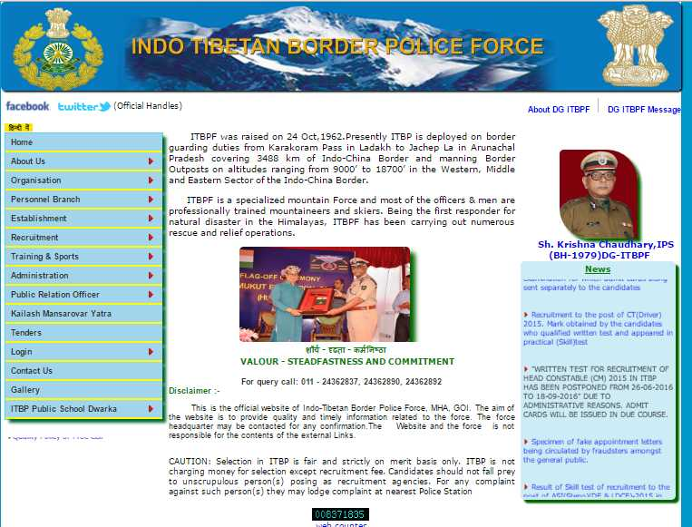
Name of post: Constable (Tradesman)

Tailor (male and female): 32 posts

Safai karamchari (male just): 99 posts

Cook (male just): 115 posts

Washerman (male just): 48 posts

Cultivator (male just): 09 posts

Shoemaker (male just): 23 posts

Water Carrier (male just): 123 posts

Stylist (male just): 47 posts

Qualification Criteria :-

Age limit : Applicants age Should be least 18 year and most extreme 33 years and age unwinding is material according to the administration rules.

Application charge : General/OBC class competitors are have to pay Rs. 50/ - and other saved class are exempted for charge.
Instructive capability: Applicants capability is pertinent according to the distinctive post they ought to have passed class 10/ITI/Diploma in significant order from any perceived foundation.

Determination methodology: Written exam, Physical Efficiency test, Physical Measurement and Interview will be taken

Instructions to apply : Download the endorse application structure group from the official site and top it off with all essential required subtle elements and after that send it alongside obliged archives to address given in authority notice.

Vital dates ought to be remind:

Last date for receipt of structure: 15/05/2016 (for far ranges 22/05/2016)

