This is the full 2006 JMET (Joint Management Entrance Test) paper with solutions. Solve previous year JMET papers to crack JMET 2011 exam.
JMET Paper 2006 Solved
Directions: Read the following passage to answer Questions 1-4. Choose the correct option in each of the questions.
We define the entrepreneur as an individual who identifies opportunities, and on the basis of his/her ability, desire and confidence, makes judgements and decisions pertaining to the coordination of resources in order to exploit those opportunities for personal gain. Personal gain in this context could be financial, fame, prestige or satisfaction from helping other people. This definition extends the concept beyond the narrow limits of profit maximization. It is important to note that entrepreneurial decision making is distinct from routine managerial / administrative decision making by corporate executives. However, this definition does include innovative venture decisions by executives and others in an already existing organization as legitimate entrepreneurial function. The entrepreneurial function consists of three main elements: recognition of opportunities, judgemental decision and coordination of resources. In terms of organization, the entrepreneur will be involved in risk bearing, autonomous decision making and residual claims.
Every person is potentially an entrepreneur. However, the extent of its manifestation in actual entrepreneurial activities, business or otherwise, is a matter of political, social, economic, cultural and ideological influences. Put differently, every human being has an innate ability to become an entrepreneur even though this ability is not always translated into action because of a variety of limiting factors. This observation allows us to propose that there are more than 5 billion entrepreneurs in this world, even though this conjecture may not have been fully manifested in the practical world of business.
If there are more than 5 billion entrepreneurs in this world, how is it that there is such a dearth of entrepreneurs in the world of business? This is an important question in view of the fact that business communities, academia and policy makers in the public realm have begun to talk about possibilities for fostering entrepreneurial growth in the global economy.
As per the passage, an entrepreneur is one who:
Take the commercial venture decisions.
Invites participation in decisionmaking
Exploits opportunities for personal gain.
Focuses on maximizing cash profits.
Which of the following statements is NOT correct, according to the passage?
Entrepreneurial decisionmaking is different from managerial decision-making.
Not everybody can become an entrepreneur.
Executives in organizations can be either managers or entrepreneurs, but not both.
There are more than 4 billion potential entrepreneurs in this world.
The passage mentions the following functions of an entrepreneur:
Coordinating resources, recognizing opportunities and leading from the front.
Making judgements, innovating and claiming responsibility.
Independent decision-making, exploiting opportunities and maximizing profits.
Risk-taking, decision-making, encouraging creativity.
The passage implies that it is important to understand:
The factors which inhibit entrepreneurship.
The meaning of personal gain for an entrepreneur.
Why there are so few entrepreneurs in business.
The main functions of an entrepreneur.
Directions: Questions 5 & 6 relate to the paragraphs given below:
At the peak of the Battle of Britain, Winston Churchill said in the Commons on August 20, 1940, that never in the field of human conflict was so much owed by so many to so few. Little did he then know how a majority of Indians would echo his sentiments, fifty years on, about 1.2 million of their compatriots. The latter have catapulted India into the international hi-tech orbit, lifting the contribution of the services sector in gross domestic product (GDP) to 52% leaving industry and agriculture jostling for space in the rear.
The latest is that software and Information Technology (IT) services are expected to account for 7.7% of GDP by 2008, with software exports of around $ 87 billion. That, in turn, should generate a demand for IT hardware of $ 50 billion. The software industry employs more than 800,000 professionals with around 260,000 in software exports, 28,000 in the domestic software market, 280,000 in captive software user organizations, and 245,000 in the ITESBPO sector. In fact, it has been planned to reach a teledensity of 9 per hundred by 2007 for New Delhi, to attain which 90 million direct exchange lines would be needed! That compares with just 20 million lines in 2000. Even Indias cellular phone market is growing and investments exceeding Rs. 25,000 crore are expected in the next three years, with a subscriber base of 120 million by 2008.
The underlined sentence in the first paragraph implies that:
Quality mass education must be sacrificed at the altar of hi-tech education
A large nation was indebted to a small army
The majority should be indebted to the minority
The small hi-tech sector in India has helped us go global
According to the author,
800,000 software professionals are expected to account for 7.7% of GDP by 2008
Industry and agriculture have contributed to 48% of our GDP
1.2 million Indians are significantly influencing the economy of India
New Delhi will need Rs. 25,000 crore to invest in 90 million direct exchange lines
Directions: In Questions 7 & 10, select the pair of words that best expresses a relationship similar to the pair in capitals:
FLIMSY : STURDY
Gauche : Eloquent
Drizzle : Downpour
Flippant : Earnest
Prognosis : Diagnosis
GREGARIOUS : OUTGOING
Grouchy : Irritable
Groggy : Lucid
Gritty : Sociable
Aggressive : Extrovert
GUEST : INVITATION
Witness : Subpoena
Petitioner : Plea
Applicant : Application
Visitor : Letter
SCHOOL : FISH
Mischief : Monkeys
Leaf : Book
Badge : Honor
Group : Deer
Directions for questions 11 to 16:
Answer the questions based on the passage given below:The guy sitting grimly alone in the corner of the office may not be anti-social. He may, in fact, even be working. That could be one of the inferences drawn from a recent survey conducted by America Online and Salary.com. Socializing with co-workers, spacing out and surfing the Web could, says that survey, cost US companies as much as $ 759 billion in salary. The survey of 10,044 employees debunks some popular myths. Men and women are found to have wasted an equal amount of time at work. Older workers were significantly more attentive. As compared to the overall average of two hours a day being wasted, lunch time not counted, workers over 55 were found to have wasted just 30 minutes. While 33% of the respondents said they wasted time because they didnt have enough work, 25% said they did so because they were underpaid. However, not all time-wasting activities are detrimental to the organization. Salary.com senior vice-president Bill Coleman felt that personal use of the Internet could even be positive since it could generate new business ideas if not contributed to a happier work environment. There is such a thing as creative waste. Not all wasted time is bad, Coleman was quoted by Reuters as saying.
A survey on time-wasting in Indian organizations could throw up interesting results. The most irritating waste of time is when those working inside the office are asked for directions by visitors. With receptionists and security staff also doing duty at the switchboard for telephone calls, it is usually the employee nearest the entrance who has to field queries ranging from Where is so and so? to Where is the toilet? However, the most formally-sanctioned way of wasting time in the Indian organization remains the office-meeting. Organizations are known to hold meetings at the drop of a hat. Even a decision to cut down on meetings would be taken at a meeting! The conference-hall is bigger than the canteen which serves a more useful purpose!
The central idea of the passage relates to:
Why time is wasted in organizations
ILL-effects of time-wasting activities
Time-wasting in organizations
Common ways of wasting time in Indian organizations
Out of the following four options, which is the odd one out?
Some time-wasting activities are good for organizations.
Younger workers waste less time.
Meetings are one of the most common ways to waste time.
Men and women waste an equal amount of time.
The passage does NOT deal with:
Creative waste
Time wasting in Indian organizations
US Workers Survey
Efficient time management in organizations
The phrase creative waste refers to:
Wastage of time that is productive
Time wasted during meetings
Wastage of time that is unproductive
Answering queries of visitors
From the passage, it may be inferred that:
Men waste more time than women at work
On an average, more than two hours of a work day are wasted.
The conference hall is a more useful place than the meal canteen.
More than 5000 respondents admitted to having wasted time at work.
One of the most common time-wasting activities in Indian organizations is:
Answering telephone calls
Holding official meetings
Surfing the Web
Sitting alone in a corner
Directions: In Questions 17 & 21, choose the option that is nearly similar in meaning to the capitalized word.
CONSISTENCY
Constancy
Congruity
Compatibility
Conformity
DYSPEPTIC
Dwarfish
Crotchety
Crafty
Dynamic
INVALIDATE
Intractable
Naught
Nullify
Invariable
MISBEGOTTEN
Misapprehension
Delusion
Purloined
Misconception
STUMPED
Terrorized
Bamboozled
Subdued
Subjugated
Directions: Questions 22 to 25: consist of groups of jumbled phrases. Only one of the four options, when unscrambled, can be grammatically correct sentence. Disregarding punctuation errors,
identify the correct option.
Own priorities / involves sorting / it always / out your
And the environmental authority / several type of complaints / by area residents / has been lodged with the plant
How to be / the good manager / and a fox / both a hedgehog
Protagonists who defeated / great stories portrays / enemy of / there community
Identify the correct option.
are expected / will attend the summit / MDs and CEOs of top companies
as many replacement is / I cannot leave my desk / being late to come
still the hot issues / this is why / celebrity endorsement are
communication skills as among / business students rank / the most important they have to master
Identify the correct option.
came like / the announcement / a bolt from the heavens
duped by a / I was / fly-in-the-night operator
throw my / I decided to / hat in the ring
a heart-on-heart / I decided to have / talk with him
Identify the correct option.
spend his last few / he preferred to / days in relative anonymity
reached to me today / about my appointment / the officious communication
to the station / I haled a taxi / to take me
get the / pronunciation correct / you cant never
Directions: Questions 26 30, only one of the four options is grammatically correct.
Identify that correct option.
Seating arrangements influence the kind of interactions that take place.
Seating arrangements influenced the kind of interaction that takes place.
Seating arrangements influences the kind of interaction that take place.
Seating arrangements influence the kind of interaction that takes place.
Identify that correct option.
Any organizations, large or small, trade with many different peoples and companies.
Any organizations, large or small, trades with many different people and companies.
Any organization, large or small, trade with many different people and company.
Any organization, large or small, trades with many different people and companies
Identify that correct option.
Using too much jargons during communication might obliterate main issue.
Using too much jargon during communication might obfuscate the main issue.
Using too much jargons during communication might obfuscate the main issues.
Using too may jargons during the communication might obdurate a main issue.
Identify that correct option.
In the course of their journey, they were able to observe a lot of local cultures.
In the course of there journey, they were able to absolve a lot of local cultures.
In the course of their journey, they were able to observe a lot of local culture.
In the coarse of their journey, they were able to absorb a lot of local culture.
Identify that correct option.
Your advise does not seem to have had any affect.
Your advise does not seem to have had any affects.
Your advice does not seem to have had any effect.
Your advice do not seems to have had any effect.
Directions: Questions 31 35, choose the word which is OPPOSITE in meaning to each of theunderlined words:
His description of the event was rather pejorative.
Predictive
Derogatory
Laudatory
Abusive
Observing his agitation, we tried to propitiate the speaker.
Facilitate
Prohibit
Placate
Provoke
Muskans ubiquitous smile helped to cheer us up in times of misery.
Frequent
Small
Common
Rare
Evidence of his moral turpitude influenced the committees decision about his promotion.
Timidity
Baseness
Courage
Honorableness
Efforts at managing differences have, till date, been more episodic than otherwise.
Continuous
Half-hearted
Eventful
Intermittent
Directions for questions 36 to 40:
Consist of four phrases each. One of the phrases (A, B, C or D) is grammatically incorrect.br .
Identify that incorrect phrase
Is aware of the methods for improving performance and making decisions.
If members (particularly those who lead them)
However, the advantages of teamwork can be minimized
And the benefits increased
Identify that incorrect phrase
Each party can consider the needs of the other and
When assertion is used with the win-win approach,
Move towards a solution that satisfies as many needs as possible.
And with others who also uses the winwin approach
Identify that incorrect phrase
The Indian car buyers perception
When it comes to designs.
It is always
Been hard to change
Identify that incorrect phrase
To the spoken message.
In a conflict, speak in a pleasant way,
And match yours non-verbal behavior
Send appropriate non-verbal messages to the other person
Identify that incorrect phrase
To serve, And
Also admiration are what
To live, To love
I aspire for.
Each of these problems has two Statements I and II as a Question. Use the information provided in Statements I and II to decide whether they are sufficient to answer the Question. For each problem, select one of the options a, b, c or d based on the following criteria:
X and Y start walking towards each other in a straight line at 9:00 AM. What is the ratio of the distance traveled by X to Y from their respective starting points to the point where they meet each other?
I. X walks twice as fast as Y.
II. The distance between the starting points of X and Y are 5 km.
Choose option a, if the question can be answered using the information given in just one of the Statements but not the other, i.e. choose this option if one of the following conditions is met:
1.Statement I is sufficient to answer the question but
Choose option b if the Question can be answered using the information given in either one of them, i.e. choose this option if Statement I alone is sufficient to answer the Question AND Statement II alone is also sufficient to answer the Question.
Choose option c if the Question can be answered using the information given in both Statements I and II together, but cannot be answered individually from I and II.
Choose option d if the Question cannot be answered even after using the information given in both Statements I and II.
Each of these problems has two Statements I and II as a Question. Use the information provided in Statements I and II to decide whether they are sufficient to answer the Question. For each problem, select one of the options a, b, c or d based on the following criteria:
What is the remainder when 3m + 1 is divided by 6?
I. m is even.
II. m is odd.
Choose option a, if the question can be answered using the information given in just one of the Statements but not the other, i.e. choose this option if one of the following conditions is met:
1. Statement I is sufficient to answer the question bu
Choose option b if the Question can be answered using the information given in either one of them, i.e. choose this option if Statement I alone is sufficient to answer the Question AND Statement II alone is also sufficient to answer the Question.
Choose option c if the Question can be answered using the information given in both Statements I and II together, but cannot be answered individually from I and II.
Choose option d if the Question cannot be answered even after using the information given in both Statements I and II.
Each of these problems has two Statements I and II as a Question. Use the information provided in Statements I and II to decide whether they are sufficient to answer the Question. For each problem, select one of the options a, b, c or d based on the following criteria:
A spherical iron ball is dropped into a cylindrical tumbler containing such an amount of water that the ball gets completely immersed but water does not overflow out of the tumbler. By how many centimeters does the water level rise in the tumbler?
I. The radius of the ball is half that of the tumbler.
II. The tumbler contained 100 cc of water.
Choose option a, if the question can be answered using the information given in just one of the Statements but not the other, i.e. choose this option if one of the following conditions is met:
1. Statement I is sufficient to answer the question but<b< p=""></b<>
Choose option c if the Question can be answered using the information given in both Statements I and II together, but cannot be answered individually from I and II.
Choose option b if the Question can be answered using the information given in either one of them, i.e. choose this option if Statement I alone is sufficient to answer the Question AND Statement II alone is also sufficient to answer the Question.
Choose option d if the Question cannot be answered even after using the information given in both Statements I and II.
Each of these problems has two Statements I and II as a Question. Use the information provided in Statements I and II to decide whether they are sufficient to answer the Question. For each problem, select one of the options a, b, c or d based on the following criteria:
What is the exact time?
I. The time is between 3 PM to 4 PM.
II. The hour hand and the minute hand are in a straight line.
Choose option d if the Question cannot be answered even after using the information given in both Statements I and II.
Choose option b if the Question can be answered using the information given in either one of them, i.e. choose this option if Statement I alone is sufficient to answer the Question AND Statement II alone is also sufficient to answer the Question.
Choose option a, if the question can be answered using the information given in just one of the Statements but not the other, i.e. choose this option if one of the following conditions is met:
1. Statement I is sufficient to answer the question but <
Choose option c if the Question can be answered using the information given in both Statements I and II together, but cannot be answered individually from I and II.
Each of these problems has two Statements I and II as a Question. Use the information provided in Statements I and II to decide whether they are sufficient to answer the Question. For each problem, select one of the options a, b, c or d based on the following criteria:
Will Q take more than 8 hours to complete job X alone?
I. P works faster than Q.
II. P and Q can together finish the job in 5 hours.
Choose option b if the Question can be answered using the information given in either one of them, i.e. choose this option if Statement I alone is sufficient to answer the Question AND Statement II alone is also sufficient to answer the Question.
Choose option c if the Question can be answered using the information given in both Statements I and II together, but cannot be answered individually from I and II.
Choose option a, if the question can be answered using the information given in just one of the Statements but not the other, i.e. choose this option if one of the following conditions is met:
1. Statement I is sufficient to answer the question but<b< p=""></b<>
Choose option d if the Question cannot be answered even after using the information given in both Statements I and II.
Each of these problems has two Statements I and II as a Question. Use the information provided in Statements I and II to decide whether they are sufficient to answer the Question. For each problem, select one of the options a, b, c or d based on the following criteria:
The monthly salary of a Boss is Rs. 40,000. What is the salary of his only subordinate?
I. The subordinate gets Rs. 10,000 less than the average salary of the Boss and his own salary.
II. The average salary of the Boss and the subordinate is Rs. 37,000.
Choose option b if the Question can be answered using the information given in either one of them, i.e. choose this option if Statement I alone is sufficient to answer the Question AND Statement II alone is also sufficient to answer the Question.
Choose option d if the Question cannot be answered even after using the information given in both Statements I and II.
Choose option a, if the question can be answered using the information given in just one of the Statements but not the other, i.e. choose this option if one of the following conditions is met:
1. Statement I is sufficient to answer the question but<b< p=""></b<>
Choose option c if the Question can be answered using the information given in both Statements I and II together, but cannot be answered individually from I and II.
Each of these problems has two Statements I and II as a Question. Use the information provided in Statements I and II to decide whether they are sufficient to answer the Question. For each problem, select one of the options a, b, c or d based on the following criteria:
In a written test, Sita, Geeta, Reena and Asha have got their ranks. Who are the first and the last rank holders?
I. Sita has scored more than Asha but less than Geeta.
II. Asha has scored more than Reena but less than Geeta and Sita.
Choose option a, if the question can be answered using the information given in just one of the Statements but not the other, i.e. choose this option if one of the following conditions is met:
1. Statement I is sufficient to answer the question but<b< p=""></b<>
Choose option d if the Question cannot be answered even after using the information given in both Statements I and II.
Choose option b if the Question can be answered using the information given in either one of them, i.e. choose this option if Statement I alone is sufficient to answer the Question AND Statement II alone is also sufficient to answer the Question.
Choose option c if the Question can be answered using the information given in both Statements I and II together, but cannot be answered individually from I and II.
Answer the questions based on the following passage:
Four students, Promila, Quadir, Rita and Sridhar, each working under the supervision of one of the four Professors â€” Anand, Bose, Chandrashekharan and Deshpande made their final year MBA Project Presentations one by one, one each in the areas of Finance, Marketing, Systems and Human Resource Management (HRM). Each Professor is an expert in only one of the above areas and supervised exactly one of the above students in his own area. The following clues are provided:
i. First presentation was made by Rita.
ii. Prof. Bose works in Finance.
iii. Prof. Deshpande was Promilas supervisor.
iv. The last presentation was in the Systems area.
v. Sridhars project was in HRM area.
vi. Prof. Boses students presentation followed that of Prof. Chandrashekharans student.
In which area was Ritas project?
Cannot be determined
Finance
Marketing
Systems
Answer the questions based on the following passage:
Four students, Promila, Quadir, Rita and Sridhar, each working under the supervision of one of the four Professors â€” Anand, Bose, Chandrashekharan and Deshpande made their final year MBA Project Presentations one by one, one each in the areas of Finance, Marketing, Systems and Human Resource Management (HRM). Each Professor is an expert in only one of the above areas and supervised exactly one of the above students in his own area. The following clues are provided:
i. First presentation was made by Rita.
ii. Prof. Bose works in Finance.
iii. Prof. Deshpande was Promilas supervisor.
iv. The last presentation was in the Systems area.
v. Sridhars project was in HRM area.
vi. Prof. Boses students presentation followed that of Prof. Chandrashekharans student.
What is Prof. Deshpandes area of expertise?
HRM
Systems
Cannot be uniquely determined
Marketing
Answer the questions based on the following passage:
Four students, Promila, Quadir, Rita and Sridhar, each working under the supervision of one of the four Professors â€” Anand, Bose, Chandrashekharan and Deshpande made their final year MBA Project Presentations one by one, one each in the areas of Finance, Marketing, Systems and Human Resource Management (HRM). Each Professor is an expert in only one of the above areas and supervised exactly one of the above students in his own area. The following clues are provided:
i. First presentation was made by Rita.
ii. Prof. Bose works in Finance.
iii. Prof. Deshpande was Promilas supervisor.
iv. The last presentation was in the Systems area.
v. Sridhars project was in HRM area.
vi. Prof. Boses students presentation followed that of Prof. Chandrashekharans student.
In which area was the second presentation?
Cannot be uniquely determined
Finance
Marketing
HRM
nswer the questions based on the following passage:
Four students, Promila, Quadir, Rita and Sridhar, each working under the supervision of one of the four Professors â€” Anand, Bose, Chandrashekharan and Deshpande made their final year MBA Project Presentations one by one, one each in the areas of Finance, Marketing, Systems and Human Resource Management (HRM). Each Professor is an expert in only one of the above areas and supervised exactly one of the above students in his own area. The following clues are provided:
i. First presentation was made by Rita.
ii. Prof. Bose works in Finance.
iii. Prof. Deshpande was Promilas supervisor.
iv. The last presentation was in the Systems area.
v. Sridhars project was in HRM area.
vi. Prof. Boses students presentation followed that of Prof. Chandrashekharans student.
Which students project did Prof. Bose supervise?
Quadir
Rita
Sridhar
Cannot be determined from above
Answer the questions based on the following passage:
Four students, Promila, Quadir, Rita and Sridhar, each working under the supervision of one of the four Professors â€” Anand, Bose, Chandrashekharan and Deshpande made their final year MBA Project Presentations one by one, one each in the areas of Finance, Marketing, Systems and Human Resource Management (HRM). Each Professor is an expert in only one of the above areas and supervised exactly one of the above students in his own area. The following clues are provided:
i. First presentation was made by Rita.
ii. Prof. Bose works in Finance.
iii. Prof. Deshpande was Promilas supervisor.
iv. The last presentation was in the Systems area.
v. Sridhars project was in HRM area.
vi. Prof. Boses students presentation followed that of Prof. Chandrashekharans student.
What is Prof. Anands area of expertise?
I. HRM
II. Systems
III. Marketing
Either I or III
Either I or II
Either II or III
Neither I, nor II, nor III
Each Question consists of a set numbered Statements. Assume that each one these Statements is individually true. Each of the four choices consists of a subset of these Statements. Choose that subset as your answer where the Statements therein are logically inconsistent among themselves.
(i) If the monsoon comes in time it rains aplenty in the peninsula.
(ii) If it rains aplenty in the peninsula there is no crop failure.
(iii) If the fertilizers are not available in the market then there is a crop failure.
(iv) If the fertilizers are available in the market that means the shipping line is working smoothly.
(v) If there is no crop failure that means fertilizers are not available in the market.
(vi) If the shipping line is working smoothly the monsoon does not come in time.
(vii) If the fertilizers are not available in the market then it rains aplenty in the peninsula.
(i), (ii), (iv), (vi), & (vii)
(i), (iii), (iv), (vi) & (vii)
(ii), (iv), (v), (vi) & (vii)
(i), (ii), (iii), (iv) & (vi)
Each Question consists of a set numbered Statements. Assume that each one these Statements is individually true. Each of the four choices consists of a subset of these Statements. Choose that subset as your answer where the Statements therein are logically inconsistent among themselves.
(i) All mammals have hairs.
(ii) Anything which does not have feathers cannot fly.
(iii) Anything which has feathers is not a mammal.
(iv) Anything which can fly does not have hair.
(v) Anything which cannot fly is a mammal.
(vi). Anything which has hair does not have feathers.
(vii) X is a mammal.
(viii) X can fly.
(ii), (iv), (vi), (vii) & (viii)
(ii), (v), (vi), (vii) & (viii)
(iii), (iv), (vi), (vii) & (viii)
(i), (ii), (vi), (vii), & (viii)
Each Question consists of a set numbered Statements. Assume that each one these Statements is individually true. Each of the four choices consists of a subset of these Statements. Choose that subset as your answer where the Statements therein are logically inconsistent among themselves.
(i) Ram always drinks orange juice while watching cricket.
(ii) If Ram is with his friends he is not at home.
(iii) Ram does not drink orange juice on weekdays.
(iv) During weekends, Ram is always with his friends.
(v) Ram drinks orange juice only at home.
(vi) Ram watches cricket onlyat home.
(vii) Ram is watching cricket.
(i), (ii), (iv), (v), (vi), & (vii)
(i), (iii), (iv), (v), (vi) & (vii)
(i), (ii), (iii), (v), (vi), & (vii)
(i), (ii), (iii), (iv), (v), & (vii)
Each Question consists of a set of numbered Statements. Among them there is only one Statement which logically follws from the rest. Choose this conclusion Statement from the given options.
(i) No soup, that is cold, has Croutons in it.
(ii) The soup in the cup is hot.
(iii) No soup that does not have Croutons in it is fit for drinking.
(iv) The soup in the cup is fit for drinking.
(ii)
(iv)
(iii)
(i)
Each Question consists of a set of numbered Statements. Among them there is only one Statement which logically follws from the rest. Choose this conclusion Statement from the given options.
(i) All the papers presented in the conference that fail to get a prize, are rejected for journal publication.
(ii) All the papers, which are rejected for journal publication, are to appear in the proceedings.
(iii) None of the papers, appearing in the proceedings, has any real data set.
(iv) All the papers without any real data set have an extensive simulation study.
(v) My paper has an extensive simulation study.
(vi) My paper did not get a prize in the conference.
(v)
(iv)
(iii)
(vi)
Each Question consists of a set of numbered Statements. Among them there is only one Statement which logically follws from the rest. Choose this conclusion Statement from the given options.
(i) Rainy days are always cloudy.
(ii) Everybody caries an umbrella when it is raining.
(iii). When people carry umbrellas the day never turns out fine.
(iv) The only days when I have a fight with my wife are cloudy days.
(v) I call no day unlucky when I do not have a fight with my wife.
(vi) My lucky days always turn out fine.
(i)
(vi)
(iii)
(iv)
Directions for questions 59 to 65:* Read each of the short passages and select the right option for the question relating to each passage:
Along with the increasing use of Electronic Refrigerators, the demand for ice in the market declined. Formerly , we were buying ice to keep our ice boxes cool and the food stored in the ice box fresh. Now the ice boxes cool themselves. Similarly, the introduction of web-based e-Learning teaching, to be offered simultaneously in different cities, will….
Which of the following best completes the argument left incomplete?
Increase the spread of the course.
Reduce the need for class room.
Reduce the ineffectiveness in teaching.
Increase the course enrolment.
Directions for questions 59 to 65:* Read each of the short passages and select the right option for the question relating to each passage:
Prosperity will eventually drive out divisive politics. In a prosperous society, there would neither be time nor need for divisive politics. The underlying driver of all forms of divisions is economic. Therefore economic policies favoring rising prosperity would do less harm to society than the redistribution of poverty policies.
I. Divisive policy is harmful to the society.
II. Redistribution of poverty policies lead to divisive politics.
I only
II only
Both I and II
Neither I nor II
It is unfortunate for the country, specially for the poor and women, that whenever any kind of disincentive – even of the mildest nature such as debarring a person with more than two children from contesting any local body election – is introduced to promote family planning, there are always some activists and organizations who unnecessarily oppose the measures without realizing that the voluntary family planning programmes are a miserable flops as clearly highlighted by the national family health surveys.
Which of the following, if true, would most strengthen the authors contention?
One child policy in China, where employees with more than one child are discriminated against, has been very effective in controlling their population.
Punitive measures are the best deterrents for refraining people from committing deeds which adversely affect the society at large.
Percentage of rural women voluntarilry seeking family planning services in government health centre facilities has drastically come down over the last decade.
Activists and organizations which seem to advocate civil rights issues typically have their own vested interest and hidden agendas.
In a recent study published in The Journal of Family Practice, no significant benefit over a placebo was found from using the antibiotic Amoxicillin among 135 patients with typical indicators of a sinus infection. All the patients complained of sinusitis, with pus in the nasal cavity, facial pressure or nasal discharge lasting longer than seven days. A small subgroup of patients receiving the antibiotic became better faster than the others. But the researches were unable to discern anything about those patients prior to administering Amoxicillin that indicated a bacterial infection, as opposed to a viral one.
From the above passage it may be inferred that:
Use of an antibiotic may be beneficial for an small percentage of sinusitis patients with bacterial infection, but in general antibiotics are useless for sinusitis patients.
Antibiotics should be administrated to only those sinusitis patients, who have been diagnosed to have a bacterial infection.
Use of an antibiotic is beneficial for sinusitis patients.
Antibiotics do not have any effect on sinusitis patients.
It defies common logic and theory that too little sleep can make one fat. If such findings are made public, Im afraid lazy people will grab the opportunity to sleep more. But Im sure this is not the only factor responsible for being overweight. There should be more research on the issue before scientists conclude something so dramatic.
Which of the following , if true, would most strengthen the authors contention?
Most of the sleep-deprived people, participating in the study which concluded that too little sleep can make one fat, love pizzas.
Most of the sleep-deprived people participating in the study which concluded that too little sleep can make one fat, had an overweight sister.
Most lazy people are fat.
Most of the people, participating in the study which concluded that too little sleep can make one fat, who got proper sleep also exercised regularly.
In spite of the economics of direct entry system of recruitment being appreciated and accepted by merchant navy, our armed forces still seem to be dragging their feet on this issue. If anything, our defence organization appears to be continually augmenting its training establishments by having in its fold professional institutions providing basic university education. There is no dearth of such institutions in our civil educational system. This results in unnecessary duplication at the expense of the defence budget.
From the above paragraph it may be inferred that:
Merchant navy no longer provides basic university education in its training programmes.
The nature of the work involved in defence organization and merchant navy are similar.
Merchant navy used to admit only college graduates in its training programmes.
A major part of the defence budget is spent on its training establishments.
The smallest of fluctuations in the BSE Sensex sees the doomsayers coming out of the woodwork. One of the popular by misguided insights is: since the market is tanking, run with your money before you are done in. I find this amusing. The same people, when they spot a sale sign in shopping malls or read about a fall in air-ticket prices to Sydney or Singapore, try and grab the deal. But when it comes to investing, they live a contradiction. Any fall in the market is a reason to buy. If you are an investor in equities or equity funds, you are there for the long term. Thus, if you were considering equities at Sensex 7500, you should be celebrating at Sensex 6500. The same companies are now cheaper by 13%! If they fall further, so much the better doomsayers be damned!
The author in the above paragraph assumes that:
One should buy equities when the prices are low.
Though markets might drop in the short -run, in the long -term they are bound to rise again.
Equity markets are similar in nature to the commodity markets like a supermarket or airline tickets.
Most people sell their equity holdings in a falling market.
Directions 66 – 70 are based on the following paragraph:
A Business School with six Professors, L, M, N, O, P, and Q, has decided to implement a new scheme of course management. Each Professor has to coordinate one course and support another course. This semester, Os support course is Finance, while three others have it in coordinators role. P and Q have marketing as one of their subjects. Q coordinates Operations, which is a support course for both N and P. Finance and IT are Ls subjects. Both L and O have same subjects . Strategy is a support course for only one of the Professors.
Who coordinates the Strategy course?
O
M
N
None of the 6
Directions 66 – 70 are based on the following paragraph:
A Business School with six Professors, L, M, N, O, P, and Q, has decided to implement a new scheme of course management. Each Professor has to coordinate one course and support another course. This semester, Os support course is Finance, while three others have it in coordinators role. P and Q have marketing as one of their subjects. Q coordinates Operations, which is a support course for both N and P. Finance and IT are Ls subjects. Both L and O have same subjects . Strategy is a support course for only one of the Professors.
Which course is supported by M?
Finance
Operations
Strategy
IT
Who coordinates the IT course?
N
O
L
None of the 6
Who all are coordinating the Finance course?
L and N
N and O
L, M, and N
M, N and O
Which course has only one coordinator and only one support Professor?
Marketing
Strategy
Operations
Finance
Directions for questions 71 to 75: Each of these questions has a set of numbered sentences. Each answer option specifies a sequence in which these sentences should appear so that a coherent meaning emerges. Choose that sequence as your answer, which logically yields the most coherent meaning.
(i) A companys market share, revenue and balance sheet are all key elements.
(ii) Share prices move up and down according to a bewildering array of factors, only some of which are readily quantifiable or even conventionally discernible by the CPAs and the clients they represent.
(iii) Financial markets are neither rational nor efficient, and any investment strategy that ignores this fact is doomed to failure.
(iv) But at least equally important are the vagaries of human psychology and behavior, the conscious and unconscious wishes, conflicts, fears and fantasies that lure people enmasse into bad-sometimes catastrophic – decisions.
(ii) – (iii) -(i) – (iv)
(iii) – (ii) -(i) – (iv)
(iii) -(i) – (ii) -(iv)
(i) – (iv) -(ii) – (iii)
(i) In most industries people cost are much higher than the capital costs.
(ii) It is no secret that business success today revolves largely around people, not capital.
(iii) Even when a company is not people-intensive overall, a people-based business embedded in the company often drives corporate performance.
(iv) Many traditional manufacturers are now essentially service businesses.
(i) – (ii) -(iii) – (iv)
(ii) – (iii) -(i) – (iv)
(iv) -(ii) – (i) – (iii)
(ii) – (iv) -(i) – (iii)
(i) I have always found that a systematically planned vacation turns out to be more enjoyable.
(ii) I decide on a list of possible destinations by carefully browsing the ITDC website .
(iii) Availability of decent accommodation and not being a popular tourist attraction are the two most important criteria for choosing the venue for any of my vacations.
(iv) Then I cross- check against the availability of good hotels near these destinations.
(iii) – (ii) – (iv) – (i)
(i) – (iv) – (ii) – (iii)
(i) – (iii) – (ii) – (iv)
(iii) – (i) – (ii) – (iv)
i) The aviation sector is booming in India but many small and medium-sized airlines in the US are on the verge of bankruptcy.
(ii) However, US airlines are free to fly any number of flights India under the latters open skies policy with the US.
(iii) Currently, the domestic aviation policy stipulates at five-year experience before they are allowed to fly abroad.
(iv) There are some hot acquisition targets available for the newly floated airlines in India.
(v) This model, if successful, will have many takers.
(i) – (iv) – (v) -(iii) – (ii)
(i) – (ii) – (iii) – (iv) – (v)
(iii) -(ii) – (i) – (iv) – (v)
(iv) -(i) – (iii) – (ii) – (v)
(i) It is this goodwill that really makes sponsorship different from advertising.
(ii) For example, sponsorship operates through different congnitive processes than advertising.
(iii) In turn, goodwill feeling comes to the company which influences attitude and behavior toward the brand.
(iv) There are several benefits of sponsorship over mass advertising.
(v) While advertising changes a consumers perception of a specific product, sponsorship changes the perception of a specific sponsor which will rub off on the brand.
(vi) It engages the consumer by bestowing benefit on an activity which the consumer has an intense emotional response to.
(v) – (vi) – (ii) – (i) -(iii) – (iv)
(v) – (iv) -(ii) – (vi) -(i) – (iii)
(iv) -(ii) – (vi) – (iii) – (i) – (v)
(iv) – (v) – (vi) – (ii) – (i) – (iii)
Consider the following three pieces of information:
I. Geeta and Sita are of same age.
II. Total age of Geeta, Reena, and Sita is 88 years.
III. Reenas age is same as the sum of Geeta and Sitas age.
Which of the above pieces of information enables you to answer the question, What is the age of Reena?
I, II and III are not sufficient
II and III
I and III
I and II
In a code, South-East becomes West; North-East becomes South and so on. What will West become?
East
North-East
North
South-East
If Ms. Q is appointed as the CEO of XYZ corporation then at least one of the following two things will happen:
(i) The stock price of XYZ corporation will appreciate,
(ii) The employee union will not call a strike. Then the following statement may be deduced:
If Ms. Q is appointed as the CEO of XYZ corporation AND the stock price of XYZ corporation does not not appreciate, then the employees union will call a strike.
If Ms. Q is appointed as the CEO of XYZ corporation AND the stock price of XYZ corporation appreciates, then the employees union will call a strike.
If Ms. Q is appointed as the CEO of XYZ corporation AND the employees union does not call a strike, then the stock price of XYZ corporation will not appreciate.
If Ms. Q is appointed as the CEO of XYZ corporation AND the employees union calls a strike, then the stock price of XYZ corporation will appreciate.
In a supply chain, P is a critical supplier in the sense that if P defaults the entire supply chain breaks down, and if the supply chain breaks down production stops. If the supply chain has broken down it may be deduced that
P has defaulted and production might have stopped.
P might have defaulted and production might have stopped.
P has defaulted and production has stopped.
P might have defaulted and production has stopped.
In a coding language, the letters of the English alphabet are arranged in such a manner that all the vowels are put in the end and the remaining letters are arranged from the first letter onwards. The rearranged alphabets are used to denote the position occupied by letters in the original alphabets.
What is the code of META?
LWPV
PWLV
TEAM
QGYB
Point P has coordinates with reference to a rectangular frame in two-dimensional space. This coordinate frame is rotated in the clockwise direction through an angle of 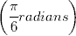. The coordinates of P with reference to the rotated frame are:
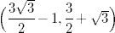
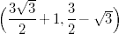
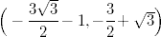
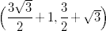
If then y is equal to:
81
729
2187
59049
An employee joined a company on 1.4.2004 in the salary grade of Rs. 8000 – 500 – 9500 – 750 – 12500 with a basic salary of 9000. He is due to retire on 31.3.2007. He contributes of his basic salary to an EPF scheme. His employer contributes an equal amount. If, on retirement, he gets full amount of his share of EPF and of the employers share, the amount of EPF received by him, ignoring any interest earned on the deposits, will be:
34500
51750
17250
43500
lim is equal to:
7
2
7e
2e
A complex number z lies on the curve |z+6|=3. The largest magnitude of |z+3| will be:
36
12
3
6
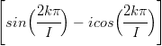is equal to
-i
i
-1
1
An equilateral triangle is inscribed in a circle such that its vertices lie on the circumference of the circle. A point is selected at random from within the circle. The probability of finding the point inside the triangle is:
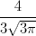
Set A consists of n elements. A subset is constituted. Elements of are replaced in A and a second subset is constituted. This process is repeated to form m subsets of A. The number of ways in which we can form such that 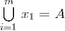are:
If A, B and C are the angles of a triangle and are in Arithmetic Progression, then the triangle is:
Equilateral
Right angled but not isosceles
Right angled isosceles
Isosceles but not right angled
Let (x) and [x] represent the fractional and integral components of . We define . The range of gof is:
[1 ,1]
(-1 ,1)
{0}
If lies on the circle whose equation is then the argument of 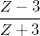is
is equal to:
0
For , 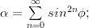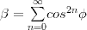, then the value of will be
i
1
-1
0
Define 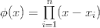then the value of 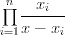is
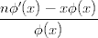
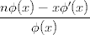
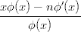
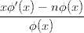
A toy consists of a base that is the section of sphere and a conical top. The volume of the conical top is and its height is 10 units. The total height of the toy is 19 units. The volume of the sphere (in cubic units) from which the base has been extracted is:
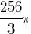
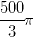
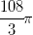
Two vessels A and B of equal capacities contain mixtures of milk and water in the ratios 4 : 1 and 3 : 1, respectively. 25% of the mixture from A is taken out and added to B. After mixing it thoroughly, an equal amount is taken out from B and added back to A. The ratio of milk to water in vessel A after the second operation is:
79 : 21
81 : 19
77 : 23
83 : 17
MTNL has a waiting list of 5005 applicants for its recently launched mobile phone scheme. The list shows that there are at least 5 males between any two females. The largest possible number of females in the waiting list is:
920
1005
835
721
If you have 3 tickets to a lottery for which 10 tickets were sold and 5 prizes are to be given, the probability that you will win at least one prize is:
We define the modulus of a m Ã— n matrix by The angle, for which the matrix
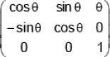
will have the maximum possible modulus is:
None of the above
The adjacent sides AB, BC of a square ABCD of side â€˜a units are tangent to a circle. The vertex D of the square lies on the circumference of the circle. The radius of the circle could be:
Operator A has the matrix representation 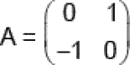
in conventional basis. Its representation in the basis of its eigenvectors (eigenbasis) is:
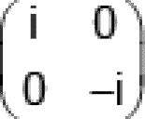
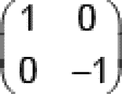

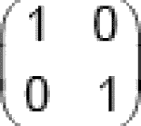
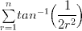is equal to:
Directions: 104 and 105 are based on the following information:-
A 300 room motel can rent all its rooms at Rs. 150 per room per day. For every one rupee increase in tariff, the occupancy falls by 2 rooms. Normal maintenance, independent of occupancy is Rs. 120 per room per day. Occupancy entails additional costs of Rs. 16 per room per day on the units occupied.
The optimal tariff (in Rupees) to maximize annual profits is:
162
160
158
150
Directions: 104 and 105 are based on the following information:-
A 300 room motel can rent all its rooms at Rs. 150 per room per day. For every one rupee increase in tariff, the occupancy falls by 2 rooms. Normal maintenance, independent of occupancy is Rs. 120 per room per day. Occupancy entails additional costs of Rs. 16 per room per day on the units occupied.
Now, suppose that rooms of the motel can be permanently shut down in blocks of 5, if desired, resulting in saving of normal maintenance of Rs. 120 per room per day. The optimal tariff (in Rupees) to maximize annual profits in this case would be:
160
162
158
156
An investor desires to invest a certain sum of money in two securities A and B. The risk and return of A and B are:
- | A | B
Risk | 3.00 | 6.00
Return in %(R) | 9.00 | 12.00
Measures of both risk and return are additive, i.e. bP = XAbA + XBbB, RP = XARA + XBRB, where XA, XB are the proportions of the money invested in the securities A & B in the portfolio P. The investor has a maximum risk tolerance of 4.00. The return that he can earn (in percent) is:
12
9
16
10
The position vector of the mirror image of the point represented by the position vector across the plane mirror is:
A man 6 feet tall standing 50 feet away from the base of a tower observes that the angle subtended by the tower at his eye level is . A flagstaff atop the tower subtends an angle of at the same point. The height (in feet) of the flagstaff is closest to:
25
18
22
20
A, B and C are assigned a piece of work which they can complete by working together in 15 days. Their efficiencies (measured in terms of rate of doing work) are in the ratio 1 : 2 : 3. After 1/3 of the work is completed, one of them has to be withdrawn due to budget constraint. Their wages per day are in the ratio 3 : 5 : 6. The number of days in which the remaining two persons can complete the work (at optimal cost) is:
15
12
18
20
A â€˜polynomial f(x) with real coefficients satisfies the functional equation If is
65
82
17
None of the above
Let [x] represent the greatest integer Define At any integral value of x, the function f(x) is:
Has only left hand limit
Discontinuous but has a unique limit
Does not have a limit
Continuous
Statistics show that 20% of smokers get lung cancer and 80% of lung cancer patients are smokers. If 30% of the population smokes, then the percentage of population having lung cancer is:
7.5
8
4
3
If then the order of a, b, c, d from largest to smallest is
a, d, c, b
c, d, a, b
c, d, b, a
d, c, a, b
If each permutation of the digits 1, 2, 3, 4, 5, 6 is listed in increasing order of magnitude, the 289th term will be:
326541
341256
314256
356241
We define 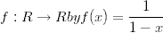. Then the function is discontinuous at:
1 and 1
0 and 1
1
None of the above
The relationship between the price of gasoline y (in Rupees) and its weekly supply, x (in hundreds of gallons) is 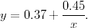If the weekly supply decreases at a rate of 50 gallons per week when the supply is 600 gallons, the price of gasoline will be changing at the rate of:
A mixture comprises two chemicals A and B. The price of A is Rs. 100/- per litre and that of B is Rs. 200/- per litre. We can spend a maximum of Rs. 600/- for making the mixture. The densities of A and B are 10 kg/litre and 12 kg/litre respectively. The mixture must contain each of the chemicals to the extent of at least 25% by weight. The maximum weight of the mixture that can be made is closest to:
54 kg
48 kg
60 kg
51 kg
Two circles and having the same radius of 2 cm and centres at P and Q respectively intersect each other such that the line of centres PQ intersects and at F and E respectively. EF = 1 cm. The whole assembly is enclosed in a rectangle of minimum area. The perimeter of rectangle is:
20 units
24 units
22 units
26 units
Semicircle is drawn with a line segment PQ as its diameter with centre at R. Semicircles and are drawn with PR and QR as diameters respectively, both and lying inside . A full circle C4 is drawn in such a way that it is tangent to all the three semicircles , and . lies inside and outside and . The radius of is:
A line makes equal intercepts of length â€˜a on the coordinate axes, intersecting the X axis and Y axis at A and B respectively. A circle is circumscribed about the triangle OAB, where O is the origin of the coordinate system. A tangent is drawn to this circle at the point O, The sum of the perpendicular distances of the vertices A, B and O from this tangent is:
2a
?Questions 121 to 127 are based on the following charts:
!{width:150px}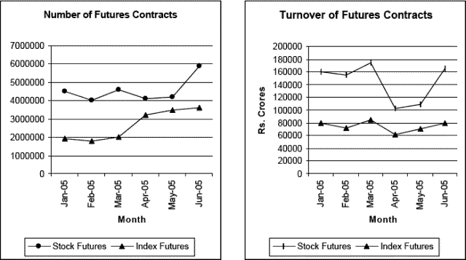
Trend of stock and index futures contracts diverged in the month of
I. March to April
II. April to May
III. May to June
I, II and III
I and III
II and III
None of these
Difference in the growth or decline rates between number and turnover of futures contract in any given month is the highest for
I. Stock futures
II Index Futures
II only
I and II
I only
Insufficient Data
The highest monthly percentage growth or decline occurred in the case of
Turnover of Index Futures contracts
Number of Stock Futures Contracts
Number of Index Futures contracts
Turnover of Stock Futures contracts
Value of a contract is defined as the ratio of turnover to number of contracts. The value of the contract was highest for both stock and index futures occurred in
February and March
Insufficient Data
January
Only March
The highest growth rate between January and June occurred in the case of
Number of Stock Futures contracts
Number of Index Futures contracts
Turnover of Index Futures contracts
Turnover of Stock Futures contracts
Consistent growth pattern is observed for
Number of Index Futures contracts
Both Stock and Index future contracts
None of the above
Number of Stock Futures contracts
Which of the following is true?
Number and Turnover of Stock futures follow a similar pattern
Number of Index futures and Turnover of Stock futures follow a similar pattern
Number of Stock futures and Turnover of Index futures follow a similar pattern
Number of Turnover of Index futures follow a similar pattern
Questions 128 to 131 are based on the following table:
!{width:500px}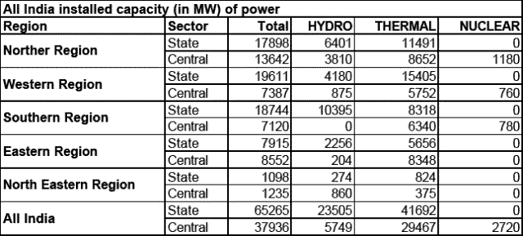

Which region has the highest installed capacity by the Central sector as compared to the State sector?
Northern Region
Southern Region
Eastern Region
North Eastern Region
What is the percentage of Nuclear Power in total installed capacity in the country?
2.74
2.81
2.51
2.63
In any sector, across the regions, the highest contribution from any one of the three sources to the total installed capacity is
78 %
79 %
89 %
98 %
Hydro power is the major source of energy in
Eastern and Western Regions
Northern and Southern Regions
Southern and North Eastern Region
None of the above
Questions 132 to 136 are based on the following charts:
!{width:350px}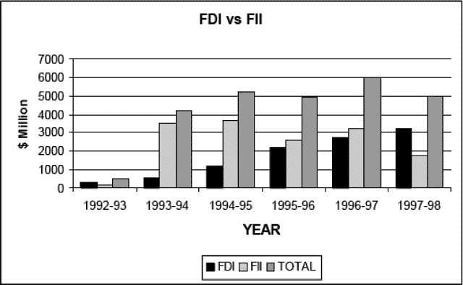
FII flows recorded negative growth rates in
Three years
One year
Four years
Two years
FDI flows recorded highest growth between
1992-93 and 1993-94
1993-94 and 1994-95
1994-95 and 1995-96
1995-96 and 1996-97
FDI flows were greater than FII flows in
1992-93 and 1993-94
1996-97 and 1997-98
1993-94 and 1997-98
1992-93 and 1997-98
Over the years which of the following flows are highly volatile?
FDI flows
Total flows
FII flows
Both FII and Total
Difference between FII and FDI flows is maximum in the year
1992-93
1995-96
1993-94
1994-95
Questions 137 to 145 are based on the following charts:
1.!{width:200px}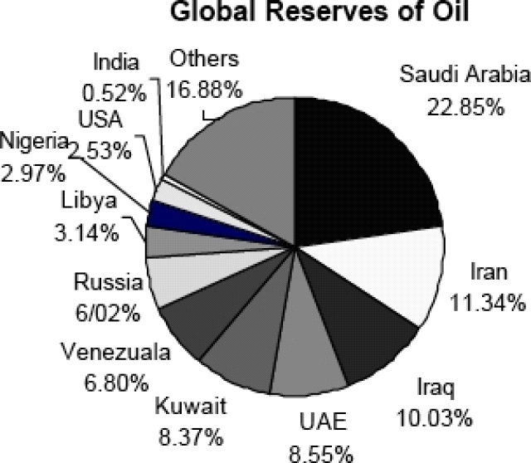 2.!{width:200px}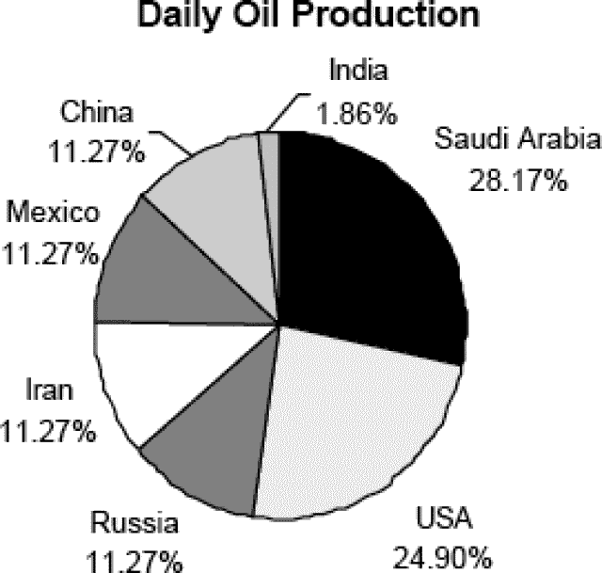 3.!{width:200px}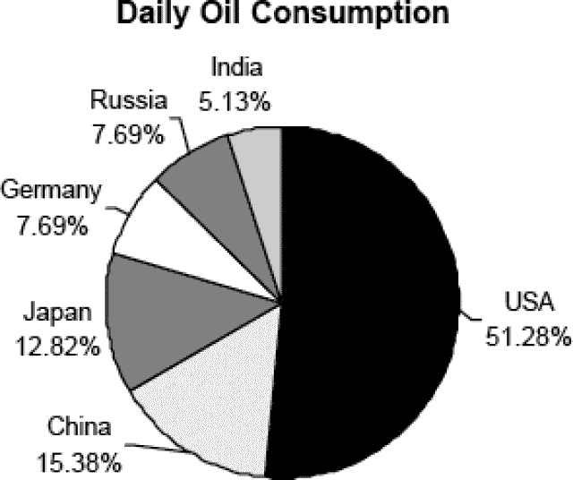
If estimated global reserves of oil is 1146.49 billion barrels, the level of reserves located in the USA in billion barrels would be approximately
98
34
29
36
Daily production and consumption of the USA is 8.84 and 20 million barrels respectively. Assuming that these levels remain constant, how long would the oil reserves in the USA last? (year = 360 days, global reserves = 1146.49 billion barrels)
8 years
9 years
4 years
6 years
Daily production and consumption figures of India are 0.66 and 2.2 million barrels. For which of the following countries the difference between consumption and production is the lowest?
Saudi Arabia
Russia
Iran
India
How many days of Indias oil consumption is equivalent to daily consumption of the USA?
Insufficient data
8
10
11
Which of the charts truly represent the global position?
Two of the charts
All the charts
One of the charts
Can not Say
Reserves and annual production figures for India are 5.58 and 0.24 billion barrels respectively. Which country has the lowest ratio of annual production to reserves?
Saudi Arabia
India
Iran
USA
Current reserves and annual consumption of India is 5.58 and 0.72 billion barrels. If the expected annual growth rate of consumption for India is 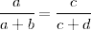, the oil reserves of India (in billion barrels) after five years would be
1.76
1.78
1.74
Can not say
The reserves located in Libya as percentage of reserves located in Russia is
56
52
50
54
Which of the following is true?
Saudi Arabia and USA are the highest producer and consumer respectively
Saudi Arabia and USA are the highest consumer and producer respectively
Russia is the lowest producer and consumer
None of the above
Questions 146 to 150 are based on the following charts:
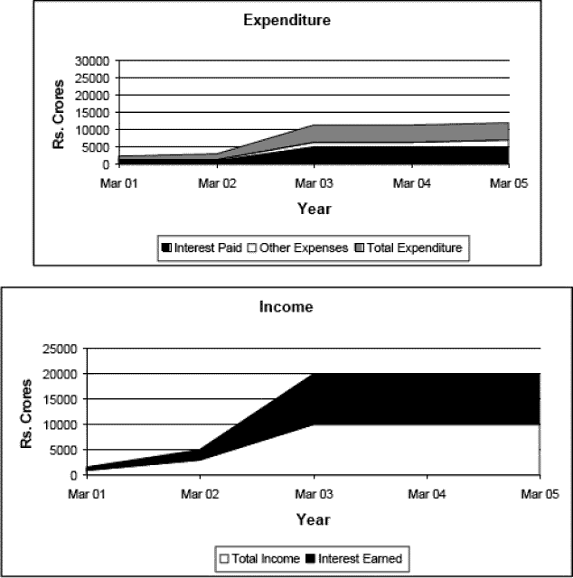
The ratio of interest earned to total income shows
Decreasing Trend
Erratic
Increasing Trend
No particular trend
Total income and interest earned reported similar decline between
2001 and 2002
2004 and 2005
2002 and 2003
2003 and 2004
The difference between total income and total expenditure is maximum in the year
2004
2002
2003
2005
The ratio of total interest paid to expenditure is minimum in the year
2002
2003
2005
2004
Which of the following statements is correct?
Other expenses and Interest paid follow similar trend
Total income and total expenditure follow similar trend
Total income and interest paid follow similar trend
Total income and total expenditure do not follow similar trend

