Reading Comp. Practice Questions
1) The author cites the scholars referring to “voting rights of women or minorities” in order to
(A) cite unquestionably justified Ninth Amendment rights
(B) demonstrate how changing priorities can alter perspectives on fundamental human rights
(C) argue for the modern extension of Natural Rights Theory
(D) refute the traditionalist interpretation of the Ninth Amendment
(E) champion the rights of all citizens in the democratic process
2) Constitutional scholars of both the traditionalist and liberal views would agree that “Ninth Amendment rights”
(A) accommodate shifts in cultural values with respect to issues affecting human rights
(B) cannot serve as the basis of legal decisions
(C) are directly reflected in our understanding of who can and can’t vote
(D) are not stated explicitly in the Bill of Rights
(E) extend the idea of Natural Rights Theory
3) According to the passage, what would the Ninth Amendment imply about a right to “a trial by jury”, guaranteed in the Seventh Amendment of the US Constitution?
(A) The Ninth Amendment would provide direct support for this right.
(B) The Ninth Amendment would not support this right directly, but would support all the logistics that would allow citizens to exercise this right.
(C) The Ninth Amendment would apply to trials that fall outside the jurisdiction of Federal Courts.
(D) The Ninth Amendment would apply to all trials that do not involve Constitutional Law
(E) The Ninth Amendment is irrelevant to any right mentioned explicitly in the Bill of Rights.
4) In the view of James Madison and the other Founding Fathers, the Ninth Amendment limits the power of the central Federal government by
(A) preventing constitutionally listed rights from being viewed as exhaustive
(B) giving the citizens rights in every area not explicitly addressed by the law
(C) codifying a vast universe of federally enforceable rights
(D) guaranteeing, in the text of US Constitution, all rights held by Natural Rights Theory
(E) ensuring all citizens are able to vote and, thus, choose the democratic leaders
5) The primary purpose of the passage is to
(A) clarify the most proper interpretation of an amendment
(B) argue for a broader perspective on human rights and their legal protection
(C) contrast historical perspectives of an amendment to its modern legal reading
(D) explain the motivation for an amendment and the ambiguity this amendment presents
(E) demonstrate how the Founding Fathers’ intentions have been distorted by subsequent legal proceedings.
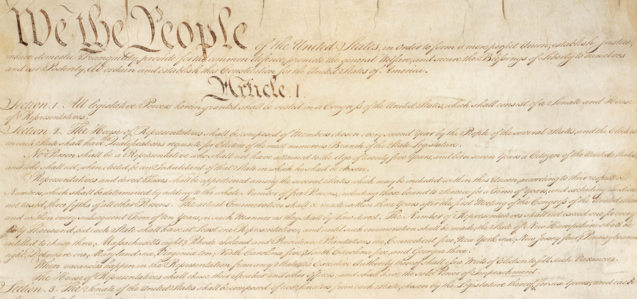

Practice Question Solutions
1) This quote appears in the third paragraph, in which the author is discussing liberal interpretations of the Ninth Amendment.
(B) is the credited answer. Scholars cited indicated these rights as examples of rights the Founding Fathers wouldn’t have recognized but which modern Americans take for granted. In other words, the change in priorities over the past two hundred years has “alter[ed our] perspectives on fundamental human rights.”
Choice (A) is wrong, because as the passage points out, these particular rights are guaranteed in other parts of the Constitution, and anything stated explicitly in the Constitution is not relevant to the Ninth Amendment.
Choice (C) is wrong, because whether these rights would in any way be considered as part of Natural Rights Theory (a 17th & 18th century theory of white European males) is not discussed at all in the third paragraph.
Choice (D) is wrong, because while this quote does support the liberal interpretation of the Ninth Amendment, and therefore raises an objection to the traditional interpretation, to say that it “refutes” the latter is far too strong. It merely raises an objection for which the traditionalist may well have a satisfactory answer.
Choice (E) is wrong, because it’s far too broad. The author is specifically talking about readings of the Ninth amendment, so conclusions about “the rights of all citizens” is a much broader concern than is being addressed in this passage.
2) Notice that the two sides vehemently disagree about the whole notion of “Ninth Amendment rights” — the liberals might argue for them, but the traditionalists thing the term itself is a fallacy. These two sides would only agree on something very basic.
(D) is the credited answer. The amendment itself says that it addresses rights that are not stated explicitly in the Bill of Rights. Both sides would have to agree — any right that is explicitly stated in the Bill of Rights is not a “Ninth Amendment right.”
Choice (A) is wrong, because this is something the liberals would embrace and the traditionalists would reject.
Choice (B) is wrong, because while we know the traditionalists accept this, it’s implied that the liberals reject it.
Choice (C) is wrong, because it focuses on a detail: the detail of voting rights isn’t even directly related to the Ninth Amendment.
Choice (E) is wrong, because it’s not completely clear where either side in the modern debate stands with respect to this much older theory. Moreover, we suspect that, if they have opinions at all, the liberals would have a much broader understanding of how the Ninth Amendment extend the idea of Natural Rights Theory, while traditionalists argue that the Ninth Amendment does extend anything.
3) The right to “a trial by jury” is an explicitly listed right in the Bill of Rights. As such, the Ninth Amendment does not apply to it at all. The whole point of the Ninth Amendment is that it applies only to rights not explicitly addressed in the Constitution. (E) is the credited answer. All the other answers, about the Ninth Amendment supporting this right or applying in one way or another, are incorrect.
4) (A) is the credited answer. The Bill of Rights listed certain rights, but Madison and other did not want this list read as if it were “exhaustive” — that is, as if it were a complete list to which nothing else could be added. This is precisely the motivation for the Ninth Amendment, explained in the first paragraph.
Choice (B) is wrong, because nothing in the passage says that the amendment automatically gives people specific tangible rights.
Choice (C) is wrong, because while the liberals might argue that it supports several rights, these new rights are not “encoded”, that is guaranteed as law.
Choice (D) is wrong, because the passage doesn’t even discuss what rights are held my Natural Rights Theory: furthermore, presumably some of those rights, such as freedom of speech, were already guaranteed in other amendments of the Bill of Rights, so the Ninth Amendment wouldn’t apply to those.
Choice (E) is wrong, because it picks up on a detail of the passage, from modern times, and says it applies to Founding Fathers. The fundamental voting rights that the Founding Fathers recognized were written explicitly in other parts of the Constitution, and are not in the “unwritten” area covered by the Ninth Amendment.
5) (D) is the credited answer. The passage gives us some history, about why the Founding Fathers felt this amendment was needed, and then the last two paragraphs exploring different ways of interpreting this amendment: because the amendment lends itself to such radically different interpretations, we can say it contains “ambiguity.”
Choice (A) is wrong, because the passage does not draw any conclusions on whether the traditionalist or liberal interpretation is better.
Choice (B) is wrong, because this answer would imply that the purpose was to agree with the liberal interpretation, but the passage does not clearly valorize one view over the other.
Choice (C) is wrong, because the primary contrast is not between 18th century readings vs. modern readings, but between two modern readings.
Choice (E) is wrong, because we don’t actually know the Founding Fathers’ intentions — the passages says very little about this, and its’ rather unclear whether Founding Fathers as a group would have agreed more with the liberal or the traditionalist interpretation of the Ninth Amendment.

