Practice problem explanations
1) The line appears to have a slope of ½ and y-intercept of 1, so its equation would be
y = 0.5x + 1
Plug in A for x and 30 for y.
30 = 0.5A + 1
29 = 0.5A
58 = A
Answer = (A)
2) Think about this visually. A slope of – 5/3 means, among other things, left 3 spaces, down 5. If the line goes through the point (–2, 7), then it must also go through (1, 2), which is must closer to the x-intercept. Let’s think about this in the vicinity of the x-intercept.
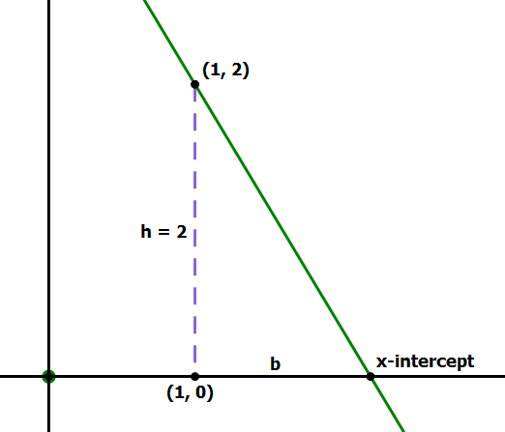
Obviously, (1, 2) is at a height of 2 above the x-axis. Let b be the distance from (1, 0) to the x-intercept. We know –h/b must equal the slope.
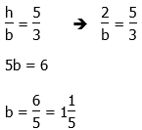
Now, we just have to add one to that to get the horizontal distance from the origin.
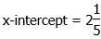
Answer = (B)
3) Think about this visually. From (–5, –1) to (2, 2), the line moves right 7 and up 3, so that’s a slope of 3/7.
From the point (2, 2) to the point (5, Q), there’s a horizontal distance of 3, an unknown vertical distance — call it h, so that h = Q – 2, or Q = h + 2. The ratio of this vertical and horizontal distance must equal the slope.
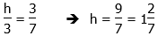
That’s h. Now, add 2 to get Q.
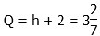
Answer = (C)
4) The radius is r = 5. First of all, 5 above the center, the circle goes through (1, 7) on the top, and 5 to the left & right of the center, the circle goes through (–4, 2) and (6, 2) on the same horizontal line as the center. That first point is choice (A).
That length of 5 can also be the hypotenuse of a 3-4-5 slope triangle, so starting from the center (1, 2), we could go over ±3 and up ±4, or over ±4 and up ±5. This means the circle must go through
right 3, up 4 = (4, 6)
right 4, up 3 = (5, 5) = option (E)
right 3, down 4 = (4, –2) = option (D)
right 4, down 3 = (5, –1)
left 3, up 4 = (–2, 6)
left 4, up 3 = (–3, 5) = option (D)
left 3, down 4 = (–2, –2)
left 4, down 3 = (–3, –1)
That’s all the points other than option (C). Notice that (–2, 6) and (4, 6) are on the circle, so another point between them, on the same horizontal line, (0, 6), could not be on the circle.
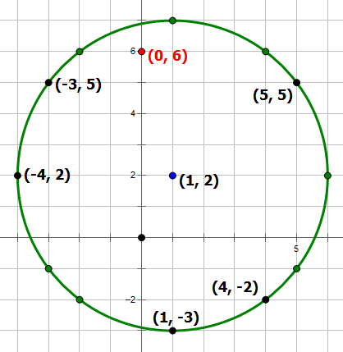
Answer = (C)
5) This one looks like it could involve a very complicated calculation, but there’s a very elegant way to do it. This involves special properties of the line y = – x. Notice that the coordinates of J & K have been switched, x for y and vice versa, and they have the opposite ± signs. This means that J and K are reflections of each other over the mirror line y = – x. As is always true of any reflection, every point on the mirror line is equidistant from a point and its reflection. Thus, we just need any point on the line y = – x, for example, (–6, 6).
Answer = (D)
6) The line of symmetry of a parabola always passes through the vertex, so the equation of the line of symmetry is the vertical line x = 2. The two x-intercepts are symmetrical around this line. The point (– 4, 0) is six units to the left of the symmetry line, so the other should be six units to right, at (8, 0).
