A STUDY ON
FINANCIAL PERFORMANCE ANALYSIS
aT


A Project report submitted to Osmania University in partial fulfillment of the Requirements For the award of the degree of
MASTER OF BUSINESS ADMINISTRATION

DECLARATION

I hereby declare that this project report titled
“A STUDY ON FINANCIAL PERFORMANCE ANALYSIS”
is submitted by me to Osmania University is a bonafide work undertaken by me and it is not submitted to any other University or Institute for the award of any Degree / Diploma / Certificate or published any time before.
.

ACKNOWLEDGEMENTS
At the out set, I wish to express my sincere thanks to almighty for showering his blessing on me to develop this project.

I would like to acknowledge my sincere thanks to _FACULTY______for her excellent guidance and supervision for the completion of this project successfully.

I am deeply indebted to the Principal__________ for enabling me to do this project.

I express my sincere thanks to ____COMPANY ASSOCIATE___ for according permission to carry out this study in his esteemed organization.

Last but not the least I wish to thank my Parents who always believed me and have faith in me in whatever I wished to do.

CONTENTS
CHAPTER | PARTICULARS | PAGE NO
CHAPTER I | INTRODUCTION AND DESIGN OF THE STUDY | 1-11
CHAPTER I | 1.1 Introduction of the Study
CHAPTER I | 1.2 Objective of the Study
CHAPTER I | 1.3 Research Methodology
CHAPTER I | 1.3.1 Research Design
CHAPTER I | 1.3.2 Nature of Data
CHAPTER I | 1.3.3 Methods Data Collection
CHAPTER I | 1.3.4 Research Tools
CHAPTER I | 1.4 Limitations of the Study
CHAPTER II | 2.1 Review of Literature | 12-15
CHAPTER III | PROFILE | 16-35
CHAPTER III | 3.1 Industry Profile
CHAPTER III | 3.2 Company Profile
CHAPTER IV | DATA ANALYSIS AND INTERPRETATION | 36-85
CHAPTER V | FINDINGS AND SUGGESTIONS | 86-91
CHAPTER V | 5.1 Findings
CHAPTER V | 5.2 Suggestions
 | CONCLUSION AND BIBLIOGRAPHY | 92-95
 | 6.1 Conclusion
 | 6.2 Bibliography

list of table

sl.no | particulrs | page no
1 | Current ratio | 38
2 | Liquid ratio | 40
3 | Absolute liquidity ratio | 42
4 | Debt equity ratio | 44
5 | Proprietary ratio | 46
6 | Stock turnover ratio | 48
7 | Fixed assets turnover ratio | 50
8 | Working capital turnover ratio | 52
9 | Total assets turnover ratio | 54
10 | Capital turnover ratio | 56
11 | Return on total assets | 58
12 | Gross profit ratio | 60
13 | Net profit ratio | 62
14 | Expenses ratio | 64
15 | Common Size Income Statement (2004, 2005) | 66
16 | Common Size Income Statement (2005, 2006) | 67
17 | Common Size Income Statement (2006, 2007) | 68
18 | Common Size Income Statement (2007, 2008) | 69
19 | Common Size Balance Sheet (2004, 2005) | 70
20 | Common Size Balance Sheet (2005, 2006) | 71
21 | Common Size Balance Sheet (2006, 2007) | 72
22 | Common Size Balance Sheet (2007, 2008) | 73
23 | Comparative income Statement (2004, 2005) | 74
24 | Comparative income Statement (2005, 2006) | 75
25 | Comparative income Statement (2006, 2007) | 76
26 | Comparative income Statement (2007, 2008) | 77
27 | Comparative Balance Sheet (2004, 2005) | 78
28 | Comparative Balance Sheet (2005, 2006) | 79
29 | Comparative Balance Sheet (2006, 2007) | 80
30 | Comparative Balance Sheet (2007, 2008) | 81
31 | Trend income statement | 82
32 | Trend Balance sheet | 85

List of CHARTs

sl.no | particulrs | page no
1 | Current ratio | 39
2 | Liquid ratio | 41
3 | Absolute liquidity ratio | 43
4 | Debt equity ratio | 45
5 | Proprietary ratio | 47
6 | Stock turnover ratio | 49
7 | Fixed assets turnover ratio | 51
8 | Working capital turnover ratio | 53
9 | Total assets turnover ratio | 55
10 | Capital turnover ratio | 57
11 | Return on total assets | 59
12 | Gross profit ratio | 61
13 | Net profit ratio | 63
14 | Expenses ratio | 65

CHAPTER- I
INTRODUCTION

Contents:

1.1 Introduction of Study

1.2 Objective of the Study

1.3 Research Methodology
1.3.1 Research Design
1.3.2 Nature of Data
1.3.3 Methods Data Collection
1.3.4 Research Tools

1.4 Limitations of the Study

1.1 INTRODUCTION

Financial statement:
A financial statement is an organized collection of data according to logical and consistent accounting procedures. Its purpose is to convey an understanding of some financial aspects of a business firm. It may show a position at a moment of time as in the case of a balance sheet, or may reveal a series of activities over a given period of time, as in the case of an income statement.
Thus, the term financial statement generally refers to the basis statements;
- The income statement
- The balance sheet
- A statement of retained earnings
- A statement of charge in financial position in addition to the above two statement.
Financial statement analysis:
It is the process of identifying the financial strength and weakness of a firm from the available accounting data and financial statement. The analysis is done by properly establishing the relationship between the items of balance sheet and profit and loss account the first task of financial analyst is to determine the information relevant to the decision under consideration from the total information contained in the financial statement. The second step is to arrange information in a way to highlight significant relationship. The final step is interpretation and drawing of inferences and conclusion. Thus financial analysis is the process of selection relating and evaluation of the accounting data/information.

This studying contain following analysis:
- comparative analysis statement
- common-size analysis statement
- Ratio analysis
- Trend analysis.
- Comparative financial statement:
Comparative financial statement is those statements which have been designed in a way so as to provide time perspective to the consideration of various elements of financial position embodied in such statements. In these statements, figures for two or more periods are placed side by side to facilitate comparison.
But the income statement and balance sheet can be prepared in the form of comparative financial statement.

i) Comparative income statement:
The income statement discloses net profit or net loss on account of operations. A comparative income statement will show the absolute figures for two or more periods. The absolute change from one period to another and if desired. The change in terms of percentages. Since, the figures for two or more periods are shown side by side; the reader can quickly ascertain whether sales have increased or decreased, whether cost of sales has increased or decreased etc.

ii) Comparative balance sheet:
Comparative balance sheet as on two or more different dates can be used for comparing assets and liabilities and finding out any increase or decrease in those items. Thus, while in a single balance sheet the emphasis is on present position, it is on change in the comparative balance sheet. Such a balance sheet is very useful in studying the trends in an enterprise.

2) common-size financial statement:
Common-size financial statement are those in which figures reported are converted into percentages to some common base in the income statement the sales figure is assumed to be 100 and all figures are expressed as a percentage of sales. Similarly, in the balance sheet, the total of assets or liabilities is taken as 100 and all the figures are expressed as a percentage of this total.

3) Ratio analysis:
Ratio analysis is a widely used tool of financial analysis. The term ratio in it refers to the relationship expressed in mathematical terms between two individual figures or group of figures connected with each other in some logical manner and are selected from financial statements of the concern. The ratio analysis is based on the fact that a single accounting figure by it self may not communicate any meaningful information but when expressed as a relative to some other figure, it may definitely provide some significant information the relationship between two or more accounting figure/groups is called a financial ratio helps to express the relationship between two accounting figures in such a way that users can draw conclusions about the performance, strengths and weakness of a firm.

Classification of ratios:
A) Liquidity ratios
B) Leverage ratios
C) Activity ratios
D) Profitability ratios

A) Liquidity ratios:
These ratios portray the capacity of the business unit to meet its short term obligation from its short-term resources (e.g.) current ratio, quick ratio.

i) Current ratio:
Current ratio may be defined as the relation ship between current assets and current liabilities it is the most common ratio for measuring liquidity. It is calculated by dividing current assets and current liabilities. Current assets are those, the amount of which can be realized with in a period of one year. Current liabilities are those amounts which are payable with in a period of one year.

Current assets
Current assets = -------------------------
Current liabilities

ii) Liquid Ratio:
The term ‘liquidity’ refers to the ability of a firm to pay its short-term obligation as and when they become due. The term quick assets or liquid assets refers current assets which can be converted into cash immediately it comprises all current assets except stock and prepaid expenses it is determined by dividing quick assets by quick liabilities.

Liquid assets
Liquid ratio = -------------------------
Liquid liabilities

iii) Absolute liquidity ratio:
Absolute liquid assets include cash, bank, and marketable securities. This ratio
Obtained by dividing cash and bank and marketable securities by current liabilities.

Cash + bank +marketable securities
Absolute liquidity ratio = ----------------------------------------------
Current liabilities

B) LEVERAGE RATIOS:
Many financial analyses are interested in the relative use of debt and equity in the firm. The term ‘solvency’ refers to the ability of a concern to meet its long-term obligation. Accordingly, long-term solvency ratios indicate a firm’s ability to meet the fixed interest and costs and repayment schedules associated with its long-term borrowings. (E.g.) debt equity ratio, proprietary ratio, etc….

i) Debt equity ratio:
It expresses the relationship between the external equities and internal equities or the relationship between borrowed funds and ‘owners’ capital. It is a popular measure of the long-term financial solvency of a firm. This relationship is shown by the debt equity ratio. This ratio indicates the relative proportion of dept and equity in financing the assets of a firm. This ratio is computed by dividing the total debt of the firm by its equity (i.e.) net worth.

Outsider’s funds
Debt equity ratio = ------------------------------
Proprietor’s funds

ii) Proprietary ratio:
Proprietary ratio relates to the proprietors funds to total assets. It reveals the owners contribution to the total value of assets. This ratio shows the long-time solvency of the business it is calculated by dividing proprietor’s funds by the total tangible assets.

Proprietor’s funds
Proprietary ratio = ---------------------------
Total tangible assets

C) Activity ratios:
These ratios evaluate the use of the total resources of the business concern along with the use of the components of total assets. They are intended to measure the effectiveness of the assets management the efficiency with which the assts are used would be reflected in the speed and rapidity with which the assets are converted into sales. The greater the rate of turnover, the more efficient the management would be (E.g.) stock turnover ratio, fixed assets turnover ratios etc….

i) Stock turnover ratio:
This ratio indicates whether investment is inventory is efficiently used or not it explains whether investment in inventories in with in proper limits or not. It also measures the effectiveness of the firms’ sales efforts the ratio is calculated as follows.
Cost of goods sold
Stock turnover ratio = -----------------------------
Average stock

Opening Stock + Closing Stock
Average stock = -----------------------------------------
2

ii) Fixed assets turnover ratio:
The ratio indicates the extent to which the investments in fixed assets contribute towards sales. If compared with a pervious year. It indicates whether the investment infixed assets has been judious or not the ratio is calculated as follows.

Net sales
Fixed assets turnover ratio = -------------------
Fixed assets

iii) Working capital turnover ratio:
Working capital turnover ratio indicates the velocity of the utilization of net working capital. This ratio indicates the number of times the working capital is turned over in the course of a year. It is a good measure over –trading and under-trading.

Net sales
Working capital turnover ratio = ----------------------------
Net working capital

iv) Return on total assets:
Profitability can be measured in terms of relationship between net profit and total assets. It measures the profitability of investment. The overall profitability can be known by applying this ratio.
Net profit
Return on total assets = ----------------------------- x100
Total assets

D) Profitability ratios:

The profitability ratios of a business concern can be measured by the profitability ratios. These ratios highlight the end result of business activities by which alone the over all efficiency of a business unit can be judged, (E.g.) gross ratios, Net profit ratio.

i) Gross profit ratio:
This ratio expresses the relationship between Gross profit and sales. It indicated the efficiency of production or trading operation. A high gross profit ratio is a good management as it implies that cost of production is relatively low.

Gross profit
Gross profit ratio = ----------------------------------- x 100
Net sales

i) Net profit ratio:
Net profit ratio establishes a relationship between net profit (after taxes) and sales. It is determined by dividing the net income after tax to the net sales for the period and measures the profit per rupee of sales.

Net profit
Net profit sales = ----------------- x 100
Net sales

iii) Expenses ratio:
This ratio establishes the relationship between various indirect expenses to net sales.
- Administrative expenses ratio:

Administrative expenses
Administrative expenses ratio = ------------------------------- x 100
Sales

b) Selling &distribution expenses ratio:

Selling &distribution expenses
Selling &distribution expenses ratio = ----------------------------------------- x 100

Sales

1.2 OBJECTIVES OF THE STUDY

- The basic objective of studying the ratios of the company is to know the financial position of the company.

- To know the borrowings of the company as well as the liquidity position of the company.

- To study the current assets and current liabilities so as to know weather the shareholders could invest in Vijay Textiles Ltd or not.

- To study the profits of the business and net sales of the business and to know the stock reserve for sales of the business.

- To know the solvency of the business and the capacity to give interest to the long term loan lenders (debenture holders) and dividend to the share holders.

- To study the balance of cash and credit in the organization.

1.3 Research methodology:
1.3.1 Research design:
The descriptive form of research method is adopted for study.
The major purpose of descriptive research is description of state of affairs of the institution as it exits at present. The nature and characteristics of the financial statements of Vijay Textiles Ltd have been described in this study.

1.3.2 Nature of data:
The data required for the study has been collected from secondary source .The relevant information were taken from annual reports, journals and internet.

1.3.3 Methods of data collection:

This study is based on the annual report of Vijay Textiles Ltd. Hence the information related to, profitability, short term and long term solvency and turnover were very much required for attaining the objectives of the present study.

1.3.4 Tools applied:
To have a meaningful analysis and interpretation of various data collected, the following tools were made for this study.

- Ratio analysis
- Common-size statement
- Comparative statement
- Trend analysis

1.4 Limitation of the study:

- The analysis was made with the help of the secondary data collected from the company.

- All the limitations of ratio analysis, common-size statement, comparative statements, and trend analysis and interpret are applicable to this study.

- The period of study is 5 years from 2003-04 to 2007-08.

CHAPTER- II
Review of Literature

Contents:

2.1 Review Of Literature

1. Environmental and Financial Performance Literature

Abstract

"We review the growing literature relating corporate environmental performance to financial performance. We seek to identify achievements and limitations of this literature and to highlight areas for further research. Our primary interest is to assess the adequacy of the literature in informing corporate managers how, when, and where to make pro-environment investments that will pay off with financial returns for long-term shareholders. To do so, we create a conceptual framework that maps the influence of regulators, public health scientists, environmental advocates, consumers, employees, and other interested parties upon corporate financial returns. Our discussion has relevance to all parties interested in influencing corporate actions that affect the environment."

2. An Investigation of the Perceived Financial Performance

Abstract

"This paper is primarily based on Rogers’ diffusion of innovations theory and Auger’s empirical study. An empirical research study was conducted to investigate the perceived financial performance of commercial printing firms for conducting business-to-customer (B2C) activities using Web technology. Financial performance was measured using four financial indicators: sales, profits, costs, and return-on-investment (ROI). The diffusion of innovations theory states that an innovation brings changes to a company. Web technology is an innovation that affects company’s performance. This paper investigates the effect of Web technology on commercial printing firms’ financial performance."

3. Strategic and Financial Performance Implications of Global Sourcing Strategy: A Contingency Analysis

Abstract

"Using a contingency model of global sourcing strategy, this study investigated the moderating effects of sourcing-related factors on the relationship between sourcing strategy and a product's strategic and financial performance. The results lent some support to the contingency model of global sourcing strategy in that product innovation, process innovation and asset specificity were significant moderator variables for financial, but not strategic, performance. However, the results provided no support for bargaining power of suppliers and transaction frequency as moderator variables. In other words, in achieving high financial performance for a product, whether a particular sourcing strategy should be used for a particular product depended on the levels of product innovation, process innovation and asset specificity."

4. Implications for financial performance and corporate social responsibility

Abstract
"We investigate whether CEO implicit motives predict corporate social performance and financial performance. Using longitudinal data on 258 CEOs from 118 firms, and controlling for country and industry effects, we found that motives significant predicted both financial performance (Tobin's Q and the CAPM) and social responsibility. In general, need for power and responsibility disposition were positively predictive whereas need for achievement and affiliation were negatively predictive of outcomes. Contrary to previous theorizing, corporate social responsibility had no link to financial performance. Our findings suggest that executive characteristics have important consequences for corporate level outcomes."

5. Financial statement analysis: A data envelopment analysis approach

Abstract
"Ratio analysis is a commonly used analytical tool for verifying the performance of a firm. While ratios are easy to compute, which in part explains their wide appeal, their interpretation is problematic, especially when two or more ratios provide conflicting signals. Indeed, ratio analysis is often criticized on the grounds of subjectivity, that is the analyst must pick and choose ratios in order to assess the overall performance of a firm.
In this paper we demonstrate that Data Envelopment Analysis (DEA) can augment the traditional ratio analysis. DEA can provide a consistent and reliable measure of managerial or operational efficiency of a firm. We test the null hypothesis that there is no relationship between DEA and traditional accounting ratios as measures of performance of a firm. Our results reject the null hypothesis indicating that DEA can provide information to analysts that is additional to that provided by traditional ratio analysis. We also apply DEA to the oil and gas industry to demonstrate how financial analysts can employ DEA as a complement to ratio analysis."

CHAPTER- III
PROFILE

Contents:

3.1 Industry Profile

3.2 Company Profile

3.1 Industry Profile

Indian Garment Industry- an Overview
The Garment industry is one of India's largest foreign exchange earning industries. This accounts to 16% of the country’s total exports earnings. As per the 1996 Indian textile exports records total garment export value was Rs.35,000 crores of which ‘apparel’ occupied over Rs14, 000 crores.
It has been estimated that India has 30,000 readymade garment manufacturing units and around three million people are working in this industry. Today garment export business grows, with the help of enthusiasm shown by the foreign buyers at a high level. Today many leading fashion labels are being associated with Indian products. India is increasingly being looked upon as a major supplier of high quality fashion apparels and Indian apparels are highly appreciated in major markets internationally. The credit goes to the exporters and the government which spontaneously helping in liberalizing the export policies and tax reduction methods.

Consistent efforts towards extensive market coverage, improving technical capabilities and putting together an attractive and wide merchandise line has paid rich dividends. But till today, our garment industry is dominated by sub-contractors and it consists mainly small units having 50 to 60 machines. India's supply base is medium quality, relatively high fashion, but small volume of business.

Recent recession in Europe and the South Asian currency crisis have also contributed their own bits to the decimating Indian exports. Though these are expected to fizzle out soon, there is no reason for complacency on the part of Indian exporters or of the garment industry. The industry will soon competitively face the short falls faced with regard short of quotas, tariffs, etc.
Thus the need of the hour is to enlarge both manufacturing as well as the marketing base. Inculcation of a spirit of innovation by way of research and development and tapping new markets especially in South Africa, Central Africa, East European countries, Latin America and Australia is also mandatory for export growth.
The Size of India's Textile industry.
- The textile industry in India covers a wide gamut of activities ranging from production of raw material like cotton, jute, silk and wool to providing high value-added products such as fabrics and garments to consumers.
- The industry uses a wide variety of fibers ranging from natural fibers like cotton, jute, silk and wool to man made fibers like polyester, viscose, acrylic and multiple blends of such fibers and filament yarn.
- The textile industry plays a significant role in Indian economy by providing direct employment to an estimated 35 million people, by contributing 4 per cent of GDP and accounting for 35 per cent of gross export earnings. The textile sector contributes 14 per cent of the value-addition in the manufacturing sector.
- Textile exports during the period of April-February 2003-2004 amounted to $11,698.5 million as against $11,142.2 million during the same period in the previous year, showing an increase of around 5 per cent.
- Estimates say that the textile sector might achieve about 15 to 18 per cent growth this year following dismantling of MFA.
Now that the quantitative restrictions are all gone in this huge industry, has it changed the way the garment manufacturers are operating these days? Are the foreign orders for Indian garment exporters going up?
"Nothing dramatic has happened in the textiles exports as of now. There is no deluge of orders. But it I think it will take somas time for the liberated textiles sector to boom," points out K Baronet, a leading exporter of knitted garments from Torpor in Tamil Nadir.
Exporters like Baronet do not expect huge orders in the immediate months.
"But we have ramped up our production capacities and are waiting for the big business to come by," he said. Textile exporters from the garment hot-spot of Torpor are keeping their fingers crossed.
Many of them as bullish on new export enquiries that have began to trickle in.
"The rush of garment exports in the quota-free regime has not yet happened in the Indian textiles sector. That is because the normal product and export cycle of garments is around 60 days. We expect increased bookings by April," says R Shiva, executive director of the Torpor-based garment factory Classic Polo.
He says in the liberalized textile era, companies will have to restructure their production capacities to meet export orders.
Textile exporters anticipate huge orders from major American stores and brands. "The biggest change is that large textile firms within India are buying small-scale garment manufacturers to shore up their production facilities," says Torpor-based textiles consultant Sinai Raja.
"In the months to come, companies will have to increase the production capacity to face changed global textile trade," he points out.
Already, the Gujarat-based Super Spinning Mills Ltd has moved in to acquire two sick textile mills in Madura. To increase the company's yarn production capacity and to cater to the united States export market.
But there are many challenges ahead. "The competitive advantage that India enjoys now is the low cost of production here. But the real challenge is to develop and offer value-added services to foreign customers, especially in countries like America," says Raja.
Consultants like Raja also add that the textile industry in India will need greater supply-chain efficiencies and flexible labor laws to succeed in the world market.
The Union government has repeatedly said that whatever the state was expected to do for the textile industry have already been done.
Thus, it is now the industry's turn to step into the new world order in the unshackled textiles global market.
RECENT TRENDS
Plans to boost textile exports to $10 bn by 2010
The Union government is planning to boost the export of textiles to the tune of $10 billion by 2010, said EVKS Elangovan, Union minister of state for textiles. The minister while speaking on the sidelines of a week-long jute exhibition informed that the five-year Technology Up gradation Fund Scheme (TUFS) launched in 2003 would come to an end in 2007.
However, the government may extend TUFS, as the scheme had evoked overwhelming response in the sector. He also added that the Centre would consider the expert's suggestion for letting out treated effluent water from the Torpor dyeing and bleaching units in the sea by setting up an exclusive pipeline. A fixed export target for jute products has been set by the government at Rest 5,000 crore by 2010 against the present annual export of Rest 1,000 crore.
The government under the joint venture with state government and private entrepreneurs was going to establish five textile parks, including one at Cuddlier, Palladium and Perunthurai at a cost of Rest 50-100 crore.
Jute, once popular in West Bengal and its surroundings, has now spread all over Tamil Nadir, Andhra Pradesh and Karnataka.
Tirupur may lose its position in global market.
Global and domestic exporters are concerned over the fall-out of frequent labor unrest and the indefinite closure announced by around 700 dyeing units in Torpor, in the wake of the effluent treatment and discharge problem faced by them. If a solution is not found quickly, Torpor runs the risk of losing its premier position in the global knitwear market, exporters said.
The knitwear hub contributes about $2 billion of the total export of $8.2 billion.
In knitwear production, its share is 70 per cent of the country's total production of $3.5billion. "If this situation continues, the foreign buyers will shift their orders to our competitors like China and once the business goes out of India, it is very difficult to regain the lost markets",
All the investments made to the tune of more than Rest 25,000 crore in the past couple of years will become idle which in turn will hit the banks which have financed the exporters.
"This apart, it posed threat to continued employment of about 500,000 people, both direct and indirect besides affecting the interest of farmers with reduced consumption of cotton", he added. To put an end to this environmental crisis, Tirupur units have decided to implement a marine discharge system.
"The Marine Discharge Project can be implemented as a public and private partnership and we could execute this project as we did in New Torpor Area Development Corporation Limited a year ago", industry sources said.
The industry is pitching for a contribution of Rest 600 crore as grant from the Centre for implementing this project and to find a permanent solution for the dyeing units' problem in the region.

3.2 COMPANY PROFILE
VIJAY was originally incorporated on 2nd February 1990 in the name and style of Vijay Textiles Private Limited. The Company was subsequently converted into a Company. Vijay Textiles Limited and a fresh certificate of incorporation was obtained on 17th June 1994.
VIJAY is an existing profit making company. Initially the company was in the business of trading in textiles. The major activity consisted of purchase of Polyester Yarn from Reliance Industries Limited converting the Yarn into Grey Cloth at Bhiwandi through job contracts and converting the Grey Cloth into finished fabrics through textile processors. The fabrics were marketed under the brand name "VIJAY" throughout India.
With the brand name established in the major markets and having created the necessary sales network the Company ventured into full fledged manufacturing of processed textiles by acquiring a running textile processing unit from M/s S.K. Textile Industries on 30th June 1993. The total sale consideration paid for the acquisition was Rs. 8 50 000/-for the land admeasuring 2 acres together with all the rights easements equipments structures. The land was purchased on the basis of negotiated price. The sale was registered vide deed no. 5688 of book 1993 by the Registrar Rangareddy District Andhra Pradesh. The above consideration was valued as follows:
Land--2 acres @ Rs. 4 00 000 per acre.
8 colour flat bed and 75 KVA Generator--Rs. 50 000.
The original and residual life of the above equipments is 5 years with normal maintenance.
The Company's facilities for manufacture of processed textiles are located at APIIC Industrial Estate Khattedan near Hyderabad on freehold land of 2 acres. The installed capacity is 172 lacs metres. This installed capacity is expressed on the basis of product mix comprising of 96 lac metre per annum of printed polyester shirting and 76 lac metre per annum of dyed polyester shirting. However the capacity utilisation will constantly vary depending on the product mix chosen as each blended variety viz. trilobal Swiss cotton jersey and boskey require different processing time. The Company proposes to manufacture more of blended fabrics as the margins are higher in these varieties.
The Company is presently operating ala capacity of 5-6 lac metres per month. The Company's Corporate Office and Godown is situated at the prime location "Surya Towers" in Secunderabad.
In the very first year of manufacturing activity i.e.1993-94 the Company has achieved a Post Tax Profits of Rs. 98.03 lacs on turnover of Rs. 1304.88 lacs. The major factors that has contributed for the tremendous increase in the sales for the year ended 31.3.1994 over the year ending 31.3.1993 are
i) The Company's manufacturing activity commenced from September 1993 onwards which have yielded higher margins. Prior to that the Company was carrying on only trading activity.
ii) The Company was able to fully meet the demand for fabrics of the desired designs required quality and quantity at a competitive price during the festive season of Pongal in January 1994.
The Company during 1993-94 concentrated mainly on 100% Polyester Fabrics and Grey Fabrics. This product mix was subsequently shifted in favour of Blended Fabrics which yield substantial margins. This is reflected in the half year results of the Company ended 31st December 1994. The Company has achieved Profits After Tax to the tune of Rs. 212.26 lacs on a turnover of Rs. 1536.58 lakhs.

Our vision is to take up new challenges and implement them with the highest quality standards. The Group also specializes in the children’s garments and bottoms sector.

It is noteworthy to mention that Vijay Textiles Ltd have been award the ISO 9002 Certification in May 2001 and have subsequently upgraded to the ISO 9001-2000 Certification.

Management

The Group is headed by Mr. Vijay Kumar Gupta, designated as the Chairman and Managing director. He has three decades of rich experience in the garment industry at various levels.
Mr. Vijay Kumar Gupta is ably supported by a team of talented and dedicated professionals from the garment and allied industries.
The Group’s progressive HR policies and welfare programmes ensure a transparent, productive and growth oriented environment to the 1300 plus employees who play a key role to the success enjoyed by the organization as a prominent exporter of garments.

Social accountability
At Vijay Textiles Ltd every employee is treated with great care. Apart from a great salary structure they benefit from ESI, PI, and Gratuity etc. Vijay Textiles Ltd is proud that some of the employees have put in more than 19 years of service that speaks a lot about the groups’ commitment to their employees. The group also strictly believes in the ‘No Child Lab our’ Law.

Environmental Accountability
Vijay Textiles Ltd maintains high safely standards, and not to forget the Effluent treatment plant, which plays a big role in their commitment to preserving the delicate eco-system.

Suppliers
Over the years Vijay Textiles Ltd has established a reliable and strong support network for all its supply needs. Nearly 500 looms are controlled and managed across South Indian towns such as Salem, Nagari, Coimbatore and Cannanore for production of power loom fabrics of various yarn counts.
Fabrics are also procured from reputed mills such as BVM and Arvind Mills- Ahmedabad, Nahar- Punjab, Velcord- Mumbai and Premier Mills- Hosur.
All Procurements are made from the above firms in accordance with predetermined quality standards and regular checks are conducted to ensure accordance of the same.

Domestic Market
The Group has recently forayed into the booming domestic apparel industry by launching its own brands Indus Valley (men’s and women’s clothing) and Sherwood (kids range) in the local market. The brands are stocked and marketed in a company owned exclusive outlet and also at various leading garment and lifestyle stores.
The products promoted under these brand names have already gained a tremendous response from the domestic market.

Infrastructure
Machinery:
Latest world class machines from Durkopp Adler of Germany , Juki, Tajima and Brother of Japan have been installed at the manufacturing units for an installed capacity of 1,40,000 garment units per month.
800 sewing machines including special purpose machines have been installed for quality production i9n large volumes.
Two TAJIMA computerized Embroidery Machines with 20 heads each, A BARUDAN computerized Embroidery Machine with 20 heads each , A pocket welting machine for cut pockets from Durkopp Adler, Germany and CAD machine from Gerber, USA for pattern development , complete sophisticated machinery set up in the factories of the East West Group . We have recently added a TAJIMA Embroidery @ sequin attaching machine.
As a matter of policy and commitment to quality production, machineries at the units are replaced every 3 years.

Warehouse
The company has a centralized warehousing, cutting and packing facilities installed at one of its units. Standard processes, strict adherence to quality norms and regular maintenance is carried out at the warehousing end as well.

Laundry
To cater to the ever growing and complex needs of the market in terms of washes and finishes a modern and well equipped laundry is set up with a processing capacity of 1, 00,000 garments per month. Varied wash procedures based on client needs such as stone wash, sand wash, enzyme wash, golf wash etc are done here according to specifications.
It is to be noted that the manufacturing facilities and machineries at the units have been inspected and approved by some of the largest garment manufacturers in the United States and the European Union.

Products
Vijay Textiles Ltd today caters toe extensive market requirements and its product range comprises men’s wear, ladies wear and kids wear. The range of products are produced and exported according to the specifications of the International fashion labels.

Purchase procedure:
A systematic procedure for purchase of raw materials helps in buying materials quickly with consistency. In general, purchase procedure of an organization includes the following aspects.
RECEIVING PURDHASE REQUISITION:
The purchase department cannot buy the materials on its own as it will not be aware of what materials are required, their quantity, quality and other details. Therefore, it will have to be intimated about the materials required by those departments which are in need of materials. This is done through purchase requisition. The purchase manager comes to know the details of materials required by the concern through the purchase requisitions. Purchase requisition is prepared by the store keeper for materials requirements which are not available in the store. This requisition has to be approved by head of the department in addition to the head of department in person who is originating the requisition.
STUDUING THE MARKET AND CHOOSING THE SUPPLIER
The purchase department generally maintains a list of suppliers and other details for each type or group of materials. Tenders / quotations may be invited from these suppliers. The comparative statement of various quotations is to be prepared and the best supplier offering most favorable terms should be selected. When selecting a particular supplier, the purchase departments supply of required quantity.
- Reliability for supply of quantity
- Price quoted
- Financial position of the supplier
- Terms of payment
- Reputation of the supplier
- Discounts offered

ISSUING PURCHASE ORDER AND FOLLOWING UP OF DELIVERY SCHEDULES:
Once the supplier is selected the purchase order is to be prepared. The purchase order is the written commitment from purchase department to buy the materials and authorization to the supplier to supply materials. It is the contract between the buyer and seller for stated terms and condition. The supplier is committed to supply and make payment. It is also an authorization to goods receiving departments to accept the invoice for payment to the supplier.
Generally, five copies of the purchase order are prepared and used as follows:
- One copy is sent to the supplier.
- The purchase department retains one copy.
- One copy is sent to the store keeper/department, which has requisition materials.
- One copy is sent to the receiving department.
- One copy is sent to the accounts department.
The purchase order provides detailed information to the supplier regarding price, quantity, delivery terms, etc. It reduces the purchasing and clerical work into a routine.
RECEIVING AND INSPECTION OF MATERIALS:
In large organization there may be a separate department for receiving the materials. But in this organization, this may be entrusted to the store keeper.

FUNCTION OF RECEIVING DEPARTMENT:
- Keeping purchase order files in a systematic way.
- Receiving and unpacking of materials sent by supplier under various challans.
- Verifying the materials received by comparing with purchase orders. This includes checking quantity, quality, and physical condition of material.

GOODS RECEIVED NOTE:
Preparing a goods received note (GRN), entering the details of materials received for the information of all those concerned with materials.
Generally, five copies of goods received are purchase and used as given below:
One copy is retained by the goods receiving department.
Four copies are to the store keeper along with materials. The store keeper will verify the entries with actual goods Countersign them and will send one copy to the purchase department; one copy to the account department; one copy to be department which initiated the requisition and one copy is retained by the store keeper.

VERIFYING AND PASSING SUPPLIERS INVOICE FOR PAYMENT AND DEDUCTION OF TDS:
Based on goods received note, purchases are verified and a payment is made to supplier. When the invoice is received from the supplier, it is sent to the accounting department to check the authenticity as well as accuracy. The quantity, price and amount received are checked with reference to purchase order and goods received note. If everything is found in order, the accounting section approves the invoice for payment and the cashier makes the payment as per the agreed.

TAX DEDUCTED AT SOURCE (TDS):
In certain specified case of income, tax should deduce at source by the person responsible for making payment of such income. As per rule, while making payment to the supplier TDS is deducted from the payment at a certain rate and the actual amount is only paid to the concerned supplier.
- Payment to contractors
- Tax deduction at source on commission and brokerage
- Tax deduction at sources on rent
- Tax deduction at sources on fees for technical or professionals services

SALES DEPARTMENTS:
Selling is most characteristic feature of the modern marketing system. It is important not only for increasing the profits of businessman but also for making the goods and services available to the consumers. The main object of production is to sell the goods produces. The efficiency of marketing efforts can be measured only from the volume of sales affected y a businessman.
According to the sec (1) of the sale of goods act, a contract of sale is “a contract where by the seller transfers or agrees to transfer the property in goods to the buyer for a price’’. In simple sense, sale means any transfer of property in goods by one person to another cash deferred payment for any other valuable consideration.

SALES PROCEDURE:

REGISTRATION

LETTER OF CREDIT

PROFOMA INVOICE

PRODUCTION OF GOODS

SHIPMENT OF GOODS

NEGOTIATION OF DOCUMENT

SECURING PAYMENT

REGISTRATION:
Exporting involves lot of formalities and it is a lengthy and complicated process. An exporter is registering his business with various government agencies. Some of the main steps are to decide the nature of business, to open a bank account, to fox credit limit, to obtain fax facility, to obtain code number etc.
LETTER OF CREDIT:
A letter of credit is a payment term generally used for international sales transactions. It is basically a mechanism, which allows importers/buyers to offer secure terms of payment to exporters/sellers in which a bank gets involved. The technical term for letter of credit is ‘documentary credit’. The idea in an international trade transaction is to shift the risk from the actual buyer to a bank. Thus the process works both in favor of both the buyer and seller.

PROFOMA INVOICE:
After opening letter of credit the exporter gives a quotation or an offer for sale to the foreign buyer. It is usually in the form of profoma invoice. This gives information regarding.
- Name and address of the buyer or consignee
- Description of goods to be sold
- Price
- Period of delivery
- Mode of payment
- Condition of sale and
- Other provision such as packing specification, Concessions or discount if any, etc.

The customers of essay exports i.e., importer plays an order for preparing sample garments mentioning type of fabric, cooler of the garments, type of print and specimen of embroidery and wash care instructions and grams per meter of the garments.

Based on the above the sample department of essay exports develop the sample and sent for approval, any further correction by the buyer is also carried out and the specimen garments is prepared which is called prototype then price is quoted for various size small, medium large of the prototype on a format which is called preformed invoice.
When a preformed invoice is accepted by the buyer, it becomes a confirmed order and it is a signal for the exporter to proceed with the formalities connected with the exporter of the goods mentioned.
PRODUCTION OF GOODS:
The next steps in the processing of a sales order are to make arrangements for production of the goods. The exporter if he is a manufacturer should then make arrangements for the productions of the item ordered by the buyer. Once the goods are ready for shipments they should be packed and marked properly.

If the buyer has given specific instructions about packing and marking they should be followed accordingly. Marking should include the shipping marks of the consignee, the part of destination, measurements, the country of origin etc.

SHIPMENTS OF GOODS:
Then the exporter may have top arrange for booking of shipping space in advance of actual sending of goods. Shipping is the most commonly used method of dispatching goods to a foreign country. Goods are also sent by air or sea good can be shipped out of India only after obtaining the customs clearance. To obtain the customs clearance, the exporter should submit bill in the prescribed form. The shipping bills should be accompanied by the following documents:

- Contracts with the overseas buyer in original
- Invoice of the goods
- Packing list
- A profoma showing details of drawback of duty if any claimed
- A copy of the letter of credit if any
The customs authorities verified the goods and scrutinize the shipping bill and other requisite documents and if satisfied, they put it for export subject to the physical examination of the cargo by the customs staff. After finishing all the customs formalities, the shipping company issues a shipping order to the exporters when it agrees to carry the exporters’ goods. The shipping order is a document containing instructions to the captain of the ship to accept goods on the board the ship from the exporter or his agent. Then, the credit worthiness of the importer should be thoroughly verified.

NEGOTIATION OF DOCUMENTS
Once the goods have been physically loaded on board the ship, the exporter should arrange to obtain payment for the exports by negotiating the relevant documents through banks. A complete set of documents submitted for the purpose of negotiation is called “negotiating set of document” which usually consists of the following.
- Letter of credit
- Commercial invoice together with the packing slip
- Certificate of origin
- Marine insurance policy in duplicate
- GR- 1 from – duplicate and triplicate
- Bill of lading/air way bill incomplete set.

COMMERCIAL INVOICE:
It is a document prepared by the exporter. It gives details of the goods shipped, their description, the shipping marks, the unit and total value as the case may be. Based on the contract, the number and date of the bill of lading as well as the name of the ship cargo. The invoice should be made out of in the name of the buyer mentioned in the LC i.e. letter of credit.

CERFICATE OF ORIGIN:
Certificate of origin states the country in which products under export were original produced manufactured. It is quite likely that the goods produced in a particular country attract preferential tariff rated in the foreign market at the time of importation or it may be that goods produced in a particular banned for import in the foreign market. The certificate of origin helps the buyer in adhering to the import regulations of the country.
MARINE INSURANCE:
In case the contract with the foreign buyer is on C.I (i.e. cost and insurance) or C.I.F. (i.e. cost, insurance and freight basis), the exporter has to make insurance cover against all the risks of damages to or loss of goods during the sea voyage or airway for getting the insurance cover the exporter has to submit an application describing the goods and mentioning the name of ship.
On which the goods are located as well as the value of the goods for application the insurance company issues a policy in the name of the exporter and endorsed in bank. Sometimes, the insurance may also be taken by the buyer as it is based on the contract between the two.

BILL OF LADING:
The bill of lading is a receipt given by the shipping company for the goods loaded on a particular ship. It is one of the most important documents in the process of exporting because it carries with it the legal title to the goods shipped on board the vessel indicated there in.
It gives broad description of goods, the quantity of goods, the total number of packages, gross and net weight, the part of shipment, the part if discharge, the name of the ship and the amount of freight to be paid in case of already prepaid or freight to be collected. The date on the bill of lading is highly significant because it is the one, which is taken as the date of the shipment of goods and should therefore be within the validity date given documentary letter of credit.

BILL OF EXCHANGE:
Submitting a complete set of negotiable document to the negotiating bank through which the documentary letter of credit has been advised is the first step in the negotiation or procedure. Where all the terms, and conditions of the letter of credit has been complied with by the exporter while submitting his documents to the negotiating bank, the documents are deemed to be clean. The letter of credit opened by the buyer through his bank authorizes drawing a bill of exchange against which payment will be made by the opening bank on behalf of the buyer, provided the terms and conditions specified in the letter of credit are complied with.
A bill of exchange is a draft drawn by the negotiating bank on the opening bank or the buyer as the may be, and is an instrument of payment, which negotiable. The drafts drawn are of two types. One is sight draft.

SECURING PAYMENT:
The exporter can resort to a number of alternatives for securing payment of export dues from the importers. This depends on his contact with the importer. In this concern, a bill of exchange is prepared for invoice amount thus two set of documents containing bill of exchange, invoice, negotiable copy of the bill of lading is presented to the bankers along with letter of credit. The bankers of essay exports scrutiny the document and credit the invoice amount in local currency.

EXPORT COUNTRIES:
This concern exporting (i.e. sales) textiles & garments to the following countries namely,

  - Germany 3.USA 5.Italy
  - France 4.Japan 6.Australia

CHAPTER- IV

DATA ANALYSIS AND INTERPRETATION

Ratio analysis:

Ratio analysis is a widely used tool of financial analysis. The term ratio in it refers to the relationship expressed in mathematical terms between two individual figures or group of figures connected with each other in some logical manner and are selected from financial statements of the concern. The ratio analysis is based on the fact that a single accounting figure by it self may not communicate any meaningful information but when expressed as a relative to some other figure, it may definitely provide some significant information the relationship between two or more accounting figure/groups is called a financial ratio helps to express the relationship between two accounting figures in such a way that users can draw conclusions about the performance, strengths and weakness of a firm.

Classification of ratios:
A) Liquidity ratios
B) Leverage ratios
C) Activity ratios
D) Profitability ratios

A) Liquidity ratios:

These ratios portray the capacity of the business unit to meet its short term obligation from its short-term resources (e.g.) current ratio, quick ratio.

i) Current ratio:

Current ratio may be defined as the relation ship between current assets and current liabilities it is the most common ratio for measuring liquidity. It is calculated by dividing current assets and current liabilities. Current assets are those, the amount of which can be realized with in a period of one year. Current liabilities are those amounts which are payable with in a period of one year.

Current assets
Current assets = -------------------------
Current liabilities

TABLE -1
CURRENT RATIO:
Year | Current asset | Current liabilities | Ratio
2003-2004 | 63,232,294 | 27,943,268 | 2.26
2004-2005 | 96,699,412 | 28,547,982 | 3.38
2005-2006 | 87,908,620 | 23,128,596 | 3.80
2006-2007 | 98,197,393 | 64,509,752 | 1.52
2007-2008 | 56,028,561 | 19,276,000 | 2.91

CHART-1
CURRENT RATIO

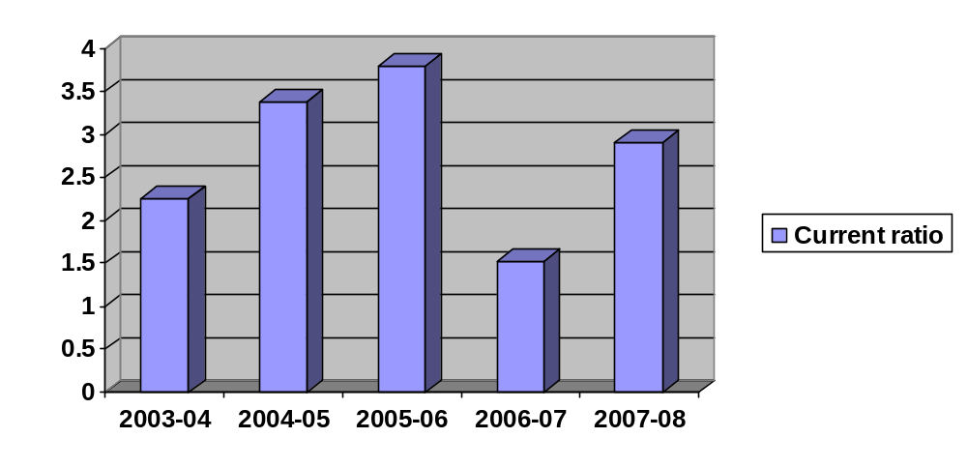 Interpretation and Analysis:

The above table and diagram shows that the current ratio in the year 2003-04 was 2.26 and then in increases to 3.38 in the year 2004-05, further move upwards to 3.80 and in the year 2006-07 it slashed down to 1.52 and finally in the year 2007-08 it again moved up to 2.91.
The normal current ratio is 2:1. The above table shows current ratio is more than 2% in all the first four years. But in 2006-2007 the current ratio is lower than the normal. This shows that the company is enjoying credit worthiness.

ii) Liquid ratio:
The term ‘liquidity’ refers to the ability of a firm to pay its short-term obligation as and when they become due. The term quick assets or liquid assets refers current assets which can be converted into cash immediately it comprises all current assets except stock and prepaid expenses it is determined by dividing quick assets by quick liabilities.

Liquid assets
Liquid ratio = -------------------------
Liquid liabilities

TABLE-2
LIQUID RATIO:

Year | Liquid assets | Liquid liabilities | Ratio
2003-2004 | 47,782,491.51 | 20,073,088.54 | 2.38
2004-2005 | 55,809,100.59 | 25,805,580.98 | 2.16
2005-2006 | 54,831,547.34 | 20,615,801.31 | 2.65
2006-2007 | 76,488,121.13 | 29,645,904.71 | 2.58
2007-2008 | 18,362,128.30 | 18,784,066.35 | 0.97

CHART-2
LIQUID RATIO:

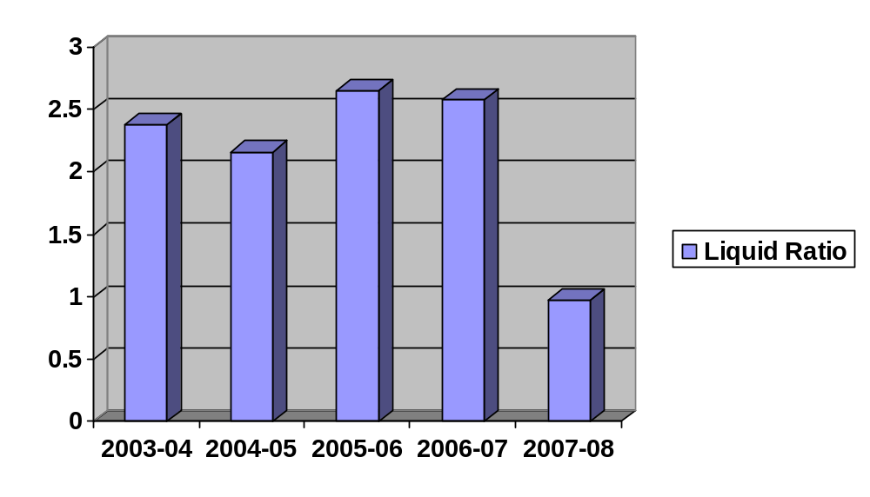

Interpretation and Analysis:

The above table and diagram shows the liquid ratio during the study period except in the year 2007-2008 is more than the normal (i.e.) 1:1.It was 2.38 in the year 2003-04 and reached the highest in 2005-06 to 2.65 and then came down to .97 in the year 2007-08.
Hence the firm is controlling its stock position because there linear relationship between current ratio and liquid ratio.

ii) Absolute liquidity ratio:

Absolute liquid assets include cash, bank, and marketable securities. This ratio Obtained by dividing cash and bank and marketable securities by current liabilities.

Cash + bank +marketable securities
Absolute liquidity ratio = ----------------------------------------------
Current liabilities

TABLE-3
ABSOLUTE LIQUID RATIO:

Year | Cash and securities | Current liabilities | Ratio
2003-2004 | 1,002,474 | 27,943,268 | 0.03
2004-2005 | 1,496,467 | 28,547,982 | 0.05
2005-2006 | 332,231 | 23,128,596 | 0.01
2006-2007 | 3,225,488 | 64,509,752 | 0.05
2007-2008 | 260,094 | 19,276,000.47 | 0.01

CHART-3
ABSOLUTE LIQUID RATIO:

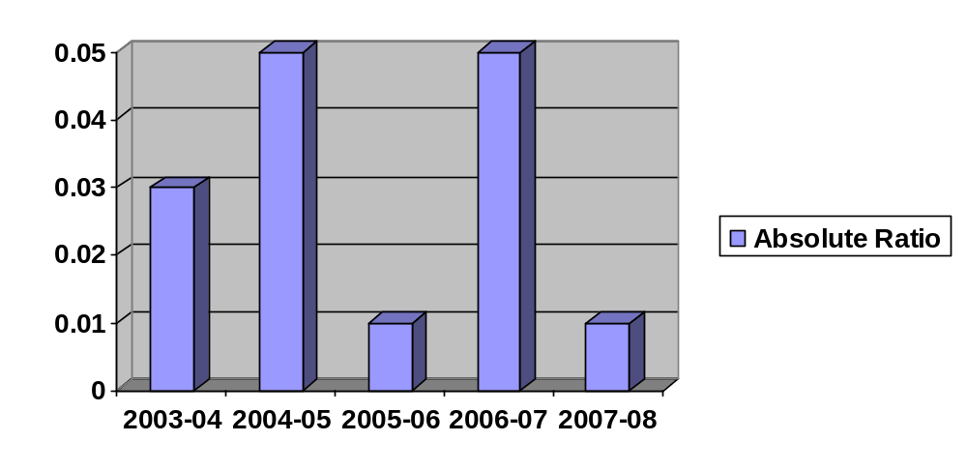

Interpretation and Analysis:
The above table and diagram shows the absolute ratio for the study period 2003-04 to 2007-08. There is fluctuation in the absolute ratio. It was 0.03 in the year 2003-04. In 2004-05 and 2006-07 it was 0.05. It was 0.01 in 2005-06 and 2007-08.

B) Leverage ratios:
Many financial analyses are interested in the relative use of debt and equity in the firm. The term ‘solvency’ refers to the ability of a concern to meet its long-term obligation. Accordingly, long-term solvency ratios indicate a firm’s ability to meet the fixed interest and costs and repayment schedules associated with its long-term borrowings. (E.g.) debt equity ratio, proprietary ratio, etc….
i) DEBT EQUITY ratio:
It expresses the relationship between the external equities and internal equities or the relationship between borrowed funds and ‘owners’ capital. It is a popular measure of the long-term financial solvency of a firm. This relationship is shown by the debt equity ratio. This ratio indicates the relative proportion of dept and equity in financing the assets of a firm. This ratio is computed by dividing the total debt of the firm by its equity (i.e.) net worth.
Outsider’s funds
Debt equity ratio = ------------------------------
Proprietor’s funds

TABLE-4
DEBT EQUITY RATIO:
Year | Outsider’s funds | Proprietor’s funds | Ratio
2003-2004 | 21,220,083 | 53,331,692 | 0.40
2004-2005 | 55,125,897 | 63,576,119 | 0.87
2005-2006 | 40,741,814 | 65,810,599 | 0.62
2006-2007 | 32,238,020 | 66,462,086 | 0.49
2007-2008 | 25,255,603 | 66,405,370 | 0.38

CHART-4
DEBT EQUITY RATIO:
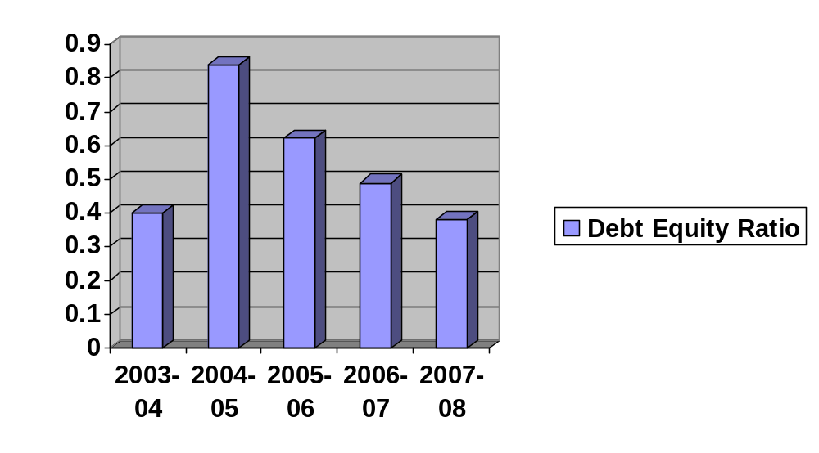

Interpretation and Analysis:
The above table and diagram shows the debt equity relationship of the company during the study period. It was 0.4 in the 2003-04 and then reached its highest in the next year and from there it began to slope downwards and ultimately came to 0.38 in the year 2007-08.
In all the years the equity is more when compared with borrowings. Hence the company is maintaining its debt position

ii) Proprietary ratio:

Proprietary ratio relates to the proprietors funds to total assets. It reveals the owners contribution to the total value of assets. This ratio shows the long-time solvency of the business it is calculated by dividing proprietor’s funds by the total tangible assets.

Proprietor’s funds
Proprietary ratio = ---------------------------
Total tangible assets

TABLE-5
PROPRIETARY RATIO:

Year | Proprietor’s funds | Total assets | Ratio
2003-2004 | 53,331,692 | 74,551,774 | 0.72
2004-2005 | 63,576,119 | 118,702,016 | 0.54
2005-2006 | 65,810,599 | 106,552,413 | 0.62
2006-2007 | 66,462,086 | 98,670,106 | 0.67
2007-2008 | 66,405,370 | 91,660,973 | 0.72

CHART-5
PROPRIETARY RATIO:
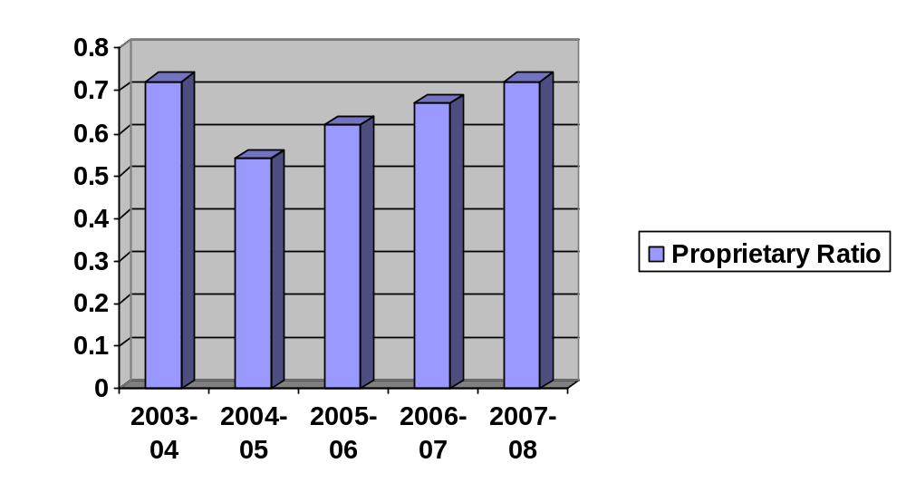

Interpretation and Analysis:
The above table and diagram shows the proprietary ratio during the study period. In all the years the owner's contribution to the total assets was appropriate and they maintain their share in the company's assets.
Except 2005-06 in all the years the proprietor's contribution in to the total assets is more than the 2/3. During 2004-05 it is more than 50%

C) Activity ratios:
These ratios evaluate the use of the total resources of the business concern along with the use of the components of total assets. They are intended to measure the effectiveness of the assets management the efficiency with which the assts are used would be reflected in the speed and rapidity with which the assets are converted into sales. The greater the rate of turnover, the more efficient the management would be (E.g.) stock turnover ratio, fixed assets turnover ratios etc….
i) Stock turnover ratio:
This ratio indicates whether investment is inventory is efficiently used or not it explains whether investment in inventories in with in proper limits or not. It also measures the effectiveness of the firms’ sales efforts the ratio is calculated as follows.
Cost of goods sold
Stock turnover ratio = -----------------------------
Average stock

Opening Stock + Closing Stock
Average stock = -----------------------------------------
2

TABLE-6
STOCK TURNOVER RATIO:

Year | Cost of goods sold | Average stock | Ratio
2003-2004 | 147,163,123 | 4,186,860 | 35.14
2004-2005 | 141,793,483 | 2,142,590 | 66.17
2005-2006 | 154,284,918 | 4,065,741 | 39.08
2006-2007 | 195,951,080 | 13,599,668 | 14.40
2007-2008 | 105,517,193 | 15,166,139 | 6.95

CHART-6
STOCK TURNOVER RATIO:

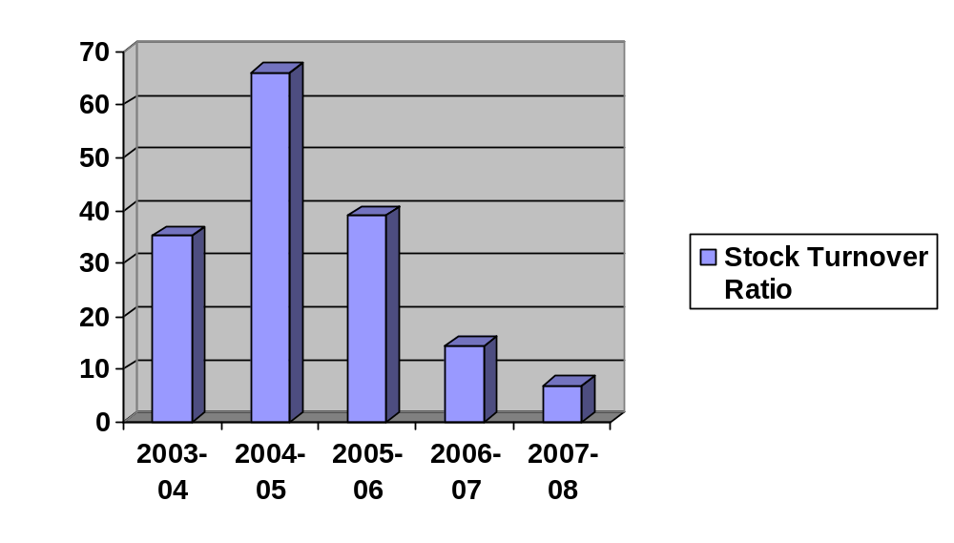

Interpretation and Analysis:
The above table and diagram shows the relation ship between costs of goods sold and average stock. During the year 2004-05 it is 66.17% which shows higher position of cost of goods sold. In the years of study it is shown above that the cost of goods sold are almost 35-65times of the average stock. But at the same time during 2007-08 it is only 6.95 which shows that more stock was remaining in the company.

ii) Fixed assets turnover ratio:

The ratio indicates the extent to which the investments in fixed assets contribute towards sales. If compared with a pervious year. It indicates whether the investment infixed assets has been judious or not the ratio is calculated as follows.

Net sales
Fixed assets turnover ratio = -------------------
Fixed assets

TABLE-7
FIXED ASSET TURNOVER RATIO:

Year | Net sales | Fixed assets | Ratio
2003-2004 | 169,056,118 | 39,262,748 | 4.30
2004-2005 | 173,896,782 | 50,550,585 | 3.41
2005-2006 | 179,231,321 | 41,772,389 | 4.29
2006-2007 | 225,250,870 | 64,982,465 | 3.47
2007-2008 | 113,095,288 | 54,908,412 | 2.06

CHART-7
FIXED ASSET TURNOVER RATIO:
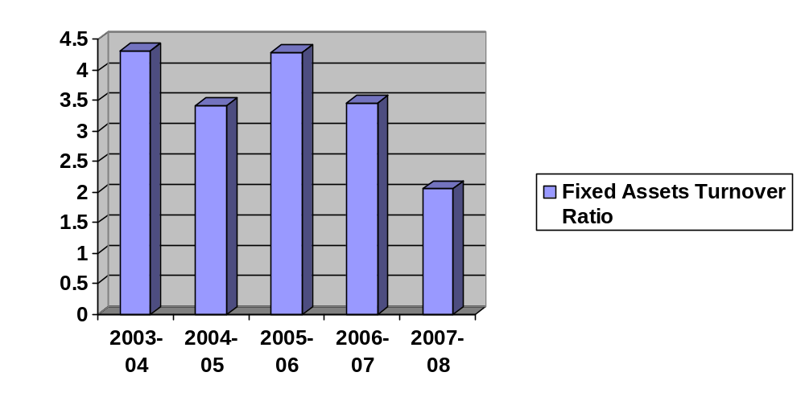

Interpretation and Analysis:
The above table and diagram shows the relation ship between the fixed assets and sales. The sale is 4 times more than the fixed assets 2003-04 and 2005-06. It is more than 3 times during 2004-05 and 2006-2007. It is more than 2 times during 2007-08. It can be observed that in the year 2006-07 the fixed assets value increased a lot and which shows that there is an additions made to the fixed assets, similarly the sales was also increased from 179,231,321(2005-06) to 225,250,870 (2006-07). However in the year 2007-08 it slashed to about 50% of the sales of 2006-07.

iii) Working capital turnover ratio:

Working capital turnover ratio indicates the velocity of the utilization of net working capital. This ratio indicates the number of times the working capital is turned over in the course of a year. It is a good measure over –trading and under-trading.

Net sales
Working capital turnover ratio = ----------------------------
Net working capital

TABLE-8
WORKING CAPITAL TURNOVER RATIO:

Year | Net sales | Net working capital | Ratio
2003-2004 | 169,056,118 | 35,289,026 | 4.79
2004-2005 | 173,869,782 | 68,151,430 | 2.55
2005-2006 | 179,231,321 | 64,780,024 | 2.77
2006-2007 | 225,250,870 | 33,687,641 | 6.69
2007-2008 | 113,095,288 | 36,752,561 | 3.08

CHART-8
WORKING CAPITAL TURNOVER RATIO:
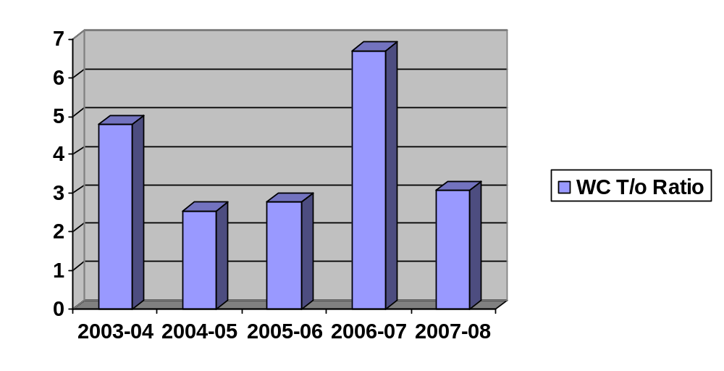

Interpretation and Analysis:
The above table and diagram shows the relation ship between net working capital and net sales. During the years the sales is 2 to 7 times more than the working capital. It was 4.79 in the year 2003-04 and as there was more working capital the ratio sloped downwards and reached 2.77 in the year 2005-06. As the sales increased and working capital decreased the ration now moved up to 6.69 times and in the very next year as the sales slashed to 50% of the previous year the ration again decreased.

iv) Total assets Turnover RATIO:

This ratio is an indicator of how the resources of the organization utilized for increasing the turnover. It shows the ratio between the total assets and the net sales of the company. From this ratio one can understand how the assets are performing and being utilized in achieving the objectives of the company.

Total assets
Total assets turnover ratio = -------------------
Net assets

TABLE-9
TOTAL ASSETS TURNOVER RATIO:

Year | Total assets | Net sales | Ratio
2003-2004 | 74,551,774 | 169,056,118 | 0.44
2004-2005 | 118,702,016 | 173,896,782 | 0.68
2005-2006 | 106,552,413 | 179,231,321 | 0.59
2006-2007 | 98,670,106 | 225,250,870 | 0.44
2007-2008 | 91,660,973 | 113,095,288 | 0.81

CHART-9
TOTAL ASSETS TURNOVER RATIO:
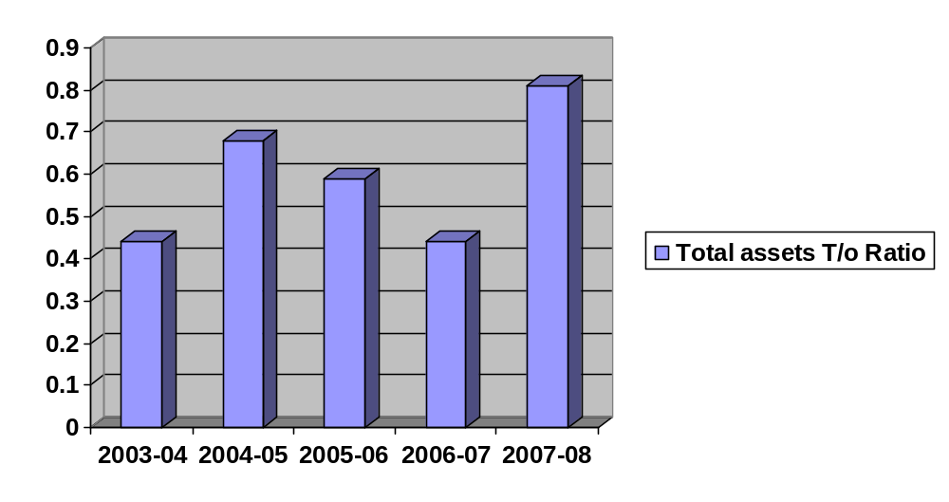

Interpretation and Analysis:
The above table and diagram shows the relation ship between the total assets to net sales. During all the study period years the relationship between sales to total assets is high. The ratio increased from 0.44 (2003-04) to 0.68 (2004-05) and then it was decreasing and reached to again 0.44 in the year 2006-07 and raised to 0.81 in the year 2007-08 due to the heavy fall in the sales. Thus the company's sales were almost directly proportionately in the first three years of the study and then in the year 2006-07 it was adversely affected.

v) Capital turnover ratio:

This is a ratio which shows how much sales are entertained from the capital. It shows how the sales are attracted from the Proprietor's Fund.

Sales
Capital turnover ratio = -----------------------
Proprietor’s fund

TABLE-10
CAPITAL TURNOVER RATIO:

Year | Sales | Proprietor’s funds | Ratio
2003-2004 | 169,056,118 | 53,331,692 | 3.17
2004-2005 | 173,896,782 | 63,576,119 | 2.74
2005-2006 | 179,231,321 | 65,810,599 | 2.72
2006-2007 | 225,250,870 | 66,462,086 | 3.39
2007-2008 | 113,095,288 | 66,405,370 | 1.70

CHART-10
CAPITAL TURNOVER RATIO:
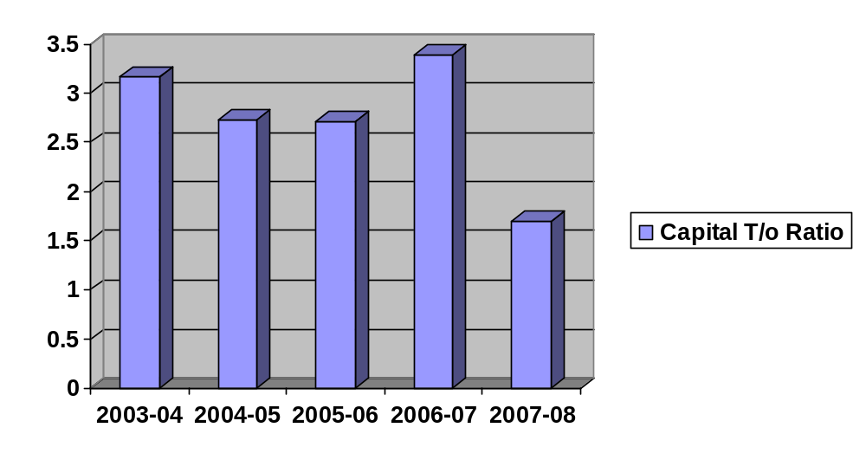

Interpretation and Analysis:

The above table and diagram shows the relationship between the sales and proprietors funds. In the year 2003-04 the ratio 3.17 and then it was decreasing and reached 2.72 in the year 2005-06 and again raised to 3.39 in 2006-07 and in the final year i.e. 2007-08 it reached the lowest to 1.70. The sales are in between 1.5 and 3.5 times more than the proprietor's funds. It shows the firms is maintaining the better utilization of own funds

vi) Return on total assets:
Profitability can be measured in terms of relationship between net profit and total assets. It measures the profitability of investment. The overall profitability can be known by applying this ratio.

Net profit
Return on total assets = ----------------------------- x100
Total assets

TABLE-11
RETURN ON TOTAL ASSETS RATIO:
Year | Net profit | Total assets | Ratio
2003-2004 | 10,699,894 | 74,551,774 | 0.144
2004-2005 | 9,472,578 | 118,702,016 | 0.080
2005-2006 | 231,044 | 106,552,413 | 0.002
2006-2007 | 621,486 | 98,670,106 | 0.006
2007-2008 | (26716) | 91,660,973 | -

CHART-11
RETURN ON TOTAL ASSETS RATIO

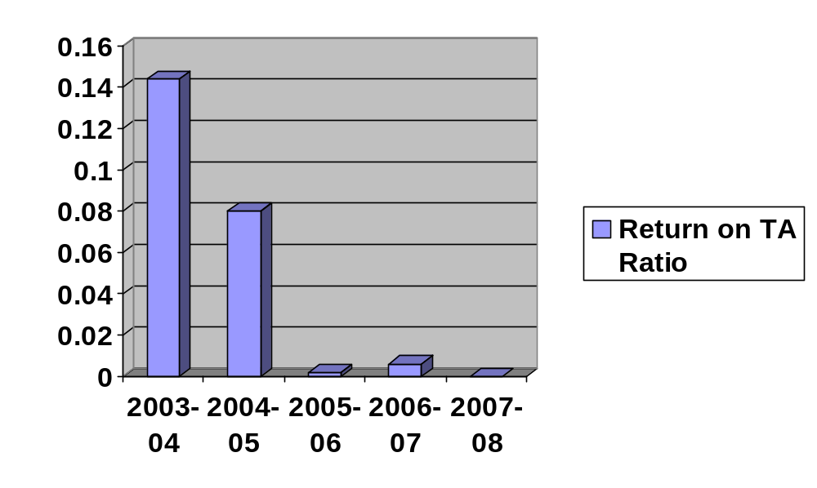
Interpretation and Analysis:
The above table and diagram shows the relationship between net profit and total assets in percentage. As the total assets were increasing year by year the net profit percentage was decreasing. The Net profit from the year 2005-06 is very less and in the year 2007-08 the company made a loss.

D) Profitability ratios:
The profitability ratios of a business concern can be measured by the profitability ratios. These ratios highlight the end result of business activities by which alone the over all efficiency of a business unit can be judged, (E.g.) gross ratios, Net profit ratio.

i) Gross profit ratio:
This ratio expresses the relationship between Gross profit and sales. It indicated the efficiency of production or trading operation. A high gross profit ratio is a good management as it implies that cost of production is relatively low.

Gross profit
Gross profit ratio = ----------------------------------- x 100
Net sales

TABLE-12
GROSS PROFIT RATIO:

Year | Gross profit | Net sales | Ratio
2003-2004 | 21,892,995 | 169,056,118 | 12.95
2004-2005 | 16,162,083 | 173,896,783 | 9.29
2005-2006 | 24,946,403 | 179,231,321 | 13.92
2006-2007 | 29,299,790 | 225,250,870 | 13.01
2007-2008 | 7,578,095 | 113,095,288 | 6.70

CHART-12
GROSS PROFIT RATIO:

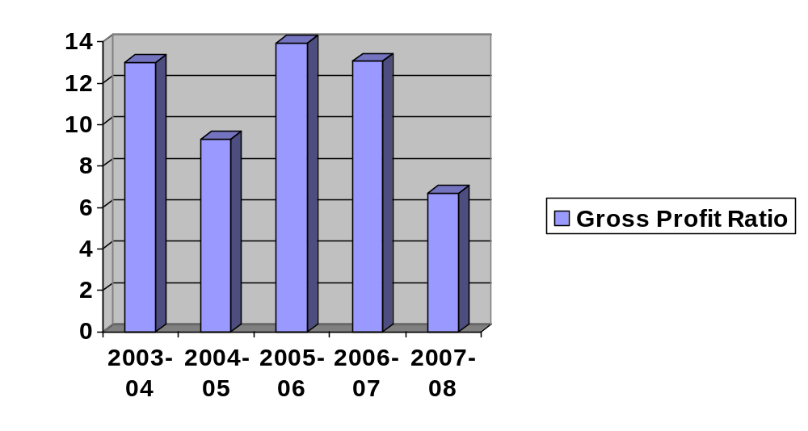
Interpretation and Analysis:
The above table and diagram shows the relation ship between the gross profit and net sales in percentage. During 2003-04 the gross profit position was 12.95% and in the very next year it slashed down to 9.29% and again raised to 13.92% and since then it was decreasing and finally reached the lowest to 6.70% in the year 2007-08. However it can be noticed that the sales also reduced to about 50% in 2007-08 when compared to sales of 2006-07.

ii) Net profit ratio:
Net profit ratio establishes a relationship between net profit (after taxes) and sales. It is determined by dividing the net income after tax to the net sales for the period and measures the profit per rupee of sales.

Net profit
Net profit sales = ----------------- x 100
Net sales

TABLE-13
NET PROFIT RATIO:

Year | Net profit | Net sales | Ratio
2003-2004 | 10,699,894 | 169,056,118 | 6.32
2004-2005 | 9,472,578 | 173,896,782.3 | 5.45
2005-2006 | 231,044 | 179,231,321 | 0.12
2006-2007 | 621,486 | 225,250,870 | 0.28
2007-2008 | (26,716) | 113,095,288 | -

CHART-13
NET PROFIT RATIO:
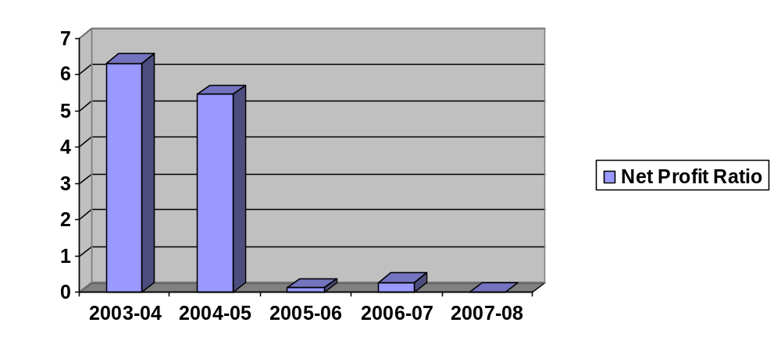

Inference:
The above table and diagram shows the relation ship between net profit and net sales during 2003-04 it was 6.32% on sales and in 2004-05 it was 5.45. But in all other 3 years it is less than 1% and even negative in the year 2007-08. This means that either there is any defect in pricing the product or excess non-value added expenditures which reduces the net profit of the company. The sales of the organization are also decreasing and hence management must take care of the quality and market situations into consideration to resolve the issue so that it may bring good profits to the organization.

iii) Expenses ratio:
This ratio establishes the relationship between various indirect expenses to net sales.

- Administrative expenses ratio:
Administrative expenses
Administrative expenses ratio = ------------------------------- x 100
Sales

b) Selling &distribution expenses ratio:
Selling &distribution expenses
Selling &distribution expenses ratio = ----------------------------------------- x 100

Sales

TABLE-14
EXPENSES RATIO:

Administration expenses + selling expenses
Expenses ratio = _______________________________________ x 100

Sales

Year | Administration& Selling expenses | Sales | Ratio
2003-2004 | 23,664,446 | 169,056,118 | 13.99
2004-2005 | 28,296,402 | 173,896,783 | 16.27
2005-2006 | 36,818,797 | 179,231,321 | 20.54
2006-2007 | 33,462,817 | 225,250,870 | 14.85
2007-2008 | 29,355,781 | 113,095,288 | 25.95

CHART-14
EXPENSES RATIO:
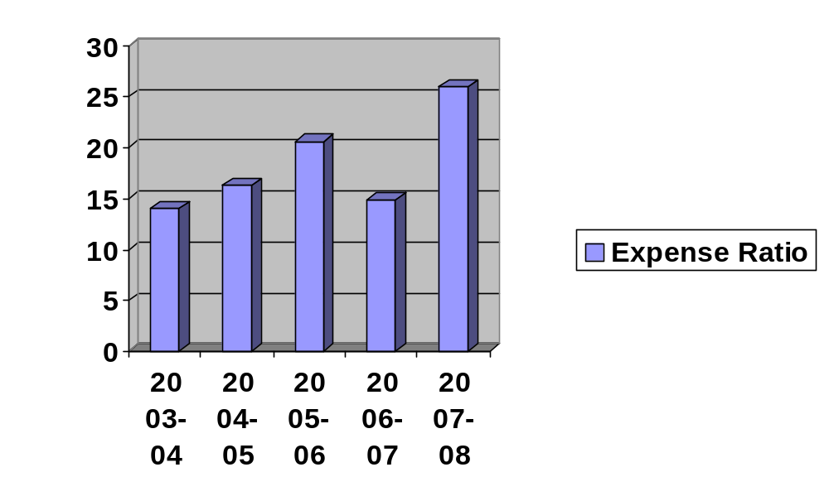

Interpretation and Analysis:
The above table and diagram shows the relation ship between the administration and selling expenses and sales. The administration and selling expenses during 2007-08 is very high when compared to previous year's %age as they were in between 13-20% of sales. This may also be one of the reasons to a net loss in that year.

TABLE-15
Common size income statement (2003-04 &2004-05)
Particulars | 2003-2004 | % | 2004-2005 | %
Income:
Sales | 169,056,118 | 89.61 | 173,896,783 | 88.16
Other income | 18,550,813 | 9.85 | 22,257,266 | 11.28
Closing stock | 1,033,090 | 0.54 | 1,109,500 | 0.56
Total income | 188,640,021 | 100 | 197,263,548 | 100
Expenditure:
Opening stock | 7,340,630 | 3.90 | 1,033,090 | 0.52
Purchases | 90,966,622 | 48.22 | 110,670,457 | 56.10
Direct expenses | 49,888,961 | 26.44 | 47,140,653 | 23.92
Administration expenses | 15,776,297 | 8.36 | 18,864,268 | 9.56
Selling Expenses | 7,888,149 | 4.18 | 9,432,134 | 4.78
Depreciation | 6,079,468 | 3.22 | 650368 | 0.32
Total expenses | 177,940,127 | 94.32 | 187,640,021 | 95.20
Net profit | 10,699,894 | 5.68 | 9,472,578 | 4.80
Total | 188,640,894 | 100 | 197,263,548 | 100

Inference:
The common size income statement for the year 2004 to 2005 reveals the following. The sales figure increasing year after year. It increased about Rs.48,40,665. Administrative and other expenses were fluctuating. The other income of the company was increased year by year.

TABLE-16
Common size income statement (2004-05 & 2005-06)

Particulars | 2004-2005 | % | 2005-2006 | %
Income:
Sales | 173,896,783 | 88.16 | 179,231,321 | 86.92
Other income | 22,257,266 | 11.28 | 19,961,865 | 9.68
Closing stock | 1,109,500 | 0.56 | 7,021,983 | 3.40
Total income | 197,263,548 | 100 | 206,215,169 | 100
Expenditure:
Opening stock | 1,033,090 | 0.52 | 1,109,500 | 0.53
Purchases | 110,670,457 | 56.10 | 81,132,703 | 39.34
Direct expenses | 47,140,653 | 23.92 | 79,064,698 | 38.34
Administration expenses | 18,864,268 | 9.56 | 24,545,865 | 11.90
Selling Expenses | 9,432,134 | 4.78 | 12,272,932 | 5.95
Depreciation | 650368 | 0.32 | 7,858,427 | 3.82
Total expenses | 187,640,021 | 95.20 | 205,984,125 | 99.88
Net profit | 9,472,578 | 4.80 | 231,044 | 0.12
Total | 197,263,548 | 100 | 206,215,169 | 100

Inference:

The common size income statement for the year 2005 to 2006 reveals the following. The sales figure increasing year after year. In the year 2005-06, cost of sales is 38.34% of the total income. Administrative and other expenses are fluctuating. Even though the sales increased but there is heavy decrease in the net profit of the organization. The net profit slashed from 4.80% to 0.12% only. The company must adopt correct pricing and control the unnecessary expenses to attain high profits

TABLE-17
Common size income statement (2005-06 & 2006-07)

Particulars | 2005-2006 | % | 2006-2007 | %
Income:
Sales | 179,231,321 | 86.92 | 225,250,870 | 88.22
Other income | 19,961,865 | 9.68 | 9,908,254 | 3.88
Closing stock | 7,021,983 | 3.40 | 20,177,353 | 7.90
Total income | 206,215,169 | 100 | 255,336,477 | 100
Expenditure:
Opening stock | 1,109,500 | 0.53 | 7,021,983 | 2.75
Purchases | 81,132,703 | 39.34 | 105,677,583 | 41.38
Direct expenses | 79,064,698 | 38.34 | 103,428,867 | 40.50
Administration expenses | 24,545,865 | 11.90 | 22,308,545 | 8.76
Selling Expenses | 12,272,932 | 5.95 | 11,154,272 | 4.36
Depreciation | 7,858,427 | 3.82 | 5,123,740 | 2.00
Total expenses | 205,984,125 | 99.88 | 254,714,990 | 99.75
Net profit | 231,044 | 0.12 | 621,487 | 0.25
Total | 206,215,169 | 100 | 255,336,477 | 100

Inference:

The common size income statement for the year 2006 to 2007 reveals the following. The sales figure increased from Rs.179,231,321 to Rs.225,250,870. In the year 2006-07 cost of sales is 40.50%. There is heavy decrease in the other incomes. In the year 2006-07 income increased from Rs.231,044 to Rs.621,487.

TABLE-18
Common size income statement (2006-07 & 2007-08)
Particulars | 2006-2007 | % | 2007-2008 | %
Income:
Sales | 225,250,870 | 88.22 | 113,095,288 | 75.74
Other income | 9,908,254 | 3.88 | 26,032,716 | 17.46
Closing stock | 20,177,353 | 7.90 | 10,154,926 | 6.80
Total income | 255,336,477 | 100 | 149,309,646 | 100
Expenditure:
Opening stock | 7,021,983 | 2.75 | 20,177,353 | 13.52
Purchases | 105,677,583 | 41.38 | 39,032,353 | 26.14
Direct expenses | 103,428,867 | 40.50 | 56,462,413 | 37.82
Administration expenses | 22,308,545 | 8.76 | 19,570,521 | 13.10
Selling Expenses | 11,154,272 | 4.36 | 9,785,260 | 6.55
Depreciation | 5,123,740 | 2.00 | 4,308,462 | 2.88
Total expenses | 254,714,990 | 99.75 | 149,336,362 | 100.01
Net profit | 621,487 | 0.25 | (26716) | (0.01)
Total | 255,336,477 | 100 | 149,309,646 | 100

Inference:
The common size income statement for the year 2007 to 2008 reveals the following. The sales figure slashed down very. It decreased from
Rs.225,250,870 to Rs.113,095,288 which is almost 50% of the previous year. In the year 2007-08 cost of sales is 37.82%. However in Administrative and other expenses there was a negligible change due to which organization attained a loss of Rs.26716.

TABLE-19
Common size balance sheet (2003-04 & 2004-05)
Particulars | 2003-2004 | % | 2004-2005 | %
Sources of funds:
Share capital | 52,599,867 | 70.55 | 53,371,716 | 44.96
Reserves & surplus | 731,825 | 0.98 | 10,204,403 | 8.60
Loan funds:
Secured loan | 21,197,278 | 28.43 | 55,103,092 | 46.42
Unsecured loan | 22,805 | 0.04 | 22,805 | 0.02
Total | 74,551,775 | 100 | 118,702,016 | 100
Application of funds:
Fixed assets | 39,262,748 | 52.67 | 50,550,586 | 42.59
Current assets & Loan and advances
Cash & bank | 1,002,474 | 1.34 | 1,490,466 | 1.26
Sundry debtors | 42,435,207 | 56.92 | 63,785,212 | 53.74
Advances and deposits | 18,761,523 | 25.17 | 30,308,234 | 25.53
Investments | ---------- | ----- | 6,000 | 0.01
Other assets | 1,033,090 | 1.39 | 1,109,500 | 0.93
Total | 63,232,294 | 84.82 | 96,699,412 | 81.46
current liabilities & provisions:
Less: Current liabilities | 19,725,023 | 26.46 | 25,486,282 | 21.47
Expenses for provisions | 8,218,245 | 11.02 | 3,061,700 | 2.58
Net Current assets | 35,289,026 | 47.33 | 68,151,430 | 57.41
Total | 74,551,775 | 100 | 118,702,016 | 100

Inference:
The common size balance sheet for the year 2004-2005 is as follows:
Share capital of the company is decreasing in %age of the net worth. In 2002-2003 in 70.55% to 44.96%.Secured loan for the company has decreasing trend. It increases 28.43 to 46.42% of the net worth of the company. Fixed asset of the company is decreasing in this year from 52.92% to 42.59%. Current liability and provisions is decreasing 37.48% to 24.05 %.

TABLE-20
Common size balance sheet (2004-05 & 2005-06)
Particulars | 2004-2005 | % | 2005-2006 | %
Sources of funds:
Share capital | 53,371,716 | 44.96 | 55,375,152 | 51.97
Reserves & surplus | 10,204,403 | 8.60 | 10,435,447 | 9.79
Loan funds:
Secured loan | 55,103,092 | 46.42 | 40,741,814 | 38.24
Unsecured loan | 22,805 | 0.02 | ------ | -----
Total | 118,702,016 | 100 | 106,552,413 | 100
Application of funds:
Fixed assets | 50,550,586 | 42.59 | 41,772,389 | 39.20
Current assets & Loan and advances
Cash & bank | 1,490,466 | 1.26 | 326,232 | 0.31
Sundry debtors | 63,785,212 | 53.74 | 58,873,736 | 55..25
Advances and deposits | 30,308,234 | 25.53 | 21,680,669 | 20.35
Investments | 6,000 | 0.01 | 6,000 | 0.01
Other assets | 1,109,500 | 0.93 | 7,021,983 | 6.59
Total | 96,699,412 | 81.46 | 78,204,998 | 82.50
current liabilities & provisions:
Less: Current liabilities | 25,486,282 | 21.47 | 19,777,355 | 18.56
Expenses for provisions | 3,061,700 | 2.58 | 3,351,241 | 3.15
Net Current assets | 68,151,430 | 57.41 | 64,780,024 | 60.80
Total | 118,702,016 | 100 | 106,552,413 | 100

Inference:
The common size balance sheet for the year 2005 to 2006 is as follows:
Share capital of the company has increased from 44.96% to 51.97. Secured loan for the company has decreasing trend. It increases 46.42% to 38.24%.Unsecured loan of the company has been paid off. Fixed asset of the company is decreasing in this year of 42.59% to 39.20%. Current liability and a provision is decreasing 24.05% to 21.71%.

TABLE-21
Common size balance sheet (2005-06 & 2006-07)
Particulars | 2005-2006 | % | 2006-2007 | %
Sources of funds:
Share capital | 55,375,152 | 51.97 | 55,375,152 | 56.12
Reserves & surplus | 10,435,447 | 9.79 | 11,056,934 | 11.21
Loan funds:
Secured loan | 40,741,814 | 38.24 | 32,212,520 | 32.65
Unsecured loan | ------ | ----- | 25,500 | 0.02
Total | 106,552,413 | 100 | 98,670,106 | 100
Application of funds:
Fixed assets | 41,772,389 | 39.20 | 64,982,465 | 65.86
Current assets & Loan and advances
Cash & bank | 326,232 | 0.31 | 1,573,364 | 1.59
Sundry debtors | 58,873,736 | 55..25 | 67,142,698 | 68.05
Advances and deposits | 21,680,669 | 20.35 | 9,297,978 | 9.42
Investments | 6,000 | 0.01 | 6,000 | 0.01
Other assets | 7,021,983 | 6.59 | 20,177,353 | 20.45
Total Current Assets | 78,204,998 | 82.50 | 98,197,393 | 99.52
current liabilities & provisions:
Less: Current liabilities | 19,777,355 | 18.56 | 54,707,520 | 55.44
Expenses for provisions | 3,351,241 | 3.15 | 9,802,232 | 9.93
Net Current assets | 64,780,024 | 60.80 | 33,687,641 | 34.14
Total | 106,552,413 | 100 | 98,670,106 | 100

Inference:
The common size balance sheet for the year 2006 to 2007 is as follows:
Share capital figure remained constant however their %age to net worth has increased from 51.97% to 56.12%. Some amount of the secured loans has been paid off. Fixed asset of the company has been increased and there share is 65.86% to the total assets in the year 2006-07. Current liability and a provision is increasing 21.71% to 65.37%. It can be noticed that the fixed assets are purchased on credit from the creditors and they both increased.

TABLE-22
Common size balance sheet (2006-07 & 2007-08)
Particulars | 2006-2007 | % | 2007-2008 | %
Sources of funds:
Share capital | 55,375,152 | 56.12 | 55,375,152 | 60.41
Reserves & surplus | 11,056,934 | 11.21 | 11,030,218 | 12.03
Loan funds:
Secured loan | 32,212,520 | 32.65 | 25,236,103 | 27.53
Unsecured loan | 25,500 | 0.02 | 19,500 | 0.03
Total | 98,670,106 | 100 | 91,660,973 | 100
Application of funds:
Fixed assets | 64,982,465 | 65.86 | 54,908,412 | 59.90
Current assets & Loan and advances
Cash & bank | 1,573,364 | 1.59 | 260,095 | 0.28
Sundry debtors | 67,142,698 | 68.05 | 41,001,210 | 44.73
Advances and deposits | 9,297,978 | 9.42 | 4,612,330 | 5.03
Investments | 6,000 | 0.01 | -------- | -----
Other assets | 20,177,353 | 20.45 | 10,154,926 | 11.08
Total | 98,197,393 | 99.52 | 56,028,561 | 61.13
current liabilities & provisions:
Less: Current liabilities | 54,707,520 | 55.44 | 15,919,410 | 17.37
Expenses for provisions | 9,802,232 | 9.93 | 3,356,590 | 3.66
Net Current assets | 33,687,641 | 34.14 | 36,752,561 | 40.10
Total | 98,670,106 | 100 | 91,660,973 | 100

Inference:
The common size balance sheet for the year 2007 to 2008 is as follows:
Share capital figure remained constant however their %age to net worth has increased from 56.12% to 60.41%. Some amount of the secured loans has been paid off. Current liability and a provision is decreased from 65.37% to 21.03% this means that a heavy amount is paid to the creditors of the fixed assets.

TABLE-23

Comparative income statement (2003-04 & 2004-05)

Particulars | 2003-2004 | 2004-2005 | INC/DCE | %
Income:
Sales | 169,056,118 | 173,896,783 | 4840665.00 | 2.86
Other income | 18,550,813 | 22,257,266 | 3706453.00 | 19.98
Closing stock | 1,033,090 | 1,109,500 | 76410.00 | 7.40
Total income | 188,640,021 | 197,263,548 | 8623527.00 | 4.57
Expenditure:
Opening stock | 7,340,630 | 1,033,090 | (6307540.00) | (85.93)
Purchases | 90,966,622 | 110,670,457 | 19703835.00 | 21.66
Direct expenses | 49,888,961 | 47,140,653 | (2748308.00) | (5.51)
Administration expenses | 15,776,297 | 18,864,268 | 3087971.00 | 19.57
Selling Expenses | 7,888,149 | 9,432,134 | 1543985.00 | 19.57
Depreciation | 6,079,468 | 650368 | (5429100.00) | (89.30)
Total expenses | 177,940,127 | 187,640,021 | 9699894.00 | 5.45
Net profit /Loss | 10,699,894 | 9,472,578 | (1227316.00) | (11.47)
Total | 188,640,894 | 197,263,548 | 8622654.00 | 4.57
Inference:
The sales level has increased 2004 to 2005 in 2.86%.Other income of the company has increased in 19.98%. The stock differential of the firm in the year of 2003 to 2004 is 7.40%.The operating expenses is increased by 19.57% in both administration and selling and the net profit of the year is decreased by 11.47%
TABLE-24
Comparative income statement (2004-05 & 2005-06)
Particulars | 2004-2005 | 2005-2006 | INC /DEC | %
Income:
Sales | 173,896,783 | 179,231,321 | 5334538.00 | 3.07
Other income | 22,257,266 | 19,961,865 | (2295401.00) | (10.31)
Closing stock | 1,109,500 | 7,021,983 | 5912483.00 | 532.90
Total income | 197,263,548 | 206,215,169 | 8951621.00 | 4.54
Expenditure:
Opening stock | 1,033,090 | 1,109,500 | 76410.00 | 7.40
Purchases | 110,670,457 | 81,132,703 | (29537754.00) | (26.69)
Direct expenses | 47,140,653 | 79,064,698 | 31924045.00 | 67.72
Administration expenses | 18,864,268 | 24,545,865 | 5681597.00 | 30.12
Selling Expenses | 9,432,134 | 12,272,932 | 2840798.00 | 30.12
Depreciation | 650368 | 7,858,427 | 7208059.00 | 1108.30
Total expenses | 187,640,021 | 205,984,125 | 18344104.00 | 9.78
Net profit /Loss | 9,472,578 | 231,044 | (9241534.00) | (97.56)
Total | 197,263,548 | 206,215,169 | 8951621.00 | 4.54

Inference:
The sales level has increased 2005 to 2006 in 3.07% .Other income of the company has decreased in 10.31%. The stock differential of the firm in the year of 2005 to 2006 is increased which is almost 533% of the last year. The operating expenses were increased by 30.12% in both administration and selling and the net profit of the year is decreased by 97.56% and it earned just 2.44% of the last year net profit.
TABLE-25
Comparative income statement (2005-06 & 2006-07)
Particulars | 2005-2006 | 2006-2007 | INC /DEC | %
Income:
Sales | 179,231,321 | 225,250,870 | 46019549.00 | 25.68
Other income | 19,961,865 | 9,908,254 | (10053611.00) | (50.36)
Closing stock | 7,021,983 | 20,177,353 | 13155370.00 | 187.35
Total income | 206,215,169 | 255,336,477 | 49121308.00 | 23.82
Expenditure:
Opening stock | 1,109,500 | 7,021,983 | 5912483.00 | 532.90
Purchases | 81,132,703 | 105,677,583 | 24544880.00 | 30.25
Direct expenses | 79,064,698 | 103,428,867 | 24364169.00 | 30.82
Administration expenses | 24,545,865 | 22,308,545 | (2237320.00) | (9.11)
Selling Expenses | 12,272,932 | 11,154,272 | (1118660.00) | (9.11)
Depreciation | 7,858,427 | 5,123,740 | (2734687.00) | (34.80)
Total expenses | 205,984,125 | 254,714,990 | 48730865.00 | 23.66
Net profit /Loss | 231,044 | 621,487 | 390443.00 | 168.99
Total | 206,215,169 | 255,336,477 | 49121308.00 | 23.82
Inference:
The sales level has increased 2006 to 2007 in 25.68% .Other income of the company has decreased by 50.36%. The stock differential of the firm in the year of 2006 to 2007 is increased. The operating expenses are decreased in 9.11% in both administration and selling and the net profit of the year is increased.
TABLE-26
Comparative income statement (2006-07 & 2007-08)

Particulars | 2006-2007 | 2007-2008 | INC / DEC | %
Income:
Sales | 225,250,870 | 113,095,288 | (112155582.00) | (49.79)
Other income | 9,908,254 | 26,032,716 | 16124462.00 | 162.74
Closing stock | 20,177,353 | 10,154,926 | (10022427.00) | (49.67)
Total income | 255,336,477 | 149,309,646 | (106026831.00) | (41.52)
Expenditure:
Opening stock | 7,021,983 | 20,177,353 | 13155370.00 | 187.35
Purchases | 105,677,583 | 39,032,353 | (66645230.00) | (63.06)
Direct expenses | 103,428,867 | 56,462,413 | (46966454.00) | (45.41)
Administration expenses | 22,308,545 | 19,570,521 | (2738024.00) | (12.27)
Selling Expenses | 11,154,272 | 9,785,260 | (1369012.00) | (12.27)
Depreciation | 5,123,740 | 4,308,462 | (815278.00) | (15.91)
Total expenses | 254,714,990 | 149,336,362 | (105378628.00) | (41.37)
Net profit /Loss | 621,487 | (26716) | (648203.00) | (104.30)
Total | 255,336,477 | 149,309,646 | (106026831.00) | (41.52)

Inference:
The sales level has slashed down by 49.79% when compared to last year sales .Other income of the company has increased. The stock differential of the firm in the year of 2007 to 2008 also decreased. The operating expense is decreased in 12.27% in both administration and selling. The company incurred a net loss of Rs.26716.

TABLE-27
Comparative balance sheet (2003-04 & 2004-05)

Particulars | 2003-2004 | 2004-2005 | INC / DEC | %
Sources of funds:
Share capital | 52,599,867 | 53,371,716 | 771,849 | 1.47
Reserves & surplus | 731,825 | 10,204,403 | 9,472,578 | 1294.38
Loan funds:
Secured loan | 21,197,278 | 55,103,092 | 33,905,814 | 159.95
Unsecured loan | 22,805 | 22,805
Total | 74,551,775 | 118,702,016 | 44,150,241 | 59.22
Application of funds:
Fixed assets | 39,262,748 | 50,550,586 | 11,287,838 | 28.75
Current assets & Loan and advances
Cash & bank | 1,002,474 | 1,490,466 | 487,992 | 48.68
Sundry debtors | 42,435,207 | 63,785,212 | 21,350,005 | 50.31
Advances and deposits | 18,761,523 | 30,308,234 | 11,546,711 | 61.54
Investments | ---------- | 6,000 | 6,000 | 100.00
Other assets | 1,033,090 | 1,109,500 | 76,410 | 7.40
Total | 63,232,294 | 96,699,412 | 33,467,118 | 52.93
current liabilities & provisions:
Less: Current liabilities | 19,725,023 | 25,486,282 | 5,761,259 | 29.21
Expenses for provisions | 8,218,245 | 3,061,700 | -5,156,545 | -62.75
Net Current assets | 35,289,026 | 68,151,430 | 32,862,404 | 93.12
Total | 74,551,775 | 118,702,016 | 44,150,241 | 59.22

Inference:
The comparative balance sheet of the year 2004-2005 is as follows
The share capital of the company has increasing in the year of 2004-05 by 1.47%. The profit of the company has increased the reserves and surplus by 1295% .The fixed assets of the company has increased in 28.75%. The cash position of the company has fluctuating increase or decreases. The current liability and provisions of the company is fluctuating year after year.

TABLE-28
Particulars | 2004-2005 | 2005-2006 | INC / DEC | %
Sources of funds:
Share capital | 53,371,716 | 55,375,152 | 2,003,436 | 3.75
Reserves & surplus | 10,204,403 | 10,435,447 | 231,044 | 2.26
Loan funds:
Secured loan | 55,103,092 | 40,741,814 | -14,361,278 | -26.06
Unsecured loan | 22,805 | ------ | -22,805 | -100.00
Total | 118,702,016 | 106,552,413 | -12,149,603 | -10.24
Application of funds:
Fixed assets | 50,550,586 | 41,772,389 | -8,778,197 | -17.37
Current assets & Loan and advances
Cash & bank | 1,490,466 | 326,232 | -1,164,234 | -78.11
Sundry debtors | 63,785,212 | 58,873,736 | -4,911,476 | -7.70
Advances and deposits | 30,308,234 | 21,680,669 | -8,627,565 | -28.47
Investments | 6,000 | 6,000 | 0 | 0.00
Other assets | 1,109,500 | 7,021,983 | 5,912,483 | 532.90
Total | 96,699,412 | 78,204,998 | -18,494,414 | -19.13
current liabilities & provisions:
Less: Current liabilities | 25,486,282 | 19,777,355 | -5,708,927 | -22.40
Expenses for provisions | 3,061,700 | 3,351,241 | 289,541 | 9.46
Net Current assets | 68,151,430 | 64,780,024 | -3,371,406 | -4.95
Total | 118,702,016 | 106,552,413 | -12,149,603 | -10.24
Comparative balance sheet (2004-05 & 2005-06)

Inference:
The comparative balance sheet of the year 2005 to 2006 is as follows
The share capital of the company has increasing in the year of 2005-06. The secured loan of the company has decreased in this year by 26.06% .The fixed assets of the company has decreased. The cash position of the company has fluctuating increase or decreases. The current liability and provisions of the company is fluctuating year after year.

TABLE-29
Comparative balance sheet (2005-06 & 2006-07)
Particulars | 2005-2006 | 2006-2007 | INC / DEC | %
Sources of funds:
Share capital | 55,375,152 | 55,375,152 | 0 | 0.00
Reserves & surplus | 10,435,447 | 11,056,934 | 621,487 | 5.96
Loan funds:
Secured loan | 40,741,814 | 32,212,520 | -8,529,294 | -20.93
Unsecured loan | ------ | 25,500 | 25,500 | 100.00
Total | 106,552,413 | 98,670,106 | -7,882,307 | -7.40
Application of funds:
Fixed assets | 41,772,389 | 64,982,465 | 23,210,076 | 55.56
Current assets & Loan and advances
Cash & bank | 326,232 | 1,573,364 | 1,247,132 | 382.28
Sundry debtors | 58,873,736 | 67,142,698 | 8,268,962 | 14.05
Advances and deposits | 21,680,669 | 9,297,978 | -12,382,691 | -57.11
Investments | 6,000 | 6,000 | 0 | 0.00
Other assets | 7,021,983 | 20,177,353 | 13,155,370 | 187.35
Total | 78,204,998 | 98,197,393 | 19,992,395 | 25.56
current liabilities & provisions:
Less: Current liabilities | 19,777,355 | 54,707,520 | 34,930,165 | 176.62
Expenses for provisions | 3,351,241 | 9,802,232 | 6,450,991 | 192.50
Net Current assets | 64,780,024 | 33,687,641 | -31,092,383 | -48.00
Total | 106,552,413 | 98,670,106 | -7,882,307 | -7.40

Inference:
The comparative balance sheet of the year 2005-2006 is as follows
The share capital of the company remains same. The secured loan of the company has decreased in this year by 20.93% .The fixed assets of the company has increased by purchasing the new assets on credit. The cash position of the company has fluctuating increase or decreases. The current liability and provisions of the company is also increasing as the fixed assets were purchased on credit and hence they both increases.

TABLE-30
Comparative balance sheet (2006-07 & 2007-08)

Particulars | 2006-2007 | 2007-2008 | INC / DEC | %
Sources of funds:
Share capital | 55,375,152 | 55,375,152 | 0 | 0.00
Reserves & surplus | 11,056,934 | 11,030,218 | -26,716 | -0.24
Loan funds:
Secured loan | 32,212,520 | 25,236,103 | -6,976,417 | -21.66
Unsecured loan | 25,500 | 19,500 | -6,000 | -23.53
Total | 98,670,106 | 91,660,973 | -7,009,133 | -7.10
Application of funds:
Fixed assets | 64,982,465 | 54,908,412 | -10,074,053 | -15.50
Current assets & Loan and advances
Cash & bank | 1,573,364 | 260,095 | -1,313,269 | -83.47
Sundry debtors | 67,142,698 | 41,001,210 | -26,141,488 | -38.93
Advances and deposits | 9,297,978 | 4,612,330 | -4,685,648 | -50.39
Investments | 6,000 | -------- | -6,000 | -100.00
Other assets | 20,177,353 | 10,154,926 | -10,022,427 | -49.67
Total | 98,197,393 | 56,028,561 | -42,168,832 | -42.94
current liabilities & provisions:
Less: Current liabilities | 54,707,520 | 15,919,410 | -38,788,110 | -70.90
Expenses for provisions | 9,802,232 | 3,356,590 | -6,445,642 | -65.76
Net Current assets | 33,687,641 | 36,752,561 | 3,064,920 | 9.10
Total | 98,670,106 | 91,660,973 | -7,009,133 | -7.10

Inference:
The comparative balance sheet of the year 2007 to 2008 is as follows
The share capital of the company remains same. The secured loan of the company has decreased in this year .The fixed assets of the company has decreased. The cash position of the company has fluctuating increase or decreases. Large amount to the creditors has been paid off during the year.

TABLE-31
Trend analysis

Particulars | 2003-04 | 2004-05 | 2005-06 | 2006-07 | 2007-08
Particulars | Trend | Trend | Trend | Trend | Trend
Sales | 100 | 102.86 | 106.02 | 133.24 | 66.90
Total income | 100 | 104.57 | 109.32 | 135.36 | 79.15
Total expenditure | 100 | 105.45 | 115.76 | 143.15 | 83.92
Net profit | 100 | 88.53 | 2.16 | 5.81 | (0.25)
Trend Income Statement in the study period (2003-04 to 2007-08)

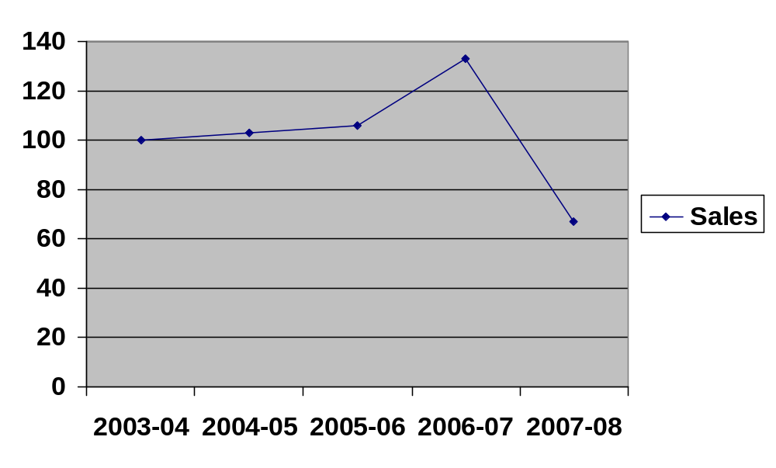
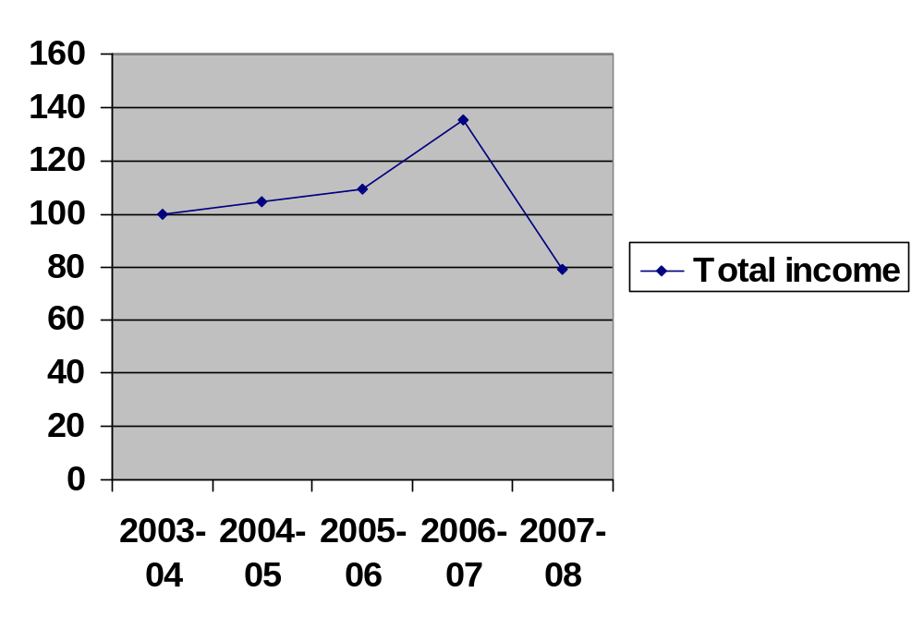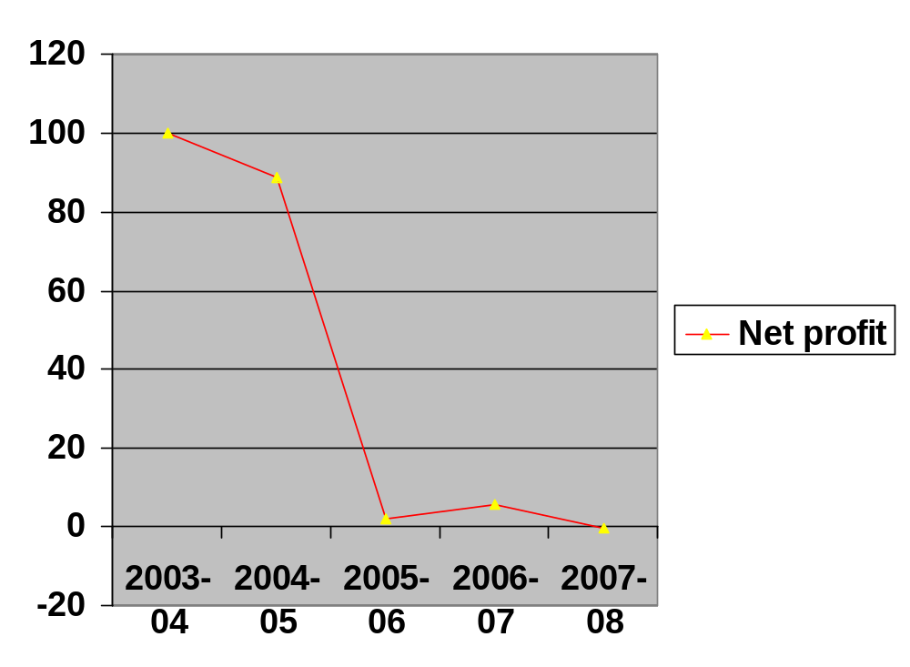

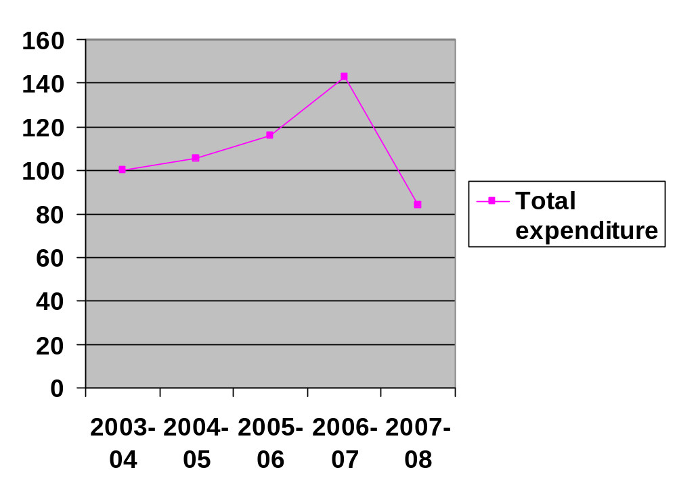

Inference:

By taking 2003-04 as base year (100%) the sales, total income, total expenditure, and net profit during the study period were analysis by taking trend as a tool. The above table shows the movement of variables during the study period. The entire variable shows the lower trend during the 2007-08.

TABLE-32

TREND BALANCE SHEET IN THE STUDY PERIOD (2003-04 to 2007-08)

Particulars | 2003 | 2004 | 2005 | 2006 | 2007
Particulars | Trend | Trend | Trend | Trend | Trend
Share capital | 100 | 101.4674 | 105.2762 | 105.2762 | 105.2762
Reserves and surplus | 100 | 1394.377 | 1425.948 | 1510.871 | 1507.221
Secured loans | 100 | 259.9536 | 192.203 | 151.9654 | 119.0535
Un secured loans | 100 | 100 | 0 | 111.8176 | 85.50756
Fixed assets | 100 | 128.7495 | 106.3919 | 165.5067 | 139.8486
Other assets | 100 | 107.3963 | 679.7068 | 1953.107 | 982.9662
Debtors | 100 | 150.312 | 138.7379 | 158.224 | 96.62074
Cash and bank balance | 100 | 148.6788 | 32.54269 | 156.9481 | 25.94531
Advances and deposits | 100 | 161.5446 | 115.5592 | 49.55876 | 24.58398
Current liability | 100 | 129.2079 | 100.2653 | 277.3509 | 80.70667
Provisions | 100 | 37.25491 | 40.77806 | 119.274 | 40.84315

Inference:
Trend Percentages of Balance Sheet is done by taking 100 as base for all financial years 2004 to 2008. Fixed assets have been decreased during the period 2007-08.current assets, Current liabilities and provisions were fluctuating during the study period. Therefore the balance sheet total shows an increasing trend in the figures.

CHAPTER- V

FINDINGS AND SUGGESTIONS

Contents:

5.1 Findings

5.2 Suggestions

5.1 FINDINGS
- The current ratio is more than 2% in all the first four years. But in 2006-2007 the current ratio is slightly lower than the normal. This shows that the company is enjoying credit worthiness.

- The liquid ratio during the study period except in the year 2007-08 is more than the normal (i.e.) 1:1. Hence the firm is controlling its stock position because there is linear relationship between current ratio and liquid ratio.

- There is fluctuation in the absolute ratio for all the years.

- In all the years the debt equity is more, when compared with borrowings. Hence the company is maintaining its debt position.

- The proprietary ratio during the study period to the total assets is more than the 2/3. During 2004-05 it is more than 50%

- During the year 2004-05 it is 66.17% which shows higher position of cost of goods sold .But at the same time during 2007-08 it is only 6.95.

- The sale is 4 times more than the fixed assets 2003-04 and 2005-06. It is more than 3 times during 2004-05 and 2006-2007. It is more than 2 times during 2007-08.

- During all the years of study period the sales is 2 to 7 times more than the working capital.

- During all the study period years the relationship between sales to total assets is high.

- The sales are in between 1.5 and 3.5 times more than the proprietor's funds. It shows the firms is maintaining the better utilization of own funds.

- The Net profit from the year 2005-06 is very less and in the year 2007-08 the company made a loss.

- During 2007-08 the gross profit position is 6.70%. But in 2003-04 it was 12.9 %.and it was fluctuating more than the base year in all other years of the study period.

- During 2003-04 it was 6.32% on sales and in 2004-05 it was 5.45. But in all other 3 years it is less than 1% and even negative in the year 2007-08. This means that either there is any defect in pricing the product or excess non-value added expenditures which reduces the net profit of the company. The sales of the organization are also decreasing and hence management must take care of the quality and market situations into consideration to resolve the issue so that it may bring good profits to the organization.

- The administration and selling expenses during 2007-08 is very high when compared to previous year's %age as they were in between 13-20% of sales. This may also be one of the reasons to a net loss in that year.

- The sales figure increasing year after year. It increased about Rs.48,40,665. Administrative and other expenses were fluctuating. The other income of the company was increased year by year.

- Net profit has been reduced from 100% to (0.25) %.

- During the period of study the total income was less than the total expenditure which is not good for the company.

- Share capital has been increased in 2004-05 and after that it remained constant.

- A sundry debtor has been fluctuating over the years. It increased during the first four years of the study period from 100% to 158.22% i.e. from 2003-04 to 2006-07 and then from there it decreased to 96.62% in the year 2007-08

5.2 Suggestion
- The company's profit over the years has been decreasing when compared to previous years and even it incurred loss in the last year. The company must increase the profit in future. The company must take steps to increase the profit level.

- The Gross Profit ratio can be improved by increasing the gross profit and the factors decreasing the gross profit ratio should be thoroughly checked timely whither they are operating factors or any misleading factors.

- A Non-operating expense of the company is high. So the management should take necessary steps to reduce the non-operating expenses. The management should take steps to reduce the borrowed capital.

- Net fixed asset of the company has increased and even though they are not utilizing the enhanced technology to increase sales. So the management should take initiative steps for the proper utilization of the resources.

- The liquidity position of the company is quite satisfactory. And this must be improved further for the purpose of proper utilization of the liquid assets of the company.

- The cash ratio position of the company is not satisfactory for the last five years. It is fluctuating over the years and there is no standard ration maintained. So the management should take steps to improving the cash position of the company.

- Debt equity ratio has not satisfactory for the past two years. So the company has enough scope for the more long-term borrowings from the outsiders as its current ratio is also good and has a sufficient amount of current assets..

- The sales of the organization can be further increased by improving the quality through optimum utilization of company's resources (i.e. assets, raw materials, credit system, etc.) and that in turn will increase the overall profits of the organization.

- The Management must find out the reasons for the decrease in sales and must take appropriate measures.

- The Management must also study the market position and it also find the demand prevailing in the market for the products and thus this will guide them to enhance their sales volume.

CONCLUSION AND BIBLIOGRAPHY

Contents:

6.1 Conclusion

6.2 Bibliography

6.1 CONCLUSION:-

On studying the financial performance of Vijay Textiles Ltd. for a period of five years from 2003-04 to 2007-08, the study reveals that the financial performance is better. Vijay Textiles Ltd has been able to maintain optimal cost positioning. Despite price drops in various products, the company has been able to maintain and grow its market share to make strong margins in market, contributing to the strong financial position of the company. The company was able to meet its entire requirements for capital expenditures and higher level of working capital commitment with higher volume of operations and from its operating cash flows.
The export sales of Vijay Textiles Ltd are only 30% of total sales during 2007-08. Present scenario of steel industry indicates the need for more steel even with the cause of lower production facilities. The company should now give more importance to exports because it provides good net sales realization but also export benefits.
The following table the contribution of export sales to sales and the justification for the above suggestions.

Year | 2003-04 | 2004-05 | 2005-06 | 2006-07 | 2007-08
Export sales | 15,215,051 | 13,911,743 | 21,507,759 | 27,030,104 | 9,047,623
Domestic  sales | 153,841,067 | 159,985,040 | 157,723,562 | 198,220,766 | 104,047,665
Total sales | 169,056,118 | 173,896,783 | 179,231,321 | 225,250,870 | 113,095,288
% Export  sale to total  sale | 9 | 8 | 12 | 12 | 8

As it is noticed due to the market situation prevailing the total sales of the organization were affected. Considering the fact that the margins in the export sales are low, but have the potential to raise in the near future, the company can maintain a minimum level of presence in the global market.

6.2 BIBLIOGRAPHY

- Annual Reports Of Vijay Textiles Ltd
- General Articles and Magazines Of Vijay Textiles Ltd.
- T.S Reddy and Y. Hariprasad Reddy, Financial management, New Delhi: Tata Mc Graw hill Publishing company Ltd., 1999, 3rd edition
- M.A Sahaf Management and Accounting 4th Edition, Tata McGraw Hill Publishing Company Ltd, 5th Reprint - 2006 - New Delhi.
- IM .Pandey, Financial Management 8th Edition, Vikas Publishing house Pvt Ltd, 6th Reprint -2006- New Delhi.
- IM .Pandey, Working capital Management 8th Edition, Vikas Publishing house Pvt Ltd, 6th Reprint -2006- New Delhi
- R.K. Sharma & S.K. Gupta, Financial Management
- R.P. Rustagi, Financial Management

