GRADUATE RECORD EXAMINATIONS®

Practice General Test #1
Section 3: Quantitative Reasoning
Section 4: Quantitative Reasoning

Copyright © 2010 by Educational Testing Service. All rights reserved. ETS, the E T S logo, GRADUATE RECORD EXAMINATIONS, and GRE are registered trademarks of Educational Testing Service (E T S) in the United States and other countries.

Revised Graduate Record Examinations® General Test

Practice Test Number 1

Instructions for the Verbal Reasoning and Quantitative Reasoning Sections

Information for screen reader users:
This document has been created to be accessible to individuals who use screen readers. You may wish to consult the manual or help system for your screen reader to learn how best to take advantage of the features implemented in this document. Please consult the separate document, GRE Screen Reader Instructions.doc, for important details.

This practice test includes content that some users may wish to skip. For example, some questions require you to complete sentences or longer texts from among several choices. For those questions where it might be helpful to hear the available choices in context, text of the choices in context is included. However, some users may wish to skip this material. Similarly, some questions include detailed figure descriptions that some users may wish to skip because they can get the required information from the accompanying tactile or large print figures. In each case, material that may be skipped is delineated by statements like “Begin skippable content” and “End skippable content” each in the Heading 6 style.

As a reminder, standard timing for each section of the test is provided in the table below:

Section Order | Section Name | Standard Time
Analytical Writing 1 | Analyze an Issue | 30 minutes
Analytical Writing 2 | Analyze an Argument | 30 minutes
1 | Verbal Reasoning | 35 minutes
2 | Verbal Reasoning | 35 minutes
3 | Quantitative Reasoning | 40 minutes
4 | Quantitative Reasoning | 40 minutes

The Quantitative sections include figures and their descriptions. In addition, separate figure supplements, in large print (18 points) and raised-line formats, are available. The large print figure supplement may be downloaded from http://www.ets.org/gre/disabilities. To obtain the raised-line figure supplement or if you have difficulty locating the large print figure supplement on the GRE® web site, contact E T S Disability Services Monday-Friday 8:30 a.m. to 5 p.m. New York time, 1-609-771-7780, 1-866-387-8602 (toll free for test takers in the United States, U.S. Territories, and Canada). E-mail: stassd@ets.org.

Important Notes
In the actual test, your scores for the multiple-choice sections will be determined by the number of questions you answer correctly. Nothing is subtracted from a score if you answer a question incorrectly. Therefore, to maximize your scores it is better for you to guess at an answer than not to respond at all. Work as rapidly as you can without losing accuracy. Do not spend too much time on questions that are too difficult for you. Go on to the other questions and come back to the difficult ones later.

Some or all of the passages in this test have been adapted from published material to provide the examinee with significant problems for analysis and evaluation. To make the passages suitable for testing purposes, the style, content, or point of view of the original may have been altered. The ideas contained in the passages do not necessarily represent the opinions of the Graduate Record Examinations Board or Educational Testing Service.

You may use a calculator in the Quantitative Reasoning sections only. You will be provided with a basic calculator and cannot use any other calculator, except as an approved accommodation.

Marking Your Answers
In the actual test, all answers must be entered in the test book (or in the supervisor’s copy of the test book if you are not using a print format test). If answers are being recorded in a large print test book, the directions for marking answers are slightly different because answers entered in large print test books are not machine-scored.
If your answers are being entered in a large print test book, make sure your marks are clear and unambiguous. Additional instructions for marking answers in large print test books are provided with the large print practice tests.

The following instructions describe how answers must be filled in if using a regular print test book, whether you are entering your own answers or a scribe is entering them at your direction.

Be sure that each mark is dark and completely fills the circle.

Any stray marks that lie in or near a circle must be erased carefully. If you change an answer, be sure that all previous marks are erased completely. Stray marks and incomplete erasures may be read as intended answers. You may work out your answers in the blank areas of the test book, but do not work out answers near the circles. Scratch paper will not be provided, except as an approved accommodation.

Question Formats
This practice test may include questions that would not be used in an actual test administered in an alternate format because they have been determined to be less suitable for presentation in such formats.

The questions in these sections have several different formats. A brief description of these formats and instructions for entering your answer choices are given below.

Multiple-Choice Questions—Select One Answer Choice
These standard multiple-choice questions require you to select just one answer choice from a list of options. You will receive credit only if you mark the single correct answer choice and no other.

Example:
What city is the capital of France?
A. Rome
B. Paris
C. London
D. Cairo

In this example, B, Paris, should be marked.

Multiple-Choice Questions—Select One or More Answer Choices
Some of these questions specify how many answer choices you must select; others require you to select all that apply. In either case, to receive credit all of the correct answer choices must be marked. In printed versions of the test, these questions are distinguished by the use of a square box to select an answer choice.

Example:
Select all that apply.

Which of the following countries are in Africa?
A. China
B. Congo
C. France
D. Kenya

In this example, B and D (Congo and Kenya) should be marked.

Column Format Questions
This question type presents the answer choices in groups (presented as columns in the printed version of the test). You must pick one answer choice from each group. You will receive credit only if you mark the correct answer choice in each group. In the following example, there is a sentence with two blanks, each indicating that something has been omitted. For each question of this type, first you will hear the text with the word “BLANK” in place of the omitted material. Next, you will hear the text again, but in place of each blank, you will hear three lettered options for filling that blank. The set of lettered options is formatted as bold and enclosed in parentheses. Each option consists of a word or phrase.

For questions containing one or two blanks, following the list of answer choices are up to nine readings of the text, one for each answer choice combination. The group of readings begins with a “Begin Skippable Content” level-6 heading and ends with an “End Skippable Content” level-6 heading. Each reading consists of the option letter or letters, the words or phrases being combined, and the text with the combination of the words or phrases inserted into the blanks.

For questions containing three blanks, the choices will not be read in context because it has been determined that replaying the question for all possible combinations of answer choices is not a useful way to present these questions.

Example:
This question has two blanks.

Complete the following sentence.
BLANK is the capital of BLANK.

Now listen to the text with the three options inserted in place of each blank.

(A. Paris, B. Rome, C. Cairo) is the capital of (D. Canada, E. France, F. China).

Indicate your two answer choices and skip hearing the answer choices in context or go on to hear them in context before indicating your answer choices. Fill all blanks in the way that best completes the text.

Begin skippable content.
Answer Choices in Context:
A, D. Paris, Canada. Paris is the capital of Canada.
A, E. Paris, France. Paris is the capital of France.
A, F. Paris, China. Paris is the capital of China.
B, D. Rome, Canada. Rome is the capital of Canada.
B, E. Rome, France. Rome is the capital of France.
B, F. Rome, China. Rome is the capital of China.
C, D. Cairo, Canada. Cairo is the capital of Canada.
C, E. Cairo, France. Cairo is the capital of France.
C, F. Cairo, China. Cairo is the capital of China.

End skippable content.

Indicate your two answer choices. Fill all blanks in the way that best completes the text.

In this example, choice A, Paris (from the group A, B, C), and E, France (from the group D, E, F), should be indicated as the answer.

Numeric Entry Questions
These questions require a number to be entered by marking entries in a grid according to the following instructions.

Your answer may be an integer, a decimal, or a fraction, and it may be negative.
Equivalent forms of the correct answer, such as 2.5 and 2.50, are all correct. Although fractions do not need to be reduced to lowest terms, they may need to be reduced to fit in the grid.
Enter the exact answer unless the question asks you to round your answer.
If a question asks for a fraction, the grid will have a built-in division slash. Otherwise, the grid will have a decimal point.

The instructions for marking the entries will depend on whether a regular print or a large print test is being used to record your answers. If your answers are being entered into a regular print edition of the test, the following instructions apply:

Start your answer in any column, space permitting. Fill in no more than one entry in any column of the grid. Columns not needed should be left blank.
Write your answer in the boxes at the top of the grid and fill in the corresponding circles. You will receive credit only if your grid entries are clearly marked, regardless of the number written in the boxes at the top.

If your answers are being entered into a large print edition of the test, instead of filling in circles on the grid in steps 5 and 6, you will be asked to circle those entries.

Section 3 follows. In an actual test, testing time will resume when you begin the section 3

Revised G R E Practice Test Number 1.

Section 3. Quantitative Reasoning.

25 Questions.

Information for screen reader users:
This document has been created to be accessible to individuals who use screen readers. You may wish to consult the manual or help system for your screen reader to learn how best to take advantage of the features implemented in this document. Please consult the separate document, GRE Screen Reader Instructions.doc, for important details.

Section Directions
For each question, indicate the best answer, using the directions given.
Notes: All numbers used are real numbers.
All figures are assumed to lie in a plane unless otherwise indicated.
Geometric figures, such as lines, circles, triangles, and quadrilaterals, are not necessarily drawn to scale. That is, you should not assume that quantities such as lengths and angle measures are as they appear in a figure. You should assume, however, that lines shown as straight are actually straight, points on a line are in the order shown, and more generally, all geometric objects are in the relative positions shown. For questions with geometric figures, you should base your answers on geometric reasoning, not on estimating or comparing quantities from how they are drawn in the geometric figure.
Coordinate systems, such as x y planes and number lines, are drawn to scale; therefore, you can read, estimate, or compare quantities in such figures from how they are drawn in the coordinate system.
Graphical data presentations, such as bar graphs, circle graphs, and line graphs, are drawn to scale; therefore, you can read, estimate, or compare data values from how they are drawn in the graphical data presentation.

For each of Questions 1 through 9, compare Quantity A and Quantity B, using the additional information given, if any. Select one of the following four answer choices. A symbol that appears more than once in a question has the same meaning throughout the question.
A. Quantity A is greater.
B Quantity B is greater.
C. The two quantities are equal.
D. The relationship cannot be determined from the information given.
Example 1:
Quantity A: 2 times 6
Quantity B: 2 + 6
Solution: Quantity A is equal to 12 and Quantity B is equal to 8, so the correct answer for Example 1 is answer choice A, Quantity A is greater.
Example 2:
Refer to the figure.
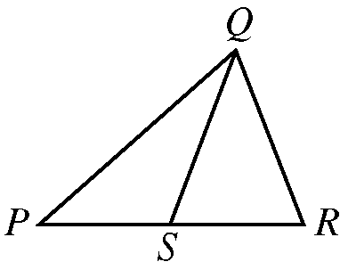
Figure for Example 2

Begin skippable figure description.
The figure shows triangle PQR, where P is the leftmost vertex of the horizontal base PR and vertex Q is above PR. Point S lies on horizontal base PR and appears to be the midpoint of PR. Line segment QS is drawn from vertex Q to point S. The lengths of PS and SR appear to be equal.

End skippable figure description.
Quantity A: PS
Quantity B: SR
Solution: The correct answer for Example 2 is answer choice D. The relationship between PS and SR cannot be determined from the information given since equal measures cannot be assumed, even though PS and SR appear to be equal in the figure.

Question 1.
Refer to the figure.
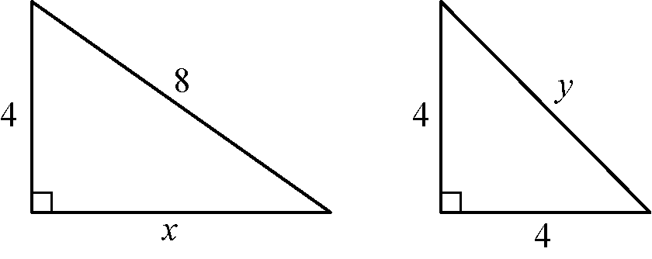
Figure for Question 1

Begin skippable figure description.
The figure shows two right triangles. One of the triangles has a leg of length 4 and a leg of length x, and a hypotenuse of length 8. The other triangle has two legs, each of which is of length 4, and a hypotenuse of length y.

End skippable figure description.
Quantity A: x
Quantity B: y
A. Quantity A is greater.
B. Quantity B is greater.
C. The two quantities are equal.
D. The relationship cannot be determined from the information given.
From the answer choices given, select and indicate the one that describes the relationship between quantity A and quantity B.

Question 2.
It is given that
open parenthesis, x minus 2y, close parenthesis, times open parenthesis, x + 2y, close parenthesis, = 4

Quantity A: x squared, minus, 4 times the quantity y squared
Quantity B: 8
A. Quantity A is greater.
B. Quantity B is greater.
C. The two quantities are equal.
D. The relationship cannot be determined from the information given.
From the answer choices given, select and indicate the one that describes the relationship between quantity A and quantity B.

Question 3.
A certain recipe requires three halves cups of sugar and makes 2 dozen cookies.
(1 dozen = 12)
Quantity A: The amount of sugar required for the same recipe to make 30 cookies
Quantity B: 2 cups
A. Quantity A is greater.
B. Quantity B is greater.
C. The two quantities are equal.
D. The relationship cannot be determined from the information given.
From the answer choices given, select and indicate the one that describes the relationship between quantity A and quantity B.

Question 4.
A power station is located on the boundary of a square region that measures 10 miles on each side. Three substations are located inside the square region.
Quantity A: The sum of the distances from the power station to each of the substations
Quantity B: 30 miles
A. Quantity A is greater.
B. Quantity B is greater.
C. The two quantities are equal.
D. The relationship cannot be determined from the information given.
From the answer choices given, select and indicate the one that describes the relationship between quantity A and quantity B.

Question 5.
It is given that
6 is less than x, which is less than 7,
and
y = 8
Quantity A: the fraction x over y
Quantity B: 0.85
A. Quantity A is greater.
B. Quantity B is greater.
C. The two quantities are equal.
D. The relationship cannot be determined from the information given.
From the answer choices given, select and indicate the one that describes the relationship between quantity A and quantity B.

Question 6.
Refer to the figure.
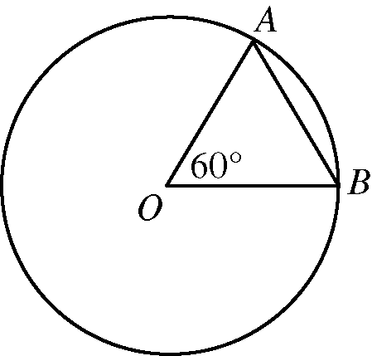
Figure for Question 6

Begin skippable figure description.
The figure accompanying this question consists of a circle and triangle B O A, where O is the center of the circle and A and B are points that lie on the circle. In the triangle, the measure of angle B O A is 60 degrees.

End skippable figure description.
It is given that O is the center of the circle and the perimeter of triangle B O A is 6.
Quantity A: The circumference of the circle
Quantity B: 12
A. Quantity A is greater.
B. Quantity B is greater.
C. The two quantities are equal.
D. The relationship cannot be determined from the information given.
From the answer choices given, select and indicate the one that describes the relationship between quantity A and quantity B.

Question 7.
Quantity A: The standard deviation of a set of 5 different integers, each of which is between 0 and 10
Quantity B: The standard deviation of a set of 5 different integers, each of which is between 10 and 20
A. Quantity A is greater.
B. Quantity B is greater.
C. The two quantities are equal.
D. The relationship cannot be determined from the information given.
From the answer choices given, select and indicate the one that describes the relationship between quantity A and quantity B.

Question 8.
It is given that x is greater than 1.
Quantity A: 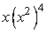x times, the fourth power of, open parenthesis, x squared, close parenthesis
Quantity B: 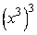open parenthesis, x cubed, close parenthesis, to the third power
A. Quantity A is greater.
B. Quantity B is greater.
C. The two quantities are equal.
D. The relationship cannot be determined from the information given.
From the answer choices given, select and indicate the one that describes the relationship between quantity A and quantity B.

Question 9.
It is given that x is not equal to 0.
Quantity A: the absolute value of x + the absolute value of negative 2
Quantity B: the absolute value of the quantity x minus 2
A. Quantity A is greater.
B. Quantity B is greater.
C. The two quantities are equal.
D. The relationship cannot be determined from the information given.
From the answer choices given, select and indicate the one that describes the relationship between quantity A and quantity B.

Questions 10 through 25 have several different answer formats, including both selecting answers from a list of answer choices and numeric entry. With each question, answer format instructions will be given.

Numeric Entry Questions
These questions require a number to be entered by marking entries in a grid according to the following instructions
Your answer may be an integer, a decimal, or a fraction, and it may be negative.
Equivalent forms of the correct answer, such as 2.5 and 2.50, are all correct. Although fractions do not need to be reduced to lowest terms, they may need to be reduced to fit in the grid.
Enter the exact answer unless the question asks you to round your answer.
If a question asks for a fraction, the grid will have a built-in division slash. Otherwise, the grid will have a decimal point.

The instructions for marking the entries will depend on whether a regular print or a large print test is being used to record your answers. If your answers are being entered into a regular print edition of the test, the following instructions apply:
Start your answer in any column, space permitting. Fill in no more than one entry in any column of the grid. Columns not needed should be left blank.
Write your answer in the boxes at the top of the grid and fill in the corresponding circles. You will receive credit only if your grid entries are clearly marked, regardless of the number written in the boxes at the top.

If your answers are being entered into a large print edition of the test, instead of filling in circles on the grid in steps 5 and 6, you will be asked to circle those entries.

Question 10.
This question has five answer choices, labeled A through E. Select the best one of the answer choices given.
The system of equations
7x + 3y = 12, and
3x + 7y = 6
is given.
If x and y satisfy the system of equations given, what is the value of x minus y?
A. two thirds
B. three halves
C. 1
D. 4
E. 6
Select and indicate the best one of the answer choices given.
Question 11.
This question has five answer choices, labeled A through E. Select all the answer choices that apply.
In triangle ABC, the measure of angle A is 25° and the measure of angle B is greater than 90°. Which of the following could be the measure of angle C?
Indicate all such measures.
A. 12°
B. 15°
C. 45°
D. 50°
E. 70°
Select and indicate all the answer choices that apply. The correct answer to a question of this type could consist of as few as one, or as many as all five of the answer choices.
Question 12.
This question has five answer choices, labeled A through E. Select the best one of the answer choices given.
What is the least integer n such that the fraction with numerator 1, and denominator 2 to the power n is less than 0.001 ?
A. 10
B. 11
C. 500
D. 501
E. There is no such least integer.
Select and indicate the best one of the answer choices given.
Question 13.
This question has five answer choices, labeled A through E. Select the best one of the answer choices given.
In the sunshine, an upright pole 12 feet tall is casting a shadow 8 feet long. At the same time, a nearby upright pole is casting a shadow 10 feet long. If the lengths of the shadows are proportional to the heights of the poles, what is the height, in feet, of the taller pole?
A. 10
B. 12
C. 14
D. 15
E. 18
Select and indicate the best one of the answer choices given.
Question 14.
This question has five answer choices, labeled A through E. Select the best one of the answer choices given.
If k is the smallest prime number greater than 21 and b is the largest prime number less than 16, then kb =
A. 299
B. 323
C. 330
D. 345
E. 351
Select and indicate the best one of the answer choices given.
Question 15.
This question does not have any answer choices; it is a numeric entry question.
To answer this question, enter a number in the answer space provided. The number entered cannot be a fraction.
The total amount of Judy’s water bill for the last quarter of the year was $40.50. The bill consisted of a fixed charge of $13.50 plus a charge of $0.0075 per gallon for the water used in the quarter. For how many gallons of water was Judy charged for the quarter?
To answer this question, enter a number in the answer space provided. The number can include a decimal point, and can be positive, negative, or 0. The number entered cannot be a fraction.

Question 16.
This question has five answer choices, labeled A through E. Select the best one of the answer choices given.
List R: 28, 23, 30, 25, 27
List S: 22, 19, 15, 17, 20
The median of the numbers in list R is how much greater than the median of the numbers in list S?
A. 8
B. 10
C. 12
D. 13
E. 15
Select and indicate the best one of the answer choices given.

Questions 17 through 20 are based on the following data.
Refer to the figure.
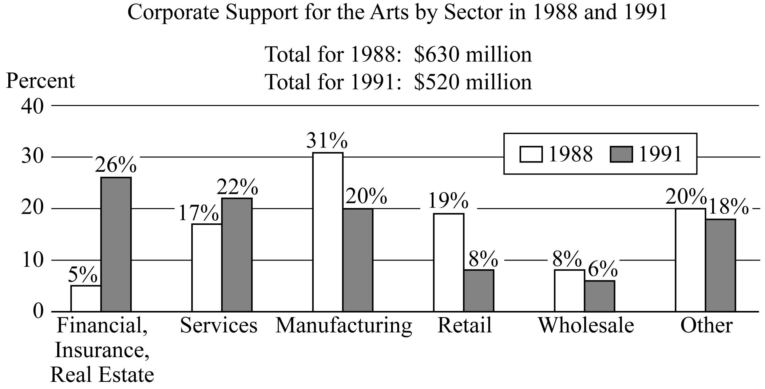
Data for Questions 17 through 20

Begin skippable data description.
The data is given in a bar graph. The title of the graph is Corporate Support for the Arts by Sector in 1988 and 1991. Under the title are two statements: “Total for 1988: $630 million” and “Total for 1991: $520 million”.
There are six sectors listed along the horizontal axis of the graph. Horizontal gridlines are drawn at 0%, 10%, 20%, 30%, and 40%.
For each of the six sectors the bars in the graph are as follows.
1. Financial Insurance, Real Estate sector. Bar for 1988, 5%. Bar for 1991, 26%.
2. Services sector. Bar for 1988, 17%. Bar for 1991, 22%.
3. Manufacturing sector. Bar for 1988, 31%. Bar for 1991, 20%.
4. Retail sector. Bar for 1988, 19%. Bar for 1991, 8%.
5. Wholesale sector. Bar for 1988, 8%. Bar for 1991, 6%.
6. Other sector. Bar for 1988, 20%. Bar for 1991, 18%.

End skippable data description.

Question 17.
This question does not have any answer choices; it is a numeric entry question.
To answer this question, enter a number in the answer space provided. The number entered cannot be a fraction.
The two corporate sectors that increased their support for the arts from 1988 to 1991 made a total contribution in 1991 of approximately how many million dollars?
Give your answer to the nearest 10 million dollars.
To answer this question, enter a number in the answer space provided. The number can include a decimal point, and can be positive, negative, or 0. The number entered cannot be a fraction.
Question 18.
This question has five answer choices, labeled A through E. Select the best one of the answer choices given.
How many of the six corporate sectors listed each contributed more than $60 million to the arts in both 1988 and 1991 ?
A. One
B. Two
C. Three
D. Four
E. Five
Select and indicate the best one of the answer choices given.
Question 19.
This question has five answer choices, labeled A through E. Select the best one of the answer choices given.
From 1988 to 1991, which corporate sector decreased its support for the arts by the greatest dollar amount?
A Services
B. Manufacturing
C. Retail
D. Wholesale
E. Other
Select and indicate the best one of the answer choices given.

Question 20.
This question has five answer choices, labeled A through E. Select the best one of the answer choices given.
Of the retail sector’s 1991 contribution to the arts, one fourth went to symphony orchestras and one half of the remainder went to public television. Approximately how many million dollars more did the retail sector contribute to public television that year than to symphony orchestras?
A 5.2
B. 6.3
C. 10.4
D. 13.0
E. 19.5
Select and indicate the best one of the answer choices given.

Question 21.
This question has three answer choices, labeled A through C. Select all the answer choices that apply.
The total number of recording titles distributed by music distributors L and M is 9,300. The number of recording titles distributed by L is 7,100, and the number of recording titles distributed by M is 5,200. Which of the following statements must be true?
Indicate all such statements.
A. More than half of the titles distributed by L are also distributed by M.
B. More than half of the titles distributed by M are also distributed by L.
C. No titles are distributed by both L and M.
Select and indicate all the answer choices that apply. The correct answer to a question of this type could consist of as few as one, or as many as all three of the answer choices.

Question 22.
This question has five answer choices, labeled A through E. Select the best one of the answer choices given.
If c and d are positive integers and m is the greatest common factor of c and d, then m must be the greatest common factor of c and which of the following integers?
A. c + d
B. 2 + d
C. cd
D. 2d
E. d squared

Select and indicate the best one of the answer choices given.

Question 23.
This question does not have any answer choices; it is a numeric entry question.
To answer this question, enter a number in the answer space provided. The number entered cannot be a fraction.
The average (arithmetic mean) of the 11 numbers in a list is 14. If the average of 9 of the numbers in the list is 9, what is the average of the other 2 numbers?
To answer this question, enter a number in the answer space provided. The number can include a decimal point, and can be positive, negative, or 0. The number entered cannot be a fraction.
Question 24.
This question has five answer choices, labeled A through E. Select the best one of the answer choices given.
Of the 750 participants in a professional meeting, 450 are female and one half of the female and one fourth of the male participants are less than thirty years old. If one of the participants will be randomly selected to receive a prize, what is the probability that the person selected will be less than thirty years old?
A. 1 eighth
B. 1 third
C. 3 eighths
D. 2 fifths
E. 3 fourths
Select and indicate the best one of the answer choices given.

Question 25.
This question has five answer choices, labeled A through E. Select the best one of the answer choices given.
In the x y plane, what is the slope of the line whose equation is 3x minus 2y = 8 ?
A. negative 4
B. negative 8 thirds
C. 2 thirds
D. 3 halves
E. 2

Select and indicate the best one of the answer choices given.

This is the end of Section 3 of Revised GRE Practice Test Number 1. In an actual test, once you complete a section you may not return to it. The answer key for this section is in a separate document.

Revised G R E Practice Test Number 1.

Section 4. Quantitative Reasoning.

25 Questions.

Information for screen reader users:
This document has been created to be accessible to individuals who use screen readers. You may wish to consult the manual or help system for your screen reader to learn how best to take advantage of the features implemented in this document. Please consult the separate document, GRE Screen Reader Instructions.doc, for important details.

Section Directions
For each question, indicate the best answer, using the directions given.
Notes: All numbers used are real numbers.
All figures are assumed to lie in a plane unless otherwise indicated.
Geometric figures, such as lines, circles, triangles, and quadrilaterals, are not necessarily drawn to scale. That is, you should not assume that quantities such as lengths and angle measures are as they appear in a figure. You should assume, however, that lines shown as straight are actually straight, points on a line are in the order shown, and more generally, all geometric objects are in the relative positions shown. For questions with geometric figures, you should base your answers on geometric reasoning, not on estimating or comparing quantities from how they are drawn in the geometric figure.
Coordinate systems, such as x y planes and number lines, are drawn to scale; therefore, you can read, estimate, or compare quantities in such figures from how they are drawn in the coordinate system.
Graphical data presentations, such as bar graphs, circle graphs, and line graphs, are drawn to scale; therefore, you can read, estimate, or compare data values from how they are drawn in the graphical data presentation.

For each of Questions 1 through 9, compare Quantity A and Quantity B, using the additional information given, if any. Select one of the following four answer choices. A symbol that appears more than once in a question has the same meaning throughout the question.
A. Quantity A is greater.
B Quantity B is greater.
C. The two quantities are equal.
D. The relationship cannot be determined from the information given.
Example 1:
Quantity A: 2 times 6
Quantity B: 2 + 6
Solution: Quantity A is equal to 12 and Quantity B is equal to 8, so the correct answer for Example 1 is answer choice A, Quantity A is greater.
Example 2:
Refer to the figure.
Figure for Example 2

Begin skippable figure description.
The figure shows triangle PQR, where P is the leftmost vertex of the horizontal base PR and vertex Q is above PR. Point S lies on horizontal base PR and appears to be the midpoint of PR. Line segment QS is drawn from vertex Q to point S. The lengths of PS and SR appear to be equal.

End skippable figure description.
Quantity A: PS
Quantity B: SR
Solution: The correct answer for Example 2 is answer choice D. The relationship between PS and SR cannot be determined from the information given since equal measures cannot be assumed, even though PS and SR appear to be equal in the figure.

Question 1.
It is given that x is a positive integer and y is a negative integer.
Quantity A: x minus y
Quantity B: y minus x
A. Quantity A is greater.
B. Quantity B is greater.
C. The two quantities are equal.
D. The relationship cannot be determined from the information given.
From the answer choices given, select and indicate the one that describes the relationship between quantity A and quantity B.

Question 2.
The probability that events E and F will both occur is 0.42.
Quantity A: The probability that event E will occur
Quantity B: 0.58
A. Quantity A is greater.
B. Quantity B is greater.
C. The two quantities are equal.
D. The relationship cannot be determined from the information given.
From the answer choices given, select and indicate the one that describes the relationship between quantity A and quantity B.

Question 3.
Refer to the figure.
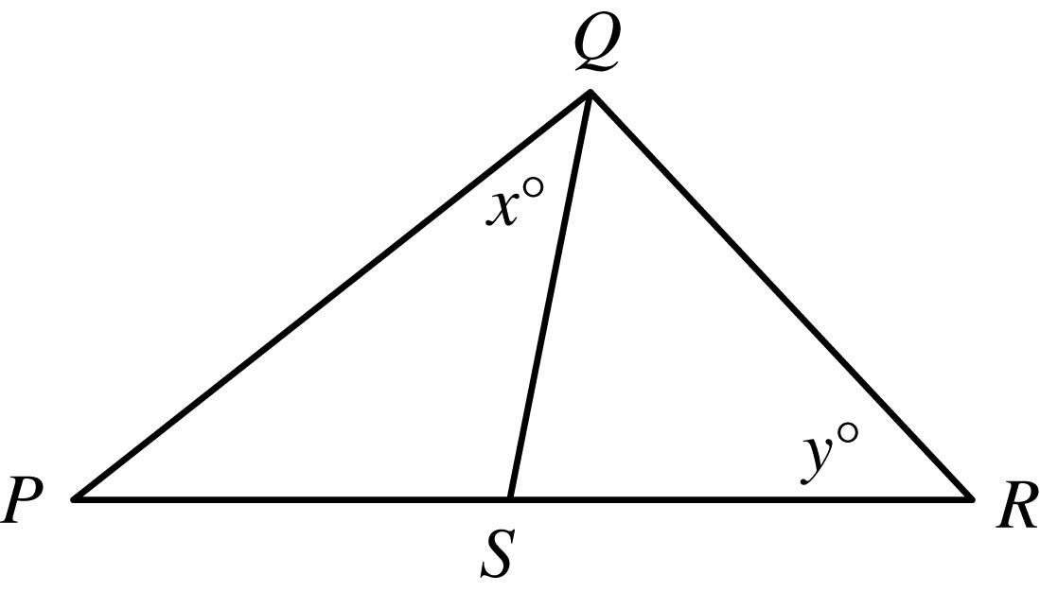
Figure for Question 3

Begin skippable figure description.
The figure accompanying this question consists of a large triangle PQR. Side PR is horizontal, with point R to the right of point P, and vertex Q lies above side PR. Point S lies on side PR and line segment QS divides the large triangle PQR into two smaller triangles, PQS and QRS. The measure of angle PQS is x degrees, and the measure of angle QRS is y degrees.

End skippable figure description.
It is given that the length of line segment PS is equal to the length of line segment SR.

Quantity A: x
Quantity B: y
A. Quantity A is greater.
B. Quantity B is greater.
C. The two quantities are equal.
D. The relationship cannot be determined from the information given.
From the answer choices given, select and indicate the one that describes the relationship between quantity A and quantity B.

Question 4.
It is given that a and b are positive integers.
Quantity A: The fraction a over b
Quantity B: 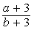The fraction with numerator a + 3. and denominator b + 3
A. Quantity A is greater.
B. Quantity B is greater.
C. The two quantities are equal.
D. The relationship cannot be determined from the information given.
From the answer choices given, select and indicate the one that describes the relationship between quantity A and quantity B.

Question 5.
The arithmetic mean of 100 measurements is 23, and the arithmetic mean of 50 additional measurements is 27.
Quantity A: The arithmetic mean of the 150 measurements
Quantity B: 25
A. Quantity A is greater.
B. Quantity B is greater.
C. The two quantities are equal.
D. The relationship cannot be determined from the information given.
From the answer choices given, select and indicate the one that describes the relationship between quantity A and quantity B.

Question 6.
Refer to the figure.
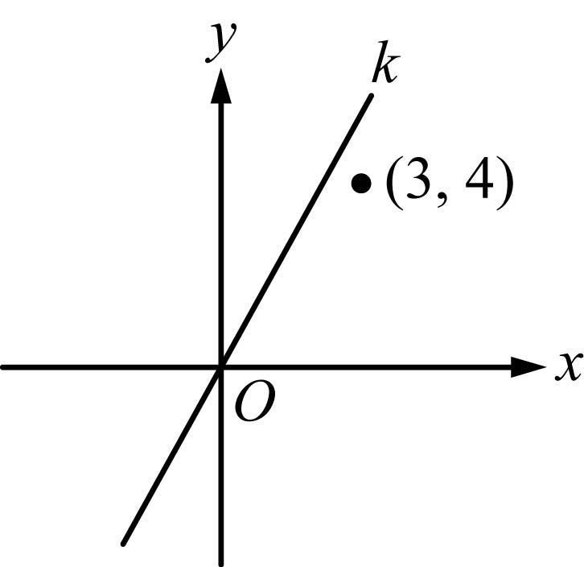
Figure for Question 6

Begin skippable figure description.
The figure accompanying this question consists of an x y plane in which there is a line k that extends upward from the lower left part of the plane, through the origin, to the upper right part of the plane. In addition, the point with coordinates 3 comma 4 is shown. This point lies in the upper right quadrant below line k and above the x axis. The horizontal axis of the x y plane is labeled x, the vertical axis is labeled y, and the origin is labeled O.

End skippable figure description.
Quantity A: The slope of line k
Quantity B: 1
A. Quantity A is greater.
B. Quantity B is greater.
C. The two quantities are equal.
D. The relationship cannot be determined from the information given.
From the answer choices given, select and indicate the one that describes the relationship between quantity A and quantity B.

Question 7.
One of the roots of the equation x squared + kx minus 6 = 0 is 3, and k is a constant.
Quantity A: The value of k
Quantity B: negative 1
A. Quantity A is greater.
B. Quantity B is greater.
C. The two quantities are equal.
D. The relationship cannot be determined from the information given.
From the answer choices given, select and indicate the one that describes the relationship between quantity A and quantity B.

Question 8.
The original price of a suit was 30 percent less than the suit’s $250 suggested retail price. The price at which the suit was sold was 20 percent less than the original price.
Quantity A: The price at which the suit was sold
Quantity B: 50% of the suit’s suggested retail price
A. Quantity A is greater.
B. Quantity B is greater.
C. The two quantities are equal.
D. The relationship cannot be determined from the information given.
From the answer choices given, select and indicate the one that describes the relationship between quantity A and quantity B.

Question 9.
Refer to the figure.
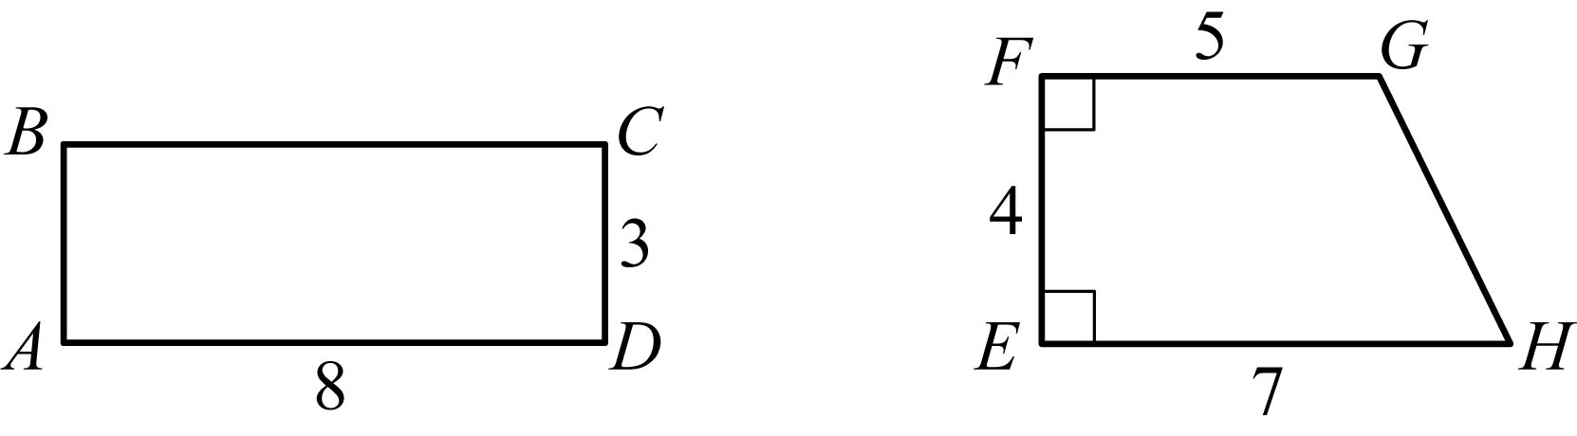
Figure for Question 9

Begin skippable figure description.
The figure accompanying this question consists of rectangle ABCD and trapezoid EFGH. In rectangle ABCD, the length of horizontal side AD is 8 and the length of vertical side CD is 3. In trapezoid EFGH, the leftmost side, E F, is a vertical line segment with endpoint F lying above endpoint E. Side E F meets the two horizontal sides, FG and E H, at right angles. The length of horizontal side FG is 5 and the length of horizontal side E H is 7. The length of vertical side E F is 4 and the length of side GH is not given.

End skippable figure description.
Quantity A: The area of rectangular region ABCD
Quantity B: The area of trapezoidal region EFGH
A. Quantity A is greater.
B. Quantity B is greater.
C. The two quantities are equal.
D. The relationship cannot be determined from the information given.
From the answer choices given, select and indicate the one that describes the relationship between quantity A and quantity B.

Questions 10 through 25 have several different answer formats, including both selecting answers from a list of answer choices and numeric entry. With each question, answer format instructions will be given.

Numeric Entry Questions
These questions require a number to be entered by marking entries in a grid according to the following instructions
1. Your answer may be an integer, a decimal, or a fraction, and it may be negative.
2. Equivalent forms of the correct answer, such as 2.5 and 2.50, are all correct. Although fractions do not need to be reduced to lowest terms, they may need to be reduced to fit in the grid.
3. Enter the exact answer unless the question asks you to round your answer.
4. If a question asks for a fraction, the grid will have a built-in division slash. Otherwise, the grid will have a decimal point.

The instructions for marking the entries will depend on whether a regular print or a large print test is being used to record your answers. If your answers are being entered into a regular print edition of the test, the following instructions apply:
5. Start your answer in any column, space permitting. Fill in no more than one entry in any column of the grid. Columns not needed should be left blank.
6. Write your answer in the boxes at the top of the grid and fill in the corresponding circles. You will receive credit only if your grid entries are clearly marked, regardless of the number written in the boxes at the top.

If your answers are being entered into a large print edition of the test, instead of filling in circles on the grid in steps 5 and 6, you will be asked to circle those entries.

Question 10.
This question has five answer choices, labeled A through E. Select the best one of the answer choices given.
If j and k are integers and j minus k is even, which of the following must be even?
A. k
B. jk
C. j + 2k
D. jk + j
E. jk minus 2j
Select and indicate the best one of the answer choices given.
Question 11.
This question does not have any answer choices; it is a numeric entry question.
To answer this question enter a fraction. Neither the numerator nor the denominator of the fraction can include a decimal point. The fraction does not have to be in lowest terms.
Refer to the figure.
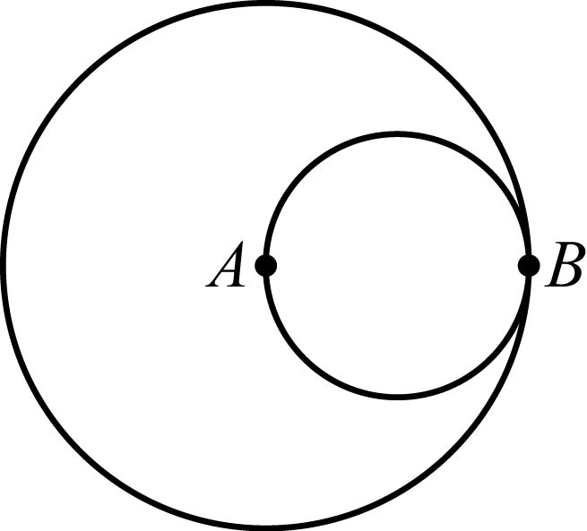
Figure for Question 11

Begin skippable figure description.
The figure accompanying this question consists of a small circle inscribed in a large circle. The two circles are tangent to each other at point B. Point A, which is the center of the larger circle, is on the smaller circle.

End skippable figure description.
The circles shown are tangent at point B. Point A is the center of the larger circle, and line segment AB (not shown) is a diameter of the smaller circle. The area of the smaller circle is what fraction of the area of the larger circle?
To answer this question enter a fraction in the answer space provided. The fraction can be positive or negative. Neither the numerator nor the denominator of the fraction can include a decimal point. The fraction does not have to be in lowest terms.
Question 12.
This question has five answer choices, labeled A through E. Select all the answer choices that apply.
Last year Kate spent between one fourth and one third of her gross income on her mortgage payments. If Kate spent $13,470 on her mortgage payments last year, which of the following could have been her gross income last year?
Indicate all such gross incomes.
A. $40,200
B. $43,350
C. $47,256
D. $51,996
E. $53,808
Select and indicate all the answer choices that apply. The correct answer to a question of this type could consist of as few as one, or as many as all five of the answer choices.
Question 13.
This question has five answer choices, labeled A through E. Select the best one of the answer choices given.
In State X, all vehicle license plates have 2 letters from the 26 letters of the alphabet followed by 3 one digit numbers. How many different license plates can State X have if repetition of letters and numbers is allowed?
A. 23,400
B. 60,840
C. 67,600
D. 608,400
E. 676,000
Select and indicate the best one of the answer choices given.
Question 14.
This question has five answer choices, labeled A through E. Select the best one of the answer choices given.
If p is a negative number and 0 is less than s, which is less than the absolute value of p, which of the following must also be a negative number?
A. open parenthesis, p + s, close parenthesis, squared
B. open parenthesis, p minus s, close parenthesis, squared
C. open parenthesis, s minus p, close parenthesis, squared
D. p squared minus s squared
E. s squared minus p squared
Select and indicate the best one of the answer choices given.
Question 15.
This question has five answer choices, labeled A through E. Select the best one of the answer choices given.
If 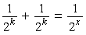 the sum of the two fractions 1 over 2 raised to the power k and 1 over 2 raised to the power k equals the fraction 1 over 2 raised to the power x, then x expressed in terms of k is
A. the fraction k over 2
B. k minus 1
C. k + 1
D. 2k
E. k squared

Select and indicate the best one of the answer choices given.

Question 16.
This question has five answer choices, labeled A through E. Select the best one of the answer choices given.
Refer to the figure.
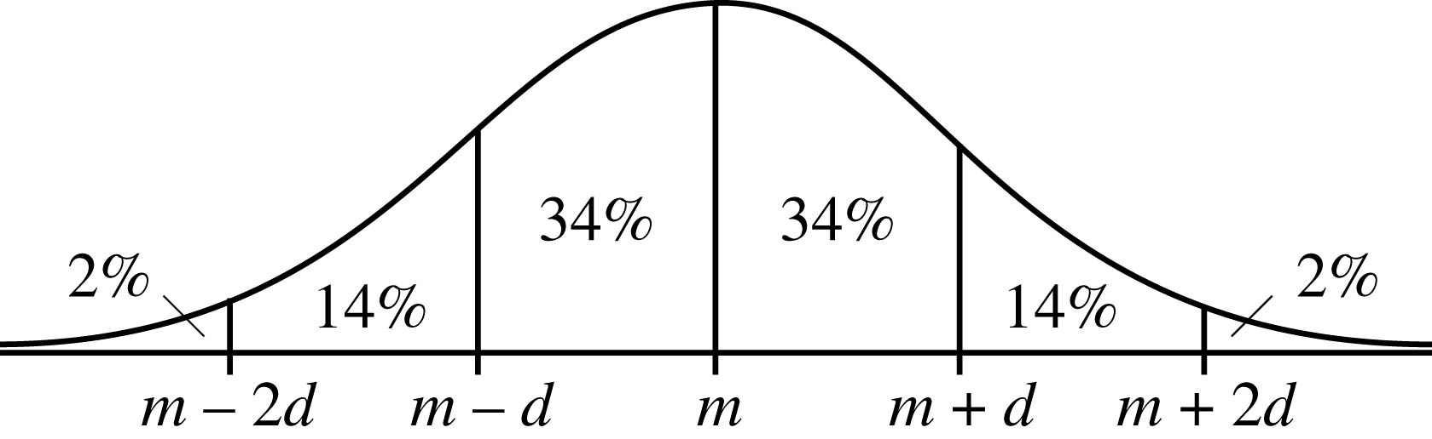
Figure for Question 16

Begin skippable figure description.
The figure accompanying this question consists of a graph of a normal distribution with mean m and standard deviation d. The graph shows a bell-shaped curve drawn above a horizontal axis. On the horizontal axis, from left to right, are the 5 equally spaced numbers; m minus 2d, m minus d, m, m + d, and m + 2d. Vertical line segments above each of these numbers divide the normal distribution into 6 regions. The approximate percents of the distribution in each of the six regions are given as follows. To the left of the number m minus 2d: 2%; between the number m minus 2d and the number m minus d: 14%; between the number m minus d and the number m: 34%; between the number m and the number m + d: 34%; between the number m + d and the number m + 2d: 14%; and to the right of the number m + 2d: 2%.

End skippable figure description.
The figure shows a normal distribution with mean m and standard deviation d, including approximate percents of the distribution in each of the six regions shown.
For a population of 800,000 subway riders, the numbers of subway trips taken per rider last January are approximately normally distributed with a mean of 56 trips and a standard deviation of 13 trips. Approximately how many of the riders took between 30 and 43 trips last January?
A. 60,000
B. 110,000
C. 160,000
D. 210,000
E. 270,000
Select and indicate the best one of the answer choices given.

Questions 17 through 20 are based on the following data.
Refer to the figure.
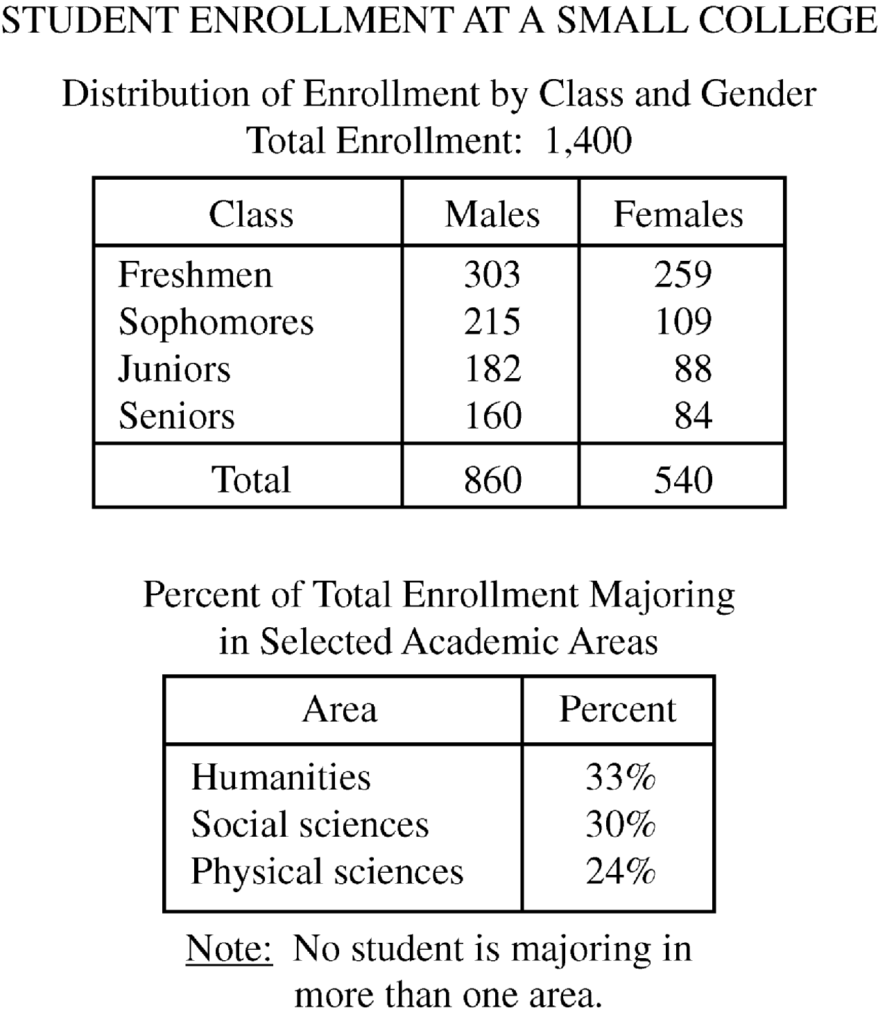
Data for Questions 17 through 20

Begin skippable data description.
The data is given in two tables. The title of the data is “STUDENT ENROLLMENT AT A SMALL COLLEGE.”
The title of the first table is “Distribution of Enrollment by Class and Gender. Total Enrollment: 1,400”. Four classes are listed in the table: Freshmen, Sophomores, Juniors, and Seniors. The rows in the table are as follows:
Freshmen: the number of males is 303, and the number of females is 259.
Sophomores: the number of males is 215, and the number of females is 109.
Juniors: the number of males is 182, and the number of females is 88.
Seniors: the number of males is 160, and the number of females is 84.
The total number of males is 860, and the total number of females is 540.
The title of the second table is “Percent of Total Enrollment Majoring in Selected Academic Areas,” and under the table is the note “No student is majoring in more than one area.” Three academic areas are listed in the table: Humanities, Social Sciences, and Physical Sciences.
The rows in the table are as follows:
Humanities: 33 percent.
Social Sciences: 30 percent.
Physical Sciences: 24 percent.

End skippable data description.

Question 17.
This question has five answer choices, labeled A through E. Select the best one of the answer choices given.
The ratio of the number of male freshmen to the number of female sophomores is approximately
A. 2 to 1
B. 3 to 1
C. 3 to 2
D. 4 to 1
E. 5 to 3
Select and indicate the best one of the answer choices given.
Question 18.
This question has five answer choices, labeled A through E. Select the best one of the answer choices given.
If the total enrollment is 12 percent greater than it was five years ago, what was the total enrollment five years ago?
A. 1,180
B. 1,192
C. 1,220
D. 1,232
E. 1,250
Select and indicate the best one of the answer choices given.
Question 19.
This question has five answer choices, labeled A through E. Select the best one of the answer choices given.
How many students are either juniors or males or both?
A 678
B. 766
C. 948
D. 1,130
E. 1,312
Select and indicate the best one of the answer choices given.

Question 20.
This question has three answer choices, labeled A through C. Select all the answer choices that apply.
Which of the following statements must be true?
Indicate all such statements.
A. The number of males majoring in physical sciences is greater than the number of females majoring in that area.
B. Students majoring in either social sciences or physical sciences constitute more than 50 percent of the total enrollment.
C. The ratio of the number of males to the number of females in the senior class is less than 2 to 1.
Select and indicate all the answer choices that apply. The correct answer to a question of this type could consist of as few as one, or as many as all three of the answer choices.

Question 21.
This question has five answer choices, labeled A through E. Select the best one of the answer choices given.
The quantities S and T are positive and are related by the equation 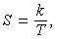 S equals the fraction k over T, where k is a constant. If the value of S increases by 50 percent, then the value of T decreases by what percent?
A. 25%
B. 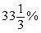33 and 1 third percent
C. 50%
D. 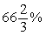66 and 2 thirds percent
E. 75%
Select and indicate the best one of the answer choices given.

Question 22.
This question has five answer choices, labeled A through E. Select the best one of the answer choices given.
If x and y are the tens digit and the units digit, respectively, of the product 725,278 times 67,066 what is the value of x + y ?
A. 12
B. 10
C. 8
D. 6
E. 4
Select and indicate the best one of the answer choices given.
Question 23.
This question has five answer choices, labeled A through E. Select the best one of the answer choices given.
A developer has land that has x feet of lake frontage. The land is to be subdivided into lots, each of which is to have either 80 feet or 100 feet of lake frontage. If 1 ninth of the lots are to have 80 feet of frontage each and the remaining 40 lots are to have 100 feet of frontage each, what is the value of x ?
A. 400
B. 3,200
C. 3,700
D. 4,400
E. 4,760
Select and indicate the best one of the answer choices given.
Question 24.
This question does not have any answer choices; it is a numeric entry question.
To answer this question, enter a number. The number you enter must be an integer or a decimal. It cannot be a fraction.
Twelve numbers are given. They are 10, 10, 10, 10, 8, 8, 8, 8, 12, 12, 11, and y.
The twelve numbers shown represent the age, in years, of the twelve houses on a certain city block. What is the median age, in years, of the twelve houses on the block?
To answer this question, enter a number. The number can include a decimal point, and can be positive, negative, or 0. The number entered cannot be a fraction.

Question 25.
This question has eight answer choices, labeled A through E. Select all the answer choices that apply.
Refer to the figure.
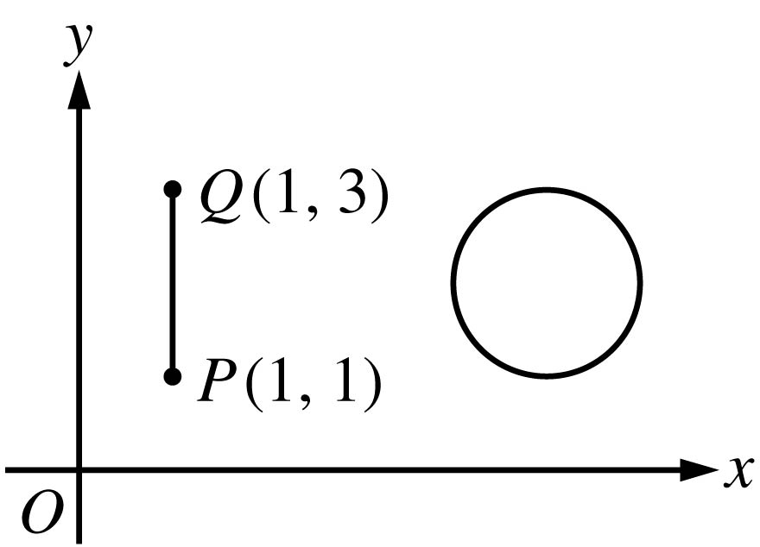
Figure for Question 25

Begin skippable figure description.
The figure accompanying this question consists of a vertical line segment PQ and a circle in the first quadrant of the x y plane. The circle lies to the right of vertical line segment PQ. It appears that if vertical line segment PQ were “slid” directly to the right it would become a diameter of the circle. On vertical line segment PQ, endpoint P has coordinates 1 comma 1, and endpoint Q has coordinates 1 comma 3.

End skippable figure description.
The figure shows line segment PQ and a circle with radius 1 and center 5 comma 2 in the x y plane. Which of the following values could be the distance between a point on line segment PQ and a point on the circle?
Indicate all such values.
A. 2.5
B. 3.0
C. 3.5
D. 4.0
E. 4.5
F. 5.0
G. 5.5
H. 6.0
Select and indicate all the answer choices that apply. The correct answer to a question of this type could consist of as few as one, or as many as all eight of the answer choices.

This is the end of Section 4 of Revised GRE Practice Test Number 1. In an actual test, once you complete a section you may not return to it. The answer key for this section is in a separate document.

