Placement 2011 Highlights

Final Placement -Batch of 2009-11
The placement season for the 2009-11 batch at SIMC Pune was the best in the 21 years history of the institute.
The performance was excellent in terms of
- Number of reputed companies participating
- Number of students placed
- Salaries offered
This performance is a testimony to the acceptance of the highly industry focused curriculum at SIMC Pune. The knowledge gained by the students through case and application oriented inputs in classrooms and minimum 2 industry projects has helped them to perform admirably in the selection processes conducted by companies from across industry sectors. Around 100 organizations participated in the recruitment process this year.
Another testimony to the acceptance of the students by the industry lies in almost 10% of the students getting placed through Pre- Placement Offers secured by virtue of their excellent performance during Summer Internships.
A noteable strength of SIMC Pune is its vibrant Alumni body which contributes significantly in creating opportunities for the students, both in terms of live projects and final placements. This year also the Alumni of SIMC Pune opened up many a door for the outgoing batch of students

Placement Statistics

MBA in Communication Management
The students of MBA in Mass Communication specializing in Advertising and Public Relations got a very good response from the recruiters. Advertising and Media agencies, PR and Event management firms, Media companies, Market Research agencies as well as top corporates recruited from this batch.
Some of the notable names were:
Advertising Agencies: Leo Burnett, FCB Ulka, Mudra.
Media agencies: Madison, Lodestar, Mediacomm.
PR Agencies: Edelman, Perfect Relations, Clea.
Event & activation agencies: Wizcraft, Encompass, Innobella, Grey.
Brand solution agencies: DMA, Synapse.
Media houses: Next Gen Publications, My FM.
Market Research firms: Quantum, Hansa Market Research.
Corporates: ICICI Bank, HP, ACC, Vedanta, Drive India
Number of recruiters | 57
% of students placed | 96%
Highest salary offered | 7 lakhs pa
Median salary offered | 4 lakhs pa
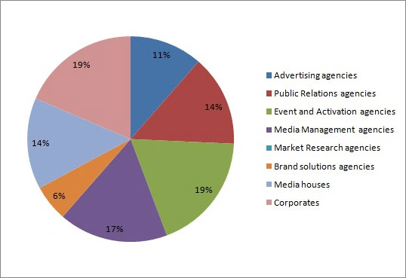
Offer % Sectorwise-MBA in Communication Management
data as on 1.7.11

Masters in Mass Communication
Journalism
The students of Masters in Mass Communication specializing in Journalism have found placements in some of the top media houses of the country. Media companies, both in traditional and new media, have participated and recruited in the current season. Since most of the large firms which SIMC Pune students aspire to be associated with are recruiting at the entry level positions only against vacant positions, the placement process is continuing to help the unplaced students find suitable opportunities
Some of the notable names were:
TV: CNBC, HeadlinesToday, TimesNow.
Newspapers: TOI, HT, New Indian Express etc.
Magazines: Infomedia 18, Nextgen Publications.
Digital: India Today, Reuters, Bloomberg.
Corporates: Cognizant, Edelman.
Number of recruiters | 29
% of students placed | 88%
Highest salary offered | 4 lakhs pa
Median salary offered | 2.5 lakhs pa
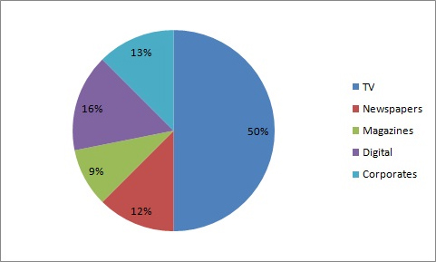
Offer % Sectorwise-Journalism
data as on 1.7.11

Audio Visual Production
The students Masters in Mass Communication specializing in Audio Visual production were recruited both by the TV channels as well as the production houses. The students, trained in the state – of- the - art studios of SIMC Pune under eminent industry professionals, found many of the companies offering final placement offers based on their internship performance
There were also a few corporate recruiters who recruited AV students for their creative skills.
The AV production industry works mainly on a project -to– project basis. Hence many of the opportunities for association for our students are also on a project basis, where they have the opportunity to gain experience quickly to move further in their career. The Placement process is currently helping students to get more such opportunities.
Some of the important names who recruited our students were:
TV: Zee, Neo Sports, Star CJ, Viacom 18, Zoom
Production houses: Glitch, Squirkle, Pixion, Swastik Films
Corporates: Infosys, Tata Steel
Number of recruiters | 24
% of students placed | 72%
Highest salary offered | 5.5 lakhs pa
Median salary offered | 2.5 lakhs pa
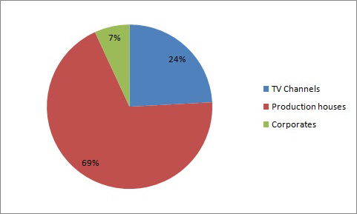
Offer % Sectorwise-Audio Visual Production
data as on 1.6.11
The way ahead
SIMC Pune will continue to offer a win-win proposition to the students and recruiters alike. The completely revamped course, increased focus on real- life connect along with a reduced batch size will facilitate higher industry connect, both in class rooms and outside it.
This is sure to increase the attractiveness of SIMC Pune students to the industry even higher in the coming years.

