Online Examination Application Processing System
(Candidates have to submit the examination application form through online)
- Examination application form can be submitted online through Alagappa University website (Those who are new to the online submission can refer to the details given in step by step method)
- Click “ Apply Online” for getting examination application form on screen
- Fill in the online examination application form carefully
- Pay the examination fee through net banking or credit/debit card (nationalized bank cards are accepted). The payment can be made through three banks- Canara Bank, Indian Bank and IDBI Bank
- After the successful payment of the examination fee, you will get a notification on the screen as “your online hall ticket generation is successful”
- Click “Hall ticket take print out” to print the hall ticket instantly.
- After the successful payment, if the hall ticket is not generated, the candidate should wait for 48 hours. No need to apply again.
- For further clarification contact number 04565-223179 regarding online submission of exam application only
- On Payment of exam fees the Payment Reference No. will be generated. (Ex: MSPD3140319200 , MIOB3145612391, etc.,) Please note down it for future reference

STEP BY STEP METHOD: ONLINE SUBMISSION OF EXAMINATION APPLICATION FORM

- Type your enrolment number and click “submit” button
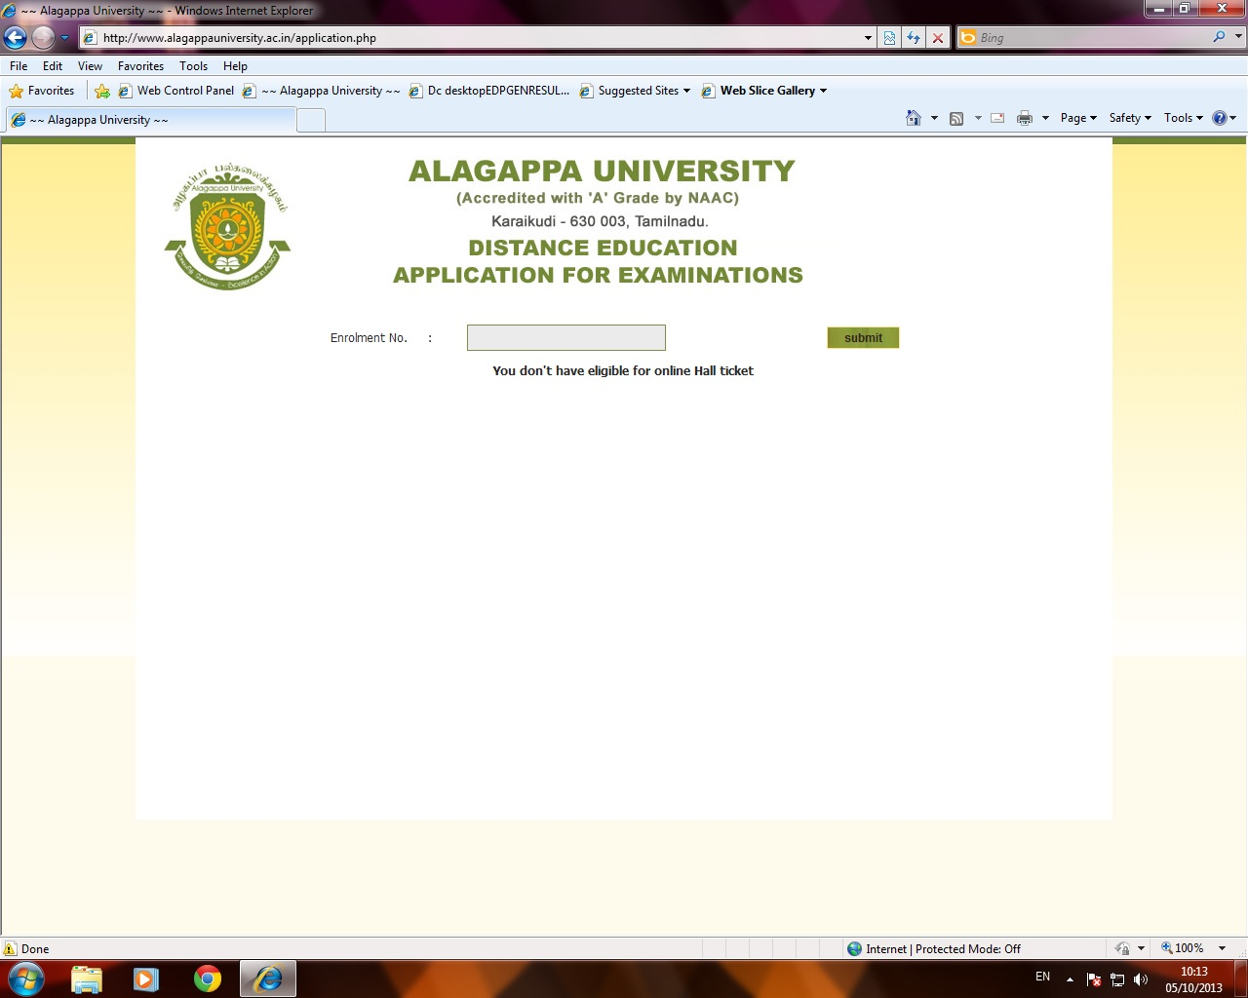

- Course, Month and Year of Examination will be automatically generated.
- Select your Exam Centre Code

- Fill in the necessary columns in the online application form carefully
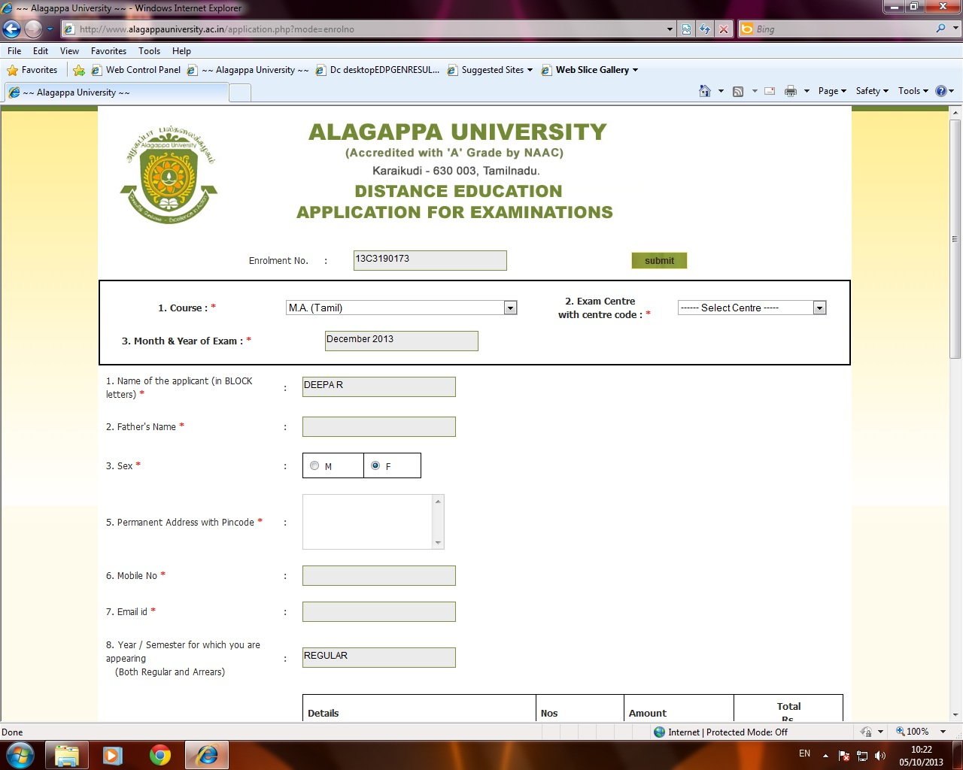

- It is compulsory to select all the subject codes for the current semester examinations
- If you are applying for arrear papers, you can select the subject codes for which you want to apply (there is an option to edit/de select the subject code for which you are not willing to apply)
- You can use any credit /debit cards (Nationalized bank cards) through the payment gateways like Canara Bank, Indian Bank and IDBI bank.
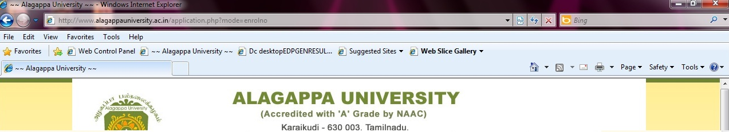
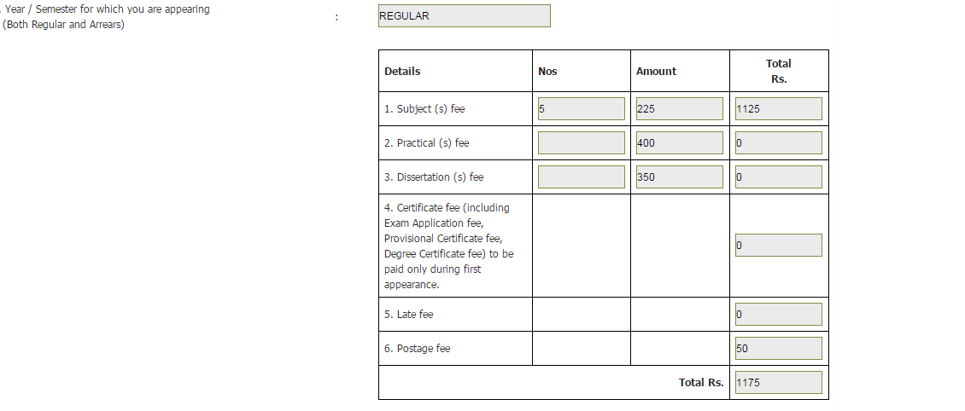
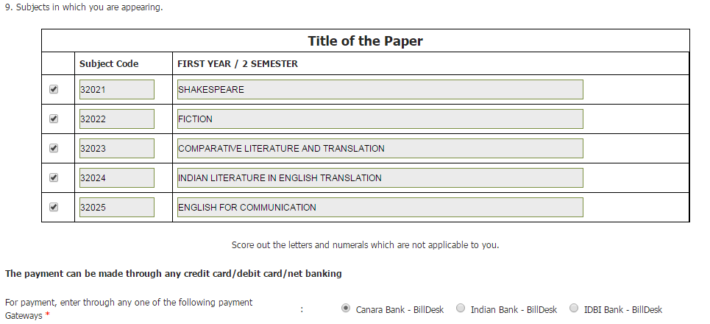

- You can use credit card, debit card or internet banking option by clicking the link furnished below
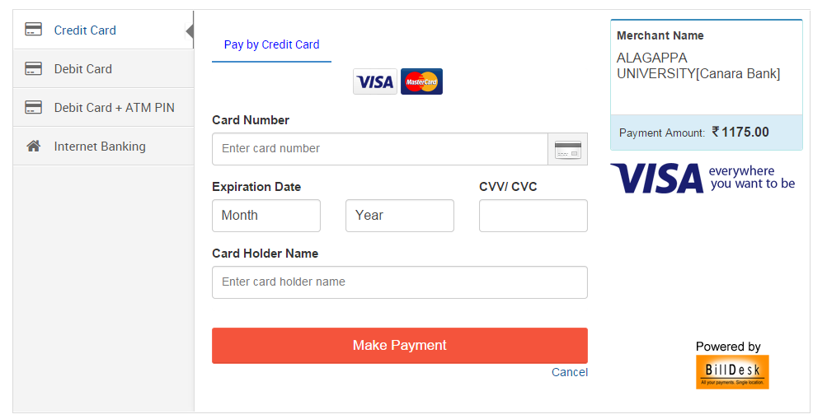

- If you choose debit card the window will be apply as below
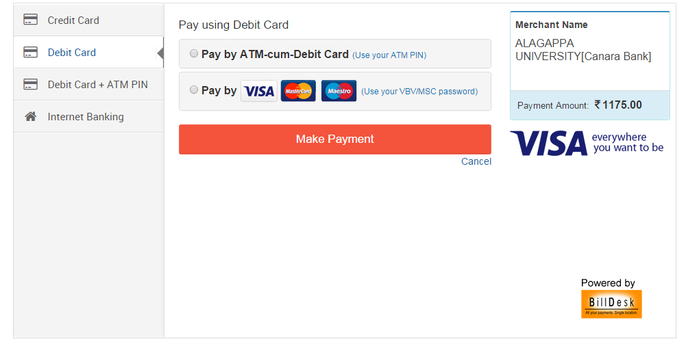

- Bu choosing visa, master card, Mastro the payment can be done

- On Payment of exam fees the Payment Reference No. will be generated. (Ex: MSPD3140319200 , MIOB3145612391, etc.,) Please note down it for future reference
- Once the payment is made successfully, the candidate is authorized to take a print out of the hall ticket instantly.
