GATE question papers: Electronics and Communication Engineering 2009 (EC)
Q. No. 1 – 20 Carry One Mark Each

1. The order of the differential equation 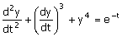 is
(A) 1 (B) 2 (C) 3 (D) 4

2. The Fourier series of a real periodic function has only
P. Cosine terms if it is even
Q. Sine terms if it is even
R. Cosine terms if it is odd
S. Sine terms if it is odd
Which of the above statements are correct?
(A) P and S (B) P and R (C) Q and S (D) Q and R

3. A function is given f(t) = sin²t + cos2t. Which of the following is true?
(A) f has frequency components at 0 and 1/2π Hz
(B) f has frequency components at 0 and 1/π Hz
(C) f has frequency components at 1/2π and 1/π Hz
(D) f has frequency components at 0, 1/2π and 1/π Hz

4. A fully charged mobile phone with a 12V battery is good for a 10minute talk-time. Assume that, during the talk-time, the battery delivers a constant current of 2A and its voltage drops linearly from 12 V to 10V as shown in the figure. How much energy does the battery deliver during this talk-time?
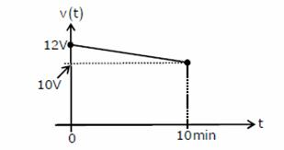

(A) 220J (B) 12kJ (C) 13.2kJ (D) 14.4kJ

5. In an n-type silicon crystal at room temperature, which of the following can have a concentration of
4 × 10¹⁹ cm⁻³ ?
(A) Silicon atoms (B) Holes
(C) Dopant atoms (D) Valence electrons

6. The full form of the abbreviations TTL and CMOS in reference to logic families are
(A) Triple Transistor Logic and Chip Metal Oxide Semiconductor
(B) Tristate Transistor Logic and Chip Metal Oxide Semiconductor
(C) Transistor Transistor Logic and Complementary Metal Oxide Semiconductor
(D) Tristate Transistor Logic and Complementary Metal Oxide Silicon

7. The ROC of Z-transform of the discrete time sequence
x(n) = 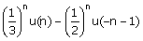 is
(A) 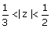 (B) |z| > (C) |z| < (D) 2 < |z| < 3

8. The magnitude plot of a rational transfer function G(s) with real coefficients is shown below. When of the following compensators has such a magnitude plot?
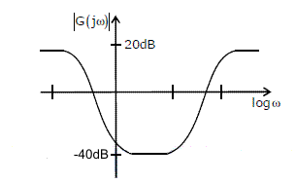

(A) Lead compensator (B) Lag compensator
(C) PID compensator (D) Lead-lag compensator

9. A white noise process X(t) with two-sided power spectral density 1 × 10⁻¹⁰ W/Hz is input to a filter whose magnitude squared response is shown below
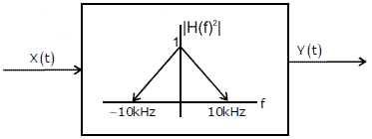

The power of the output process Y(t) is given by
(A) 5 × 10⁻⁷ W (B) 1 × 10⁻⁶ W (C) 2 × 10⁻⁶ W (D) 1 × 10⁻⁵ W

10. Which of the following statements is true regarding the fundamental mode of the metallic waveguides shown?
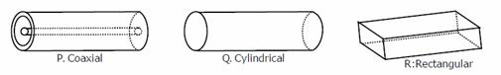

(A) Only P has no cutoff-frequency (B) Only Q has no cutoff-frequency
(C) Only R has no cutoff-frequency (D) all three have cutoff-frequency

11. A fair coin is tossed 10times. What is the probability that ONLY the first two tosses will yield heads?
(A) 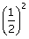 (B) 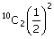 (C) 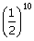 (D) 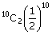

12. If the power spectral density of stationary random process is a sine-squared function of frequency, the shape of its autocorrelation is
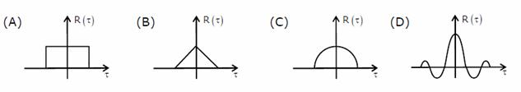

13. If f(z) = c₀ + c₁z⁻¹, then 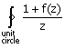 dz is given by
(A) 2πc₁ (B) 2π (1 + c₀) (C) 2πjc₁ (D) 2πj (1 + c₀)

14. In the interconnection of ideal sources shown in the figure, it is known that the 60V source is absorbing power
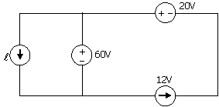

Which of the following can be the value of the current source ?
(A) 10A (B) 13A (C) 15A (D) 18A

15. The ratio of the mobility to the diffusion coefficient in a semiconductor has the units
(A) V⁻¹ (B) em ⋅ V⁻¹ (C) V ⋅ cm⁻¹ (D) V ⋅ s

16. In a microprocessor, the service routine for a certain interrupt starts from a fixed location of memory which cannot be externally set, but the interrupt can be delayed or rejected. Such an interrupt is
(A) non-maskable and non-vectored (B) maskable and non-vectored
(C) non-maskable and vectored (D) maskable and vectored

17. If the transfer function of the following network is 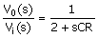
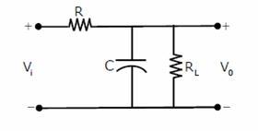
The value of the load resistance R_{L} is
(A) R/4 (B) R/2 (C) R (D) 2R

18. Consider the system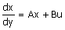 with A = 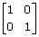 and B = where p and q are arbitrary real numbers. Which of the following statements about the controllability of the system is true?
(A) The system is completely state controllable for any nonzero values of p and q
(B) Only p=0 and q=0 result in controllability
(C) The system is uncontrollable for all values of p and q
(D) We cannot conclude about controllability from the given data

19. For a message signal m(t) = cos(2πf_{m}t) and carrier of frequency f_{c}, which of the following represents a single side band (SSB) signal?
(A) cos(2πf_{m}t) cos(2πf_{c}t) (B) cos(2πf_{c}t)
(C) cos[2π(f_{c} + f_{m})t] (D) [1 + cos(2πf_{m}t) ] cos(2πf_{c}t)

20. Two infinitely long wires carrying current are as shown in the figure below. One wire is in the y-z plane and parallel to the y-axis. The other wise is in the x-y plane and parallel to the x-axis. Which components of the resulting magnetic field are non-zero at the origin?
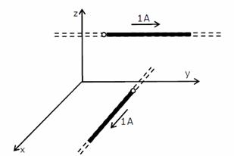

(A) x, y, z components (B) x, y components
(C) y, z components (D) x, z components

Q. No. 21 – 56 Carry Two Marks Each

21. Consider two independent random variables X and Y with identical distributions. The variables X and Y take values 0, 1 and 2 with probabilities 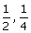 and respectively. What is the conditional probability P (X + Y = 2| X − Y = 0)?
(A) 0 (B) (C) (D) 1

22. The Taylor series expansion of 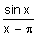at x = π is given by
(A) 1 +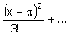 (B) −1 −
(C) 1 − (D) −1 +

23. If a vector field is related to another vector field through = ∇ × , which of the following is true? Note: C and SC refer to any closed contour and any surface whose boundary is C.
(A) 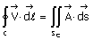 (B) 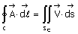
(C) 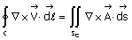 (D) 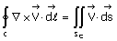
24. Given that F(s) is the one-sided Laplace transform of f(t), the Laplace transform of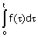 is
(A) sF(s) − f(0) (B) 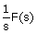 (C) 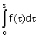 (D) 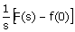
25. Match each differential equation in Group I to its family of solution curves from
Group II.
Group - I Group - II
P. 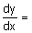 1. Circles
Q. 2. Straight lines
R. 3. Hyperbolas
S.
(A) P-2, Q-3, R-3, S-1 (B) P-1, Q-3, R-2, S-1
(C) P-2, Q-1, R-3, S-3 (D) P-3, Q-2, R-1, S-2

26. The eigen values of the following matrix are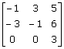

(A) 3,3 + 5j,6 − j (B) −6 + 5j,3 + j,3 − j
(C) 3 + j,3 − j,5 + j (D) 3, −1 + 3j, −1 − 3j

27. An AC source of RMS voltage 20V with internal impedance Z_{s} = (1 + 2j) Ω feeds a load of impedance Z_{t} = (7 + 4j) Ω in the figure below. The reactive power consumed by the load is

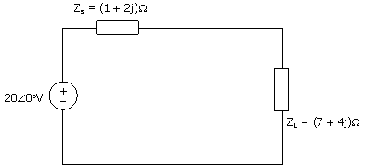

(A) 8VAR (B) 16AVR (C) 28VAR (D) 32VAR

28. The switch in the circuit shown was on position a for a long time, and is moved to position b at time t=0. The current i(t) for t>0 is given by
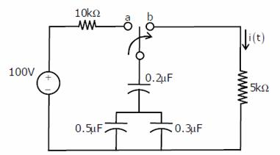

(A) 0.2e^{-125t} u(t) mA (B) 20e^{-1250t} u(t) mA
(C) 0.2e^{-1250t} u(t) mA (D) 20e^{-1000t} u(t) mA

29. In the circuit shown, what value of R_{L} maximizes the power delivered to R_{L}?
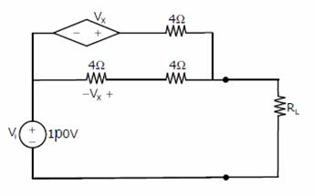

(A) 2.4Ω (B) Ω (C) 4Ω (D) 6Ω

30. The time domain behavior of an RL circuit is represented by
L+ Ri = V₀(1 +1Be^{-Rt/L}sint) u (t).
For an initial current of i(0) =, the steady state value of the current is given by
(A) i (t) → (B) i (t) →
(C) i (t) → (1 + B) (D) i (t) → (1 + B)

31. In the circuit below, the diode is ideal. The voltage V is given by
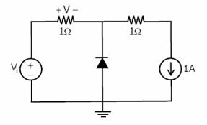

(A) min (V_{i},1) (B) max (V_{i},1) (C) min (−V_{i},1) (D) max (−V_{i},1)

32. Consider the following two statements about the internal conditions in an n-channel MOSFET operating in the active region
S1: The inversion charge decreases from source to drain
S2: The channel potential increases from source to drain
Which of the following is correct?
(A) Only S2 is true
(B) Both S1 and S2 are false
(C) Both S1 and S2 are true, but S2 is not a reason for S1
(D) Both S1 and S2 are true, and S2 is a reason for S1

33. In the following astable multivibrator circuit, which properties of v_{o}(t) depend on R₂?
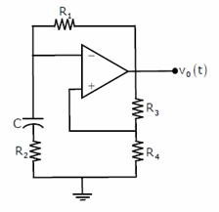

(A) Only the frequency
(B) Only the amplitude
(C) Both the amplitude and the frequency
(D) Neither the amplitude nor the frequency

34. In the circuit shown below, the op-amp is ideal, the transistor has V_{BE} = 0.6V and β = 150. Decide whether the feedback in the circuit is positive or negative and determine the voltage V at the output of the op-amp
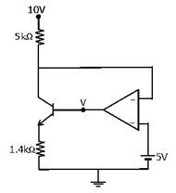
(A) Positive feedback, V=10 V (B) Positive feedback, V=0 V
(C) Negative feedback, V=5 V (D) Negative feedback, V=2 V

35. A small signal source v_{i} (t) = A cos20t + B sin10⁶ t is applied to a transistor amplifier as shown below. The transistor has β = 150 and h = 3kΩ. Which expression best approximates V₀ (t)
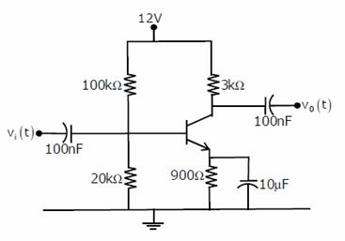

(A) v₀ (t) = −1500 ( A cos20t + B sin10⁶ t) (B) v₀ (t) = −150 (A cos20t + B sin10⁶ t)
(C) v₀ (t) = −1500B sin10⁶ t (D) v₀ (t) = −150B sin10⁶ t

36. If X = 1 in the logic equation 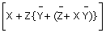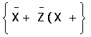= 1, then
(A) Y=Z (B) Y = Z (C) Z=1 (D) Z=0

37. What are the minimum number of 2 to 1 multiplexers required to generate a 2 input AND gate and a 2 input Ex-OR gate?
(A) 1 and 2 (B) 1 and 3 (C) 1 and 1 (D) 2 and 2

38. Refer to the NAND and NOR latches shown in the figure. The inputs (P₁,P₂ ) for both the latches are first made (0, 1) and then, after a few seconds, made (1, 1). The corresponding stable outputs (Q₁, Q₂) are

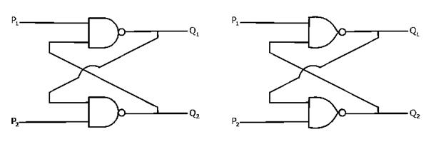
(A) NAND: first (0, 1) then (0, 1) NOR: first (1, 0) then (0, 0)
(B) NAND: first (1, 0) then (1, 0) NOR: first (1, 0) then (1, 0)
(C) NAND: first (1, 0) then (1, 0) NOR: first (1, 0) then (0, 0)
(D) NAND: first (1, 0) then (1, 1) NOR: first (0, 1) then (0, 1)

39. What are the counting stages (Q₁, Q₂) for the counter shown in the figure below?
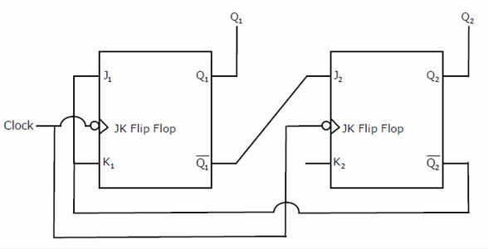

(A) 11,10,00,11,10,.... (B) 01,10,11,00,01,....
(C) 00,11,01,10,00,.... (D) 01,10,00,01,10,....

40. A system with transfer function H(z) has impulse response h(.) defined as h(2) = 1, h(3) = −1 and h(k) = 0 otherwise. Consider the following statements
S1 : H(z) is a low pass filter
S2 : H(z) is a FIR filter
Which of the following is correct?
(A) Only S2 is true
(B) Both S1 and S2 are false
(C) Both S1 and S2 are true, and S2 is a reason for S1
(D) Both S1 and S2 are true, but S2 is not a reason for S1

41. Consider a system whose input x and output y are related by the equation y(t) = 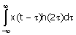
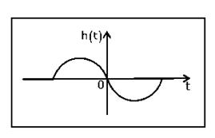
Where h(t) is shown in the graph
Which of the following four properties are possessed by the system?
BIBO: Bounded input gives a bounded output
Causal: The system is causal
LP: The system is low pass
LTI: The system is linear and time invariant
(A) Causal, LP (B) BIBO, LTI (C) BIBO, Causal, LTI (D) LP, LTI

42. The 4 point Discrete Fourier Transform (DFT) of a discrete time sequence {1, 0, 2, 3} is
(A) [0, −2 + 2j, 2, −2 −2j] (B) [2, 2 + 2j, 6, 2 − 2j]
(C) [6, 1 −3j, 2, 1 + 3j] (D) [6, −1 + 3j, 0, −1 −3j]

43. The feedback configuration and the pole-zero locations of G(s) = 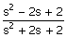 are shown below. The root locus for negative values of k, i.e. for −∞ < k < 0, has breakaway/break in points and angle of departure at pole P (with respect to the positive real axis) equal to
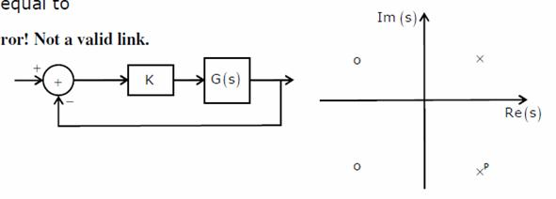
(A) ± 2 and 0ºError! Not a valid link. (B) ± 2 and 45º
(C) ± 3 and 0º (D) ± 3 and 45º

44. An LTI system having transfer function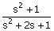 and input x(t)=sin(t+1) is in steady state. The output is sampled at a rate ω_{s} rad/s to obtain the final output {y(k)}. Which of the following is true?
(A) y(.) is zero for all sampling frequencies ω_{s}
(B) y(.) is nonzero for all sampling frequencies ω_{s}
(C) y(.) is nonzero for ω_{s} >2, but zero for ω_{s} >2
(D) y(.) is zero for ω_{s} >2 but nonzero forω_{s} >2

45. The unit step response of an under-damped second order system has steady state value of -2. Which one of the following transfer functions has these properties?
(A) 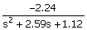 (B) 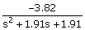
(C) 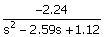 (D) 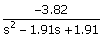

46. A discrete random variable X takes values from 1 to 5 with probabilities as shown in the table. A student calculates the mean of X and 3.5 and her teacher calculates the variance of X as 1.5. Which of the following statements is true?

k | 1 | 2 | 3 | 4 | 5
p(X = k) | 0.1 | 0.2 | 0.4 | 0.2 | 0.1
(A) Both the student and the teacher are right
(B) Both the student and the teacher are wrong
(C) Both the student is wrong but the teacher is right
(D) The student is right but the teacher is wrong

47. A message signal given by
m(t) = cosω₁t − sinω₂t
Is amplitude modulated with a carrier of frequencyω_{c} to generate s (t) = [1 + m(t)] cosω_{c}t
(A) 8.33% (B) 11.11% (C) 20% (D) 25%

48. A communication channel with AWGN operating at a signal to noise ratio SNR>>1 and bandwidth B has capacity C₁. If the SNR is doubled keeping B constant, the resulting capacity C₂ is given by
(A) C₂ ≈ 2C₁ (B) C₂ ≈ C₁ + B (C) C₂ ≈ C₁ + 2B (D) C₂ ≈ C₁ + 0.3B

49. A magnetic field in air is measured to be 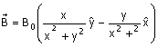
What current distribution leads to this field? [Hint: The algebra is trivial in cylindrical coordinates.]
(A) 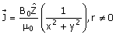 (B) 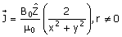

(C) (D)

50. A transmission line terminates in two branches, each of length λ/4, as shown. The branches are terminated by 50Ω loads. The lines are lossless and have the characteristic impedances shown. Determine the impedance Z₁ as seen by the source
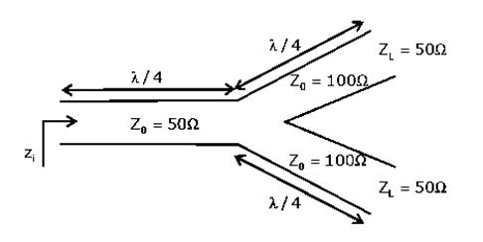

(A) 200Ω (B) 100Ω (C) 50Ω (D) 25Ω

Common Data Questions: 51 & 52
Consider a silicon p-n junction at room temperature having the following parameters:
Doping on the n-side = 1×10¹⁷ cm⁻³
Depletion width on the n-side = 0.1μm
Depletion width on the p-side =1.0μm
Intrinsic carrier concentration = 1.4×10¹⁴ F. cm⁻¹
Thermal voltage = 26mV
Permittivity of free space = 8.85×10⁻¹⁴ F. cm⁻¹
Dielectric constant of silicon = 12

51. The built in potential of the junction
(A) is 0.70V (B) is 0.76V
(C) is 0.82V (D) cannot be estimated from the data given

52. The peak electric field in the device is
(A) 0.15 MV. cm⁻¹, directed from p-region to n-region
(B) 0.15 MV. cm⁻¹, directed from n-region to p-region
(C) 1.80 MV. cm⁻¹, directed from p-region to n-region
(D) 1.80 MV. cm⁻¹, directed from n-region to p-region

Common Data Questions: 53 & 54

The Nyquist plot of a stable transfer function G(s) is shown in the figure. We are interested in the tability of the closed loop system in the feedback configuration shown.
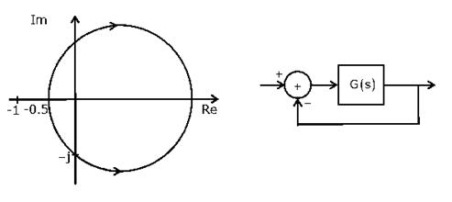
53. Which of the following statements is true?
(A) G(s) is an all-pass filter
(B) G(s) has a zero in the right-half plane
(C) G(s) is the impedance of a passive network
(D) G(s) is marginally stable

54. The gain and phase margins of G(s) for closed loop stability are
(A) 6dB and 180º (B) 3dB and 180º (C) 6dB and 90º (D) 3dB and 90º

Common Data Questions: 55 & 56

The amplitude of a random signal is uniformly distributed between -5V and 5V

55. If the signal to quantization noise ratio required in uniformly quantizing the signal is 43.5dB, the step size of the quantization is approximately
(A) 0.0333V (B) 0.05V (C) 0.0667V (D) 0.10V

56. If the positive values of the signal are uniformly quantized with a step size of 0.05V, and the negative values are uniformly quantized with a step size of 0.1V, the resulting signal to quantization noise ratio is approximately
(A) 46dB (B) 43.8dB (C) 42dB (D) 40dB

Linked Answer Questions: Q.57 to Q.60 Carry Two Marks Each

Statement for Linked Answer Questions: 57 & 58
Consider the CMOS circuit shown, where the gate voltage V_{G} of the n-MOSFET is increased from zero, while the gate voltage of the p-MOSFET is kept constant at 3 V. Assume that, for both transistors, the magnitude of the threshold voltage is 1 V and the product of the transconductance parameter and the (W/L) ratio, i.e. the quantity μ C_{ox} (W/ L) , is 1mA ⋅ V⁻² .
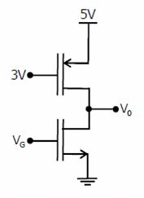
57. For small increase in V_{G} beyond 1V, which of the following gives the correct description of the region of operation of each MOSFET?
(A) Both the MOSFETs are in saturation region
(B) Both the MOSFETs are in triode region
(C) n-MOSFET is in triode and p-MOSFET is in saturation region
(D) n-MOSFET is in saturation and p-MOSFET is in triode region

58. Estimate the output voltage V₀ for V_{G} = 1.5V. [Hint: Use the appropriate current voltage equation for each MOSFET, based on the answer to Q.57]
(A) 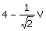 (B) 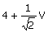 (C) 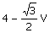 (D) 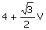

Statement for Linked Answer Questions: 59 & 60

Two products are sold from a vending machine, which has two push buttons P₁ and P₂. When a button is pressed, the price of the corresponding product is displayed in a 7-segment display.
If no buttons are pressed, '0' is displayed, signifying 'Rs. 0'.
If only P₁ is pressed, '2' is displayed, signifying 'Rs. 2'.
If only P₂ is pressed, '5' is displayed, signifying 'Rs. 5'.
If both P₁ and P₂ are pressed, 'E' is displayed, signifying 'Error'.
The names of the segments in the 7-segment display, and the glow of the display for '0', '2', '5' and 'E', are shown below
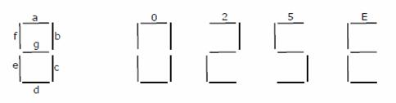
Consider
(i) push button pressed/not pressed is equivalent to logic 1/0 respectively
(ii) a segment glowing / not glowing in the display is equivalent to logic 1/0 respectively
59. If segments a to g are considered as functions of P₁ and P₂, then which of the following is correct?
(A) g = + P₂, d = c + e (B) g = P₁ + P₂, d = c + e
(C) g = + P₂, e = b + c (D) g = P₁ + P₂, e = b + c

60. What are the minimum numbers of NOT gates and 2-input OR gates required to design the logic of the driver for this 7-segment display?
(A) 3 NOT and 4 OR (B) 2 NOT and 4 OR
(C) 1 NOT and 3 OR (D) 2 NOT and 3 OR

