IPS Eligibility Criteria
Age Limit
Applicant’s age limit should be in between 21 to 30 years.
No. of Attempts
- GEN: 4 times
- OBCs: 7 times
- SC/ST: No limit
IPS Syllabus 2015
IPS 2015 exam consist of total 9 papers which are based on different topics. These are as follows
- Paper I: General Studies
- Paper II: Language Exam
- Paper III: General English
- Paper IV: Essay
- Paper V, VI, VII, VIII and IX: Optional Subjects
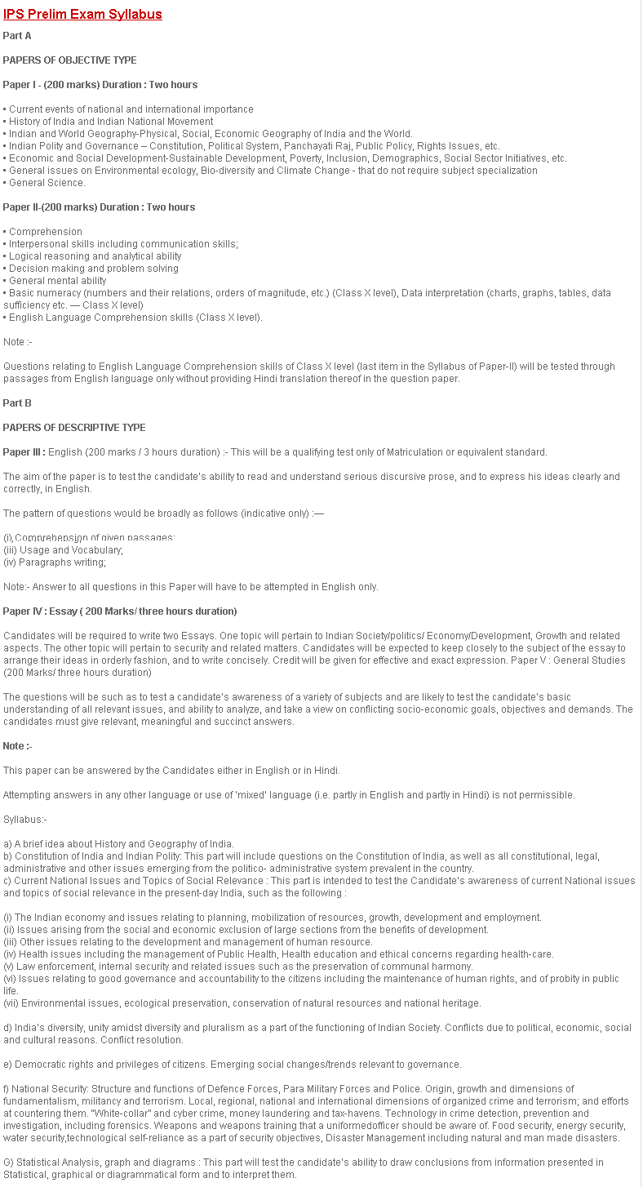
General Studies
- Paper Type: Objective Type
- Duration: 2 Hours
- Marks: 200
How to Prepare for Reasoning | How To Prepare For GK
How to Prepare for English | How to Prepare for Maths
This sections covers the questions which are related to Current events of national and international importance, History of India and Indian National Movement, Indian and World Geography-Physical, Social, Economic Geography of India and the World, Indian Polity and Governance – Constitution, Political System, Panchayati Raj, Public Policy, Rights Issues, etc, Economic and Social Development-Sustainable Development, Poverty, Inclusion, Demographics, Social Sector Initiatives, etc., General issues on Environmental ecology, Bio-diversity and Climate Change – that do not require subject specialization.
Language Exam
- Paper Type: Subjective
- Duration: 2 Hours
- Marks: 200
In Language section, the question consists of Comprehension, Logical reasoning and analytical ability, Decision making and problem solving, General mental ability, Basic numeracy questions etc.
Check Civil Services Exam
General English
- Paper Type: Descriptive
- Duration: 3 Hours
- Marks: 200
The paper pattern of English Section consists of Comprehension of given passages, Precis Writing, Usage and Vocabulary, Paragraphs writing etc.
Essay
- Paper Type: Descriptive
- Duration: 3 Hours
- Marks: 200
In this section, aspirants are required to write at least 2 essays on which first topic is related to Indian Society/politics/ Economy/Development, Growth and related aspects and second topic related to security and related matters.
IPS Exam Pattern
Paper | Type | Marks | Duration
Paper I | Objective | 200 | 2 Hrs
Paper II | Objective | 200 | 2 Hrs
Paper III | Descriptive | 200 | 3 Hrs
Paper IV | Descriptive | 200 | 3 Hrs
Paper V | Descriptive | 200 | 3 Hrs
Interview |  | 200

Something That You Should Put An Eye On
UPSC Entrance Exam | UPSC Calendar
UPSC Syllabus | UPSC Eligibility Criteria
UPSC Exam Pattern | UPSC Previous Year Question
UPSC Books | UPSC Challan Form
UPSC Online Application Status | Strategy for UPSC Pre Examination

