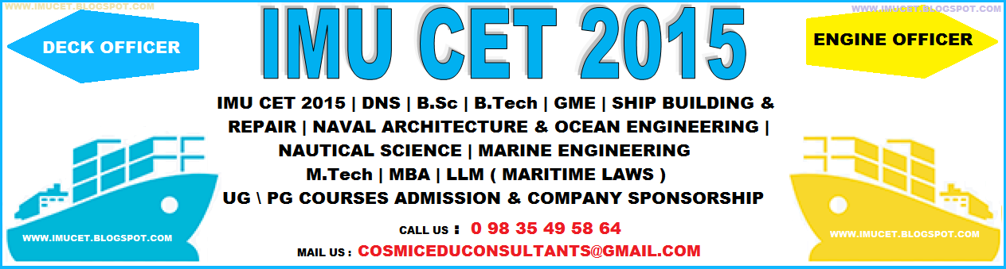

Pages
- HOME
- ABOUT
- MERCHANT NAVY
- IMU CET 2015 Application
- IMU CET 2015
- STUDY MATERIALS
- IMU CET COACHING
- COURSES
- SPONSORSHIP
- SHIPPING COMPANIES
- RPSL No.
- D.G.Shipping
- DG DOCTORS
- FAQs
- IMU
- E-Counseling
- CONTACT US
- G.P.RATINGS
- RESULTS
- DIPLOMA IN NAUTICAL SCIENCE-DNS
- B.TECH MARINE ENGINEERING
- GRADUATE MECHANICAL ENGINEER
- EXAMINATIONS
This Blog
Linked From Here
Like Us
This Blog

Top of Form
Bottom of Form
Linked From Here

Like Us

IMU CET 2015,IMU CET 2015, IMU CET 2015 FEB BATCH, Results, IMU CET 2015 APPLICATION FORM,COMPANY SPONSORSHIP FORMS,IMU CET 2015 STUDY MATERIALS, IMU CET COACHING CLASSES,LAST YEAR QUESTION PAPERS, IMU CET 2015 EXAM DATE, IMU CET 2015 SAMPLE PAPERS, IMU CET 2015 MODEL TEST PAPERS, IMU CET 2015 EXAM CENTERS @ 9835495864 COMPANY SPONSORSHIP TESTS
IMU CET 2015 / INDIAN MARITIME UNIVERSITY COMMON ENTRANCE TEST 2015 . Admission and Registration for IMU- CET FEB 2015 & AUG 2015 is now open:
TO GET COMPANY SPONSORSHIP FORMS & REVISED/UPDATED STUDY MANUALS FOR FEB 2015 & AUGUST 2015 BATCH.
CALL @ 98 35 49 58 64


: 0 98 35 49 58 64

Dear Friends, it is quite often now a days that the prospect seafarers are being cheated by the fake Agents/Institutes/Companies.
BEFORE APPLYING INTO ANY MARITIME INSTITUTES FOR ANY COURSE, KINDLY CHECK APPROVAL OF COLLEGE & COURSE FROM D.G.SHIPPING AND I.M.U. ALSO, BEFORE APPLYING IN SHIPPING COMPANIES FOR COMPANY SPONSORSHIP, MUST CHECK R.P.S.L NUMBER.

COMMON ENTRANCE TEST 2015 (FEB & AUG '2015 BATCH)
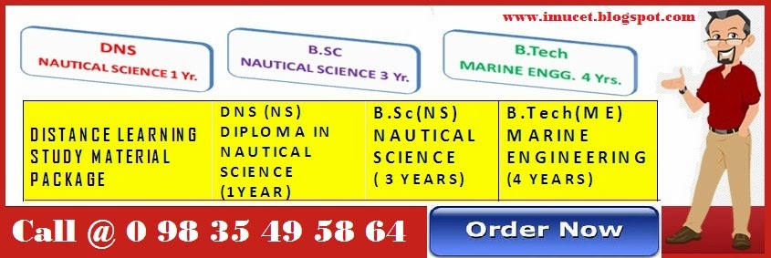
STUDY PACKAGE IS AVAILABLE FOR DNS,B.SC,B.TECH MARINE ENGINEERING

JOIN MERCHANT NAVY
HOW TO JOIN MERCHANT NAVY
Courses : Career in Merchant Navy can be pursued either as an officer or a rating in mainly two specialized fields, i.e. Marine Engineering and Nautical (deck). To become a seafarer, following streams of entries (Pre-Sea courses) are available to Indian citizens in the Government as well as in private training institutions (recognized and approved by Director General of Shipping, Ministry of Shipping):-
Officers
- 3 year degree course in Nautical Science for (10+2) students.
- 4 year degree course in Marine Engineering for (10+2) students.
- 2 year course for Diploma Holders.
- 1 year course for Graduate Mechanical Engineers.
- 3 month course for Deck Cadets for (10+2) students.

Rating (Entry standard Xth)
- 4 month Pre-Sea Course for General Purpose (GP) rating.
- 3 month Pre-Sea Course for Deck rating.
- 3 month Pre-Sea Course for Engine rating.
- 4 month Pre-Sea Course for Saloon rating.
In addition, a candidate can join as utility hand or Petty Officers (Fitters) after completing 4 Basic Courses, i.e. FPFF, EFA, PSSR and PST.
Govt training Institutes : There are four Government Training Institutes providing Pre-Sea and Post-Sea training of international standard :
- Training Ship Chanakya, Navi Mumbai.
- Marine Engineering & Research Institute (MERI), Kolkata.
- Marine Engineering & Research Institute (MERI), Mumbai.
- Lal Bahadur Shastri College of advanced Maritime Studies and Research, Mumbai.
T.S. Chanakya, Navi Mumbai
This is a shore based academy, which carries the reputation and tradition of T.S. Dufferin and T.S. Rajendra. The Institute is of international repute and the alumni of the institute are well known worldwide. The admission to this Institute for three year degree course is done through Joint Entrance Exam (JEE) conducted by IIT. The candidate should not be more than 20 years of age, on 1st October and should have cleared screening test of IIT, to apply for this course. After qualifying the screening test of the IIT, the boy who is keen to pursue the career in Merchant Navy, as a Deck Officer, has to fill up an application form which is available at Directorate General of Shipping, Mumbai, and at the selected branches of Syndicate Bank all over India. The advertisement for this, is published in leading news papers of the country in the month of July and December every year, giving procedure for admission. After completing a 3-year course at T.S. Chanakya, a student is awarded Degree in Nautical Science by Mumbai University and is required to go on board ship for one year sea training. The cost of the training in T.S. Chanakya is about Rs. 30,000. per year including tuition fees, hostel and messing. Personal expenses are to be borne by the student. T S. Chanakya also conducts 3 month Pre-Sea Deck Cadets Course. The candidates should be less than 20 years of age on the commencement of the course and should have minimum 60% of marks in P.C.M. at 10+2 level or 55% marks in the B. Sc. and should be below 22 years of age or should have passed BE/B.Tech. from a college recognized by AICTE and is below 24 years of age. The advertisement for this course is published 2 months before the commencement of the course in Employment News and other leading news papers. After completion of the course, the candidate is to obtain requisite sea time of 2 to 3 years before appearing for 2nd Mate competency exam. During their sea attachment, these candidates, usually, are paid nominal pocket allowances by the shipping companies, in addition to free messing and accommodation on the ship. For further details, contact Capt. Superintendent, T.S. Chanakya at the following address : Capt.Superintendent, Training Ship Chanakya, Karave, Navi Mumbai., Tel. 022- 770 3876.
Marine Engineering & Research Institute (MERI), Kolkata.
This Institute was established in 1949 to impart training to marine engineering cadets and is presently situated at Kolkata. The Institute conducts 4 year degree course in Marine Engineering recognized by AICTE and affiliated to University of Jadhavpur. The admission to this course is also done through Joint Entrance Exam (JEE) of IIT and the eligibility for this course is same as of Training Ship Chanakya and the admission to this Institute is also conducted along with the selection to the T.S. Chanakya on the basis of the merit list provided by JEE, IIT. The admission procedure and the fees for this course is also in line of T.S. Chanakya as mentioned above. For any further query, the Director, MERI, Kolkata, may be contacted at the following address : Marine Engineering & Research Institute, P-19, New Taratalla Road, Kolkata – 700 088, Tel. 033- 401 4673
Marine Engineering & Research Institute (MERI), Mumbai.
This Institute is situated at Mumbai at Haybundar and provides 1 year Pre-Sea Training to graduate Mechanical Engineers to enable them to go on ships as Junior Engineers. To be eligibile for this course, the candidate should have passed engineering degree in mechanical or in Naval Architecture from the AICTE recognized Institute. The selection is done on the basis of merit and the advertisement for this course is published in Employment News and other leading news papers in the month of November every year. The fees for this course is around Rs. 1,40,000/- including messing, uniform and accommodation. The address is : Marine Engineering & Research Institute, Hay Bunder Road, Mumbai – 400 033, Tel. 022- 3723577,E-mail - meribom@vsnl.com
Lal Bahadur Shastri College of Advanced Maritime Studies and Research, Mumbai
Lal Bahadur Shastri College of Advanced Maritime Studies and Research is a premier post-sea Maritime Education and Training Institute offering a comprehensive range of courses for Merchant Navy Officers. The college was established by the Ministry of Transport, Government of India, in 1948.
In addition to Government Training Institutes, there are number of private training institutes which are conducting pre-sea courses for Nautical as well as Engineering candidates both for 10+2 students and engineering candidates. These institutes follow their own selection procedure, which is published regularly in the news papers. For further details, these institutes may be contacted. The institutes provide training to the students and are recognized by the Directorate General of Shipping, Government of India. But on completion of the training, the students have to appear for the competency examination, which enable them to be employed on board Merchant Ships. It is necessary for all candidates to obtain a Certificate of Competency from Directorate General of Shipping, Government of India, the certificates are recognized and respected by all the countries. The examinations for these certificates are conducted by the D.G. Shipping through Mercantile Marine Departments. The 1st exam for 2nd Mate (Deck) and MEO IV (Engineering) is to be given by the candidates after successfully completing the Pre-Sea Training in the above institutes and required sea time on ships. After acquiring the Certificate of Competency, the officer is eligible to be appointed as 3rd Officer / 5th Engineer on board Merchant Ship and draw a handsome salary. For subsequent promotion, he has to render further sea service and pass higher examinations and post-sea courses at LBS College (Govt. of India) or in other private training institutes.
In addition to the above entries for officers, the candidate can join Merchant Navy as rating on board ship. The minimum qualification for rating is 10th standard with Maths and Science and the age limit is less than 24 ½ years at the commencement of the course. After completing the course, the trainees are required to go on ship minimum for 6 months to earn their watchkeeping certificate. After obtaining the Watch Keeping Certificate, they can sail on ships as rating for Deck/Engine Room/Saloon/Petty Officers and are paid handsome salary.

