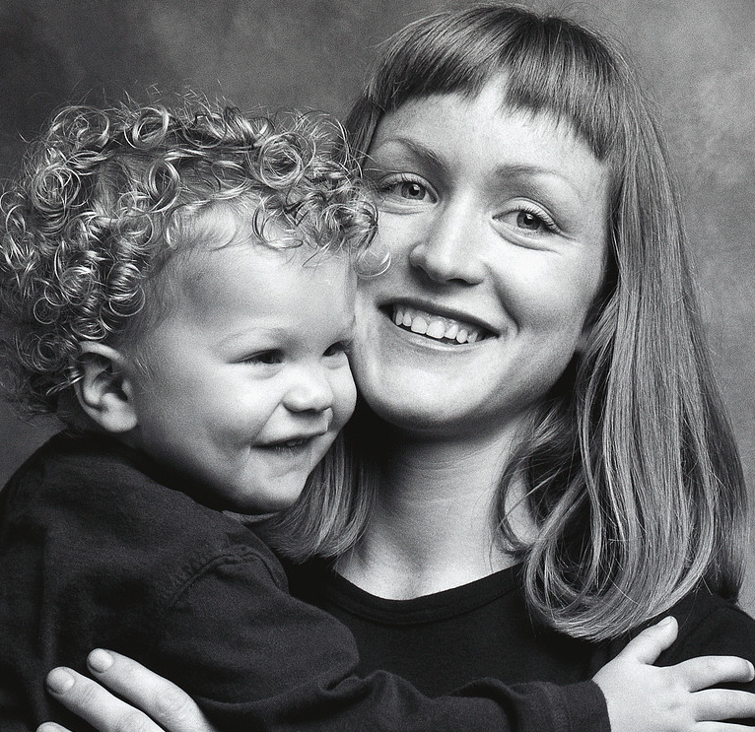
Building Toward…
The Future.

At CHILDREN'S DEVELOPMENTAL PROGRAM
October 2006 Newsletter

It’s always cool to be kind: Wouldn’t it be wonderful to live in a kind world? A place where everyone said sweet words, doors were always held open, there was no bullying and peace reigned supreme. Sure, that’s a dream world, but it’s one you can at least aim for creating with your kids. Children who learn respect and empathy and turn those principles into words and acts of kindness can have a huge impact. They make their home and schools better places. And studies show that kind kids are less likely to bully or be violent. So how do you start? Here are some suggestions for bringing more kindness into your family:

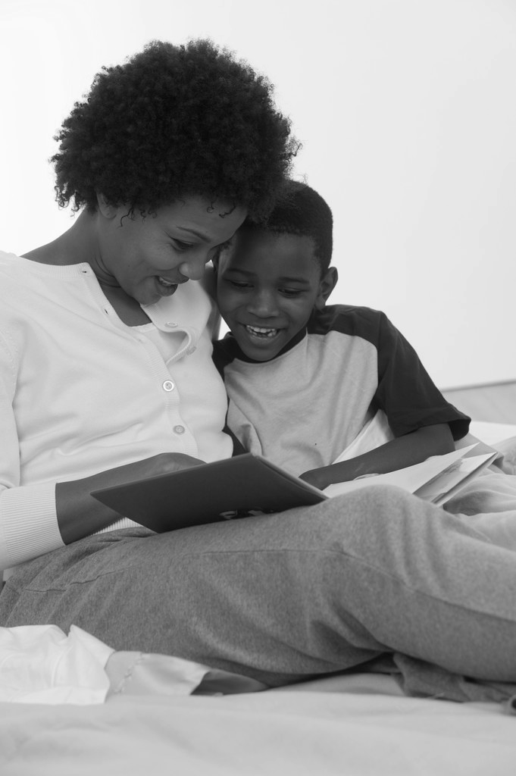
Model it
The best way to teach your children kindness is not by explaining: it’s by doing. Whether you do volunteer work, mow an elderly neighbor’s lawn or just treat others with dignity and respect, kids pick up on this and want to emulate it. But there’s a caveat: your actions should match your words (that means no being nice to someone in person and then talking about them behind their back!) and you should show respect for others no matter what their financial situation, religion or even personality. And even if someone is not a great person and you dislike them for good reason, you can still be civil.

Be kind to your kids
If you run a kind, respectful household, kids learn what it feels like to be treated kindly. That doesn’t mean you never punish a child! But it does help to make sure all discipline comes with an explanation.

Reward kind acts
You know how kids love attention: so shower them with it, when they’ve done kind things. Instead of just scolding them for not sharing or being rough with another child, make a fuss when they do share or give. Better still, if your child is ages 6-10, you might want to adapt the "Caught Being Kind" program that Maury Nation, assistant professor at Vanderbilt University and an expert in bullying, has been testing in schools. If you catch your child doing something kind, give them a star on the fridge, and have those build towards a treat such as a special dinner or an outing.

Read about it
Ages 3-5
Koi and the Kola Nuts
The Giving Tree by Shel Silverstein
The Gift of the Crocodile by Judy Sierra
The Giant Hug by Sandra Horning
Ages 6-9
The Quiltmaker's Gift by Jeff Brumbeau
The Paper Crane by Molly Bang
Smoky Night by Eve Bunting
Ages 9-14
Little Women by Louisa May Alcott
Pay it Forward by Catherine Ryan Hyde
The Acorn People by Ron Jones
Give them tasks to do
One study out of the University of Minnesota showed that children who did housework had better feelings of responsibility and self-worth years later. And children who feel good about themselves are more respectful to others.

Help others
Organizations such as the Random Acts of Kindness Foundation and the Pay it Forward Foundation all suggest teaching children kindness by having them do kind acts, such as:
- Take part in an event that raises money for a good cause.
- Donate regularly to the local food bank.
- Let your child think of ways to help out victims of hurricanes,
earthquakes and other disasters.
- If you have money to give to charity, ask your children to help
you decide who to give to.
- Initiate a fundraiser through school to help people in need.

Make friends
Friendship is the most long lasting way we can show kindness to another person. Have your children make friendship bracelets and necklaces or encourage your child to befriend someone at school who is lonely or left out.

Watch the language
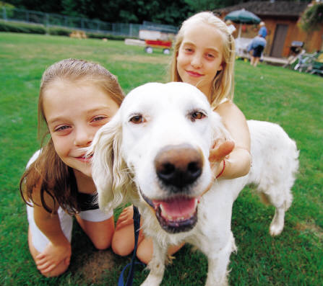
Words have enormous power. Work on purging your vocabulary of words such as stupid, shut up, idiot and any racist or biased terms. When your child says such words, right away tell them that those words hurt others and ask them to rephrase what they want to say. No need for a big lecture just a quick correction.

Enjoy kindness
Finally, the whole point of being kind is to make the world a more fun, safe and happy place. So when your child does a kind act, when you witness something kind or even when you’re the recipient of kindness, show your joy. Keep an open discussion about your feelings around kind acts and let your child feel how wonderful it is to give — and receive — from others.

Halloween Safety
➢Wear makeup, not masks.
➢Avoid gear that blocks vision and pointed props.
➢Wear bright reflective cloth.
➢Have parties instead of trick-or-treating.
➢Have adults supervise closely.

Silent Auction
Leaves are slowing turning, the days are getting shorter and the temperature is dropping. What does all this mean? It’s time once again for CDP’s Annual Silent Auction!

Each fall the Board of Directors holds a Silent Auction as a fundraiser for the school. A live auction for some of the higher priced items is definitely a highlight of the evening. This year the auction will be held on Sunday, November 5, 2006 at the Spinnerstown Hotel.
This year’s auction marks the kick-off for next year’s year-long celebration of CDP’s 50th Anniversary! And since CDP first opened its doors back in 1957, the auction theme will be a trip back in time to the Fabulous Fifties!

This is always an enjoyable event and we are inviting our families to support the program here at CDP by purchasing tickets. Feel free to get into the night’s theme with a 50’s inspired ensemble! Your ticket includes admission to the auction, light refreshments and a bidding number.

Whether or not you are able to attend, you may choose to support the auction by donating an item to be bid on. Watch your child’s box for ticket info and special theme baskets being donated by each classroom. If you have any other questions about the event please see the office staff.

Dog Safety
The American Society for the Prevention of Cruelty to Animals (ASPCA) reports that over half of all U.S. children are bitten by a dog before their 12th birthday. Most bites are from a male dog known to the child. Many dog bite injuries in young children involve their heads and necks. Early Childhood Health Link has adapted some simple rules that the ASPCA suggests be taught to young children. The messages are best taught one at a time when the situation occurs.
- Do not stare into a dog’s eyes.
- Do not tease dogs that are being kept behind fences.
- Do not go near dogs chained up in yards.
- Do not touch a dog that is loose outside.
- Immediately tell an adult if you see a loose dog.
- Do not run and scream if a loose dog comes near you.
- Stand very still (like a tree) and be very quiet if a dog comes near you.
- Do not touch or play with a dog while it’s eating or sleeping.
- Pet a dog only if its owner says it is OK.
- Ask the dog if it is OK to touch by letting it sniff your closed hand.
- Do not approach a dog without a grownup that helps you manage the situation.
For a list of worksheets and materials you can buy from the ASPCA, visit them at aspca.org.

Mark Your Calendar

October

1 - Family Picnic @ Quakertown Park
13 - Picture Day
18 - Jen & Anne’s Classes Pumpkin Trip
18 - Pampered Chef Night 6:30-8:30
20 - Lynne, Heather & Cheryl’s Classes Pumpkin Trip
26 – NO IU – Daycare Only
November

5 - Silent Auction

