How To Transfer Money Online From SBI To Other Bank Account
July 23, 2015
Most people need to send money to an individual, family member or friend. Maybe you need to top off the account of a child away at college, pay your son’s piano teacher or help support relatives abroad. Whatever the reason, there are several ways to send money, each with its own advantages.
Before knowing how to transfer money from one bank to other bank, lets us know different ways to transfer money form one bank account to another bank account. Here we provide you the list of ways where you can transfer your money to other’s account.


1.By Cash
- Go to the branch [your bank, if both the a/c s are in the same bank; otherwise go to the person’s bank, whom you want to pay]
- Take a deposit slip. In the a/c type for savings a/c, write SB and for Current Account, write CA. In the a/c no. write the a/c no., in which you want to transfer the amount. In the name, write person’s name to whom, you want to transfer / deposit the amount.
- Deposit the cash deposit slip, you will get back a cash deposit receipt.

2.By Cheque
- In the name, write person’s name to whom you want to transfer / deposit the amount and if available his / her a/c no. in brackets (A/c No. xyz).
- Then go to the person’s bank to whom you want to pay and deposit the cheque, against cheque receipt, generally the receipt is not stamped.
- If now the person does not have a bank a/c, write the same cheque same way without writing a/c payee and his a/c no. Tell him to visit your bank branch with a photo id card, to withdraw the money. This is done only in the case of small amount money not more than Rs.5,000 and mostly for labourers.

3.By Demand Draft (DD)
Same as cheque. This facility is done only when the specific person to whom you are paying is staying in a remote location, where all the bank’s branches are not there. Pay Order (PO) is done when the amount is less than Rs.50,000 and issued and withdrawn within a state..

4.By credit card
Transfer deposit money into the credit card of the person whom you want to pay.

5.By Net banking
If you have net banking facility, you can transfer money to any a/c. First you have to register the person’s bank a/c no. in your net banking account. For Same bank’s a/c takes 3 business days and for different banks, it takes 7 days register. Once, registered you can transfer money immediately.

6.By RTGS / Swift
If don’t have time, you want to immediately transfer money, contact your local branch for RTGS / Swift. They will charge a fee. But your transfer will be within 5 to 20 minutes depending on the service of the bank.

7.Via PayPal.
If the person to whom you are paying, has a pay pal a/c, you either transfer money by your credit card / pay pal a/c.
In this article we are going to show how to make a fund transfer from SBI to HDFC bank account using sbi net banking

How to transfer money from one bank account to another

Step 1:

Login in into your Internet Banking website with your login details.

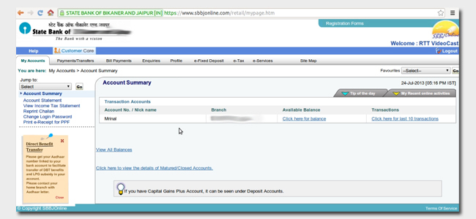
Step 2:
Before transferring the funds to other account add them to beneficiary. Then select inter-bank beneficiary to transfer fund to someone else account in another bank.
Go to Profile > manage beneficiary.
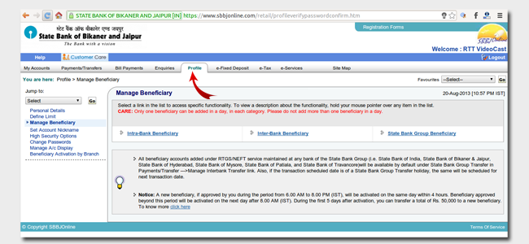
Note: The beneficiary approval from the bank may take up to one day. Once the status is active you can proceed with next step.

Step 3:
Now you will need to enter details like Name , Account no. along with branch address or IFS code. After filling all the details you just need to click on submit.
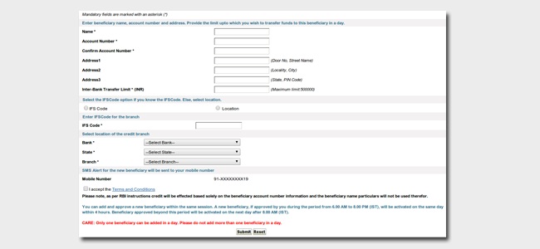

Step 4:
After the beneficiary has been approved by the bank. You are ready to make fund transfer.
Go to Payment/ Transfer > Interbank beneficiary.
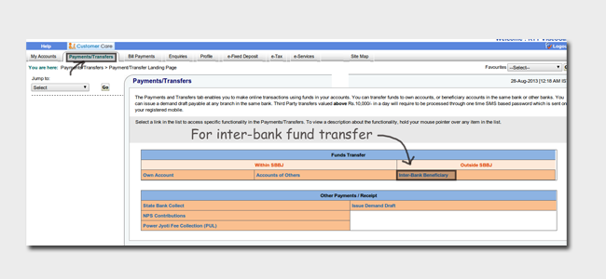
Step 5:
Next select the transaction type as NEFT or RTGS.
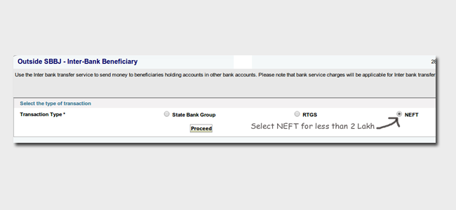
Step 6
Next select the Beneficiary name and enter the amount to be transfer and submit it. You may need to verify your details once again, make sure the details are correct and hit submit button.
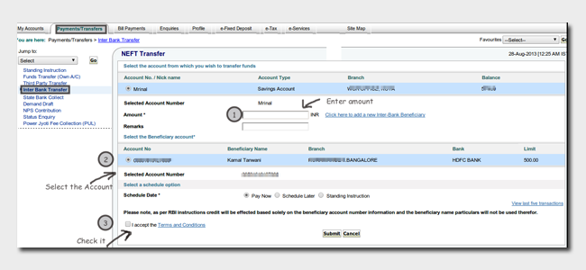
You can also transfer money using ATM but this works within the same bank only.If you face any sort of problem in transferring money please do comment below.

